
"Ausgrenzung liegt im Wesen sozialer Strukturen"

Das Phänomen der Marginalität und der Marginalisierung

Gunther Grewe
Games for Criminal Status
Justice as Order
through
Structured Social Inequality – edited 2022 -

PETER LANG
Frankfurt am Main • Bern • Las Vegas

Games for Criminal Status:
Justice as Order through Structured Social Inequality
Abstract

Günther Grewe
The study proposes that we live in a world of social inequality where social status determines our behavior in the observer's perception.
Depending on the relative social position of the actor and the observer, "saintly behavior" of the high-status actor may be phenomenologically identical to "deviant behavior" of the social miscreant but carries rewards for the "saint" and sanctions for the "deviant."
Such a view of social texture is sobering. Is Justice "Order through Structured Social Inequality"? The study develops a model of the processes leading to the differential distribution of immunity in society. These processes are a sequence of status degradation ceremonies. In a social psychological model based on game-theoretical conceptualizations, the status degradation ceremonies play a series of games where the grand prize is criminal status.
The study illustrates that the processes leading to criminal status parallel everyday life if we understand social life as a sequence of encounters, as games for social status. Given this understanding, the study of criminology attains a new meaning. It is no longer the study of some marginal, exotic, and esoteric group, be it criminals or criminologists, but as a part of social science, the study of social differentiation in general. Whatever we learn about the dynamics of obtaining criminal status clarifies the criminalization process and holds the properties for a novel understanding of the processes of reality construction in everyday life - of becoming prominent, an outsider, or simply of being a plain man.
For criminological research, the model of games for criminal status conceptualizes the labeling approach and the principle of marginality (i.e., the phenomenon of ubiquity, scarcity, and relativity of marginal positions in social groupings). Based on this model, we can reach a new understanding of justice and, especially, of criminal justice, which would allow us to develop the labeling approach into a theory from which we derive hypotheses whose validity is open to empirical investigation and validation.
The author, a sociologist, uses symbolic interactionist modeling and simulations from game theory. His publications deal with the interdependence of behavior and status. In essence, he observes that marginal positions are ubiquitous, rare, and relative in any social structure. A chilling aspect of the model is that removing someone from a marginal position pushes someone else into the margins of society. Even more chilling is that these processes could be socially engineered and misused.
He previously published "Straßenverkehrsdelinquenz und Marginalität" (Lang: 1978), a study on the possibilities and limitations of regulating social behavior through law and law enforcement
TABLE OF CONTENTS
1. INTRODUCING THE CONCEPT AND THE MODEL 6
1.1. Perspective and Assumptions 6
1.2. The Concept of Marginality 7
1.3. The Model of “Games for Status” 9
2. BEYOND THE "COMMON SENSE": TOWARDS A SCIENCE OF SOCIAL DIFFERENTIATION 13
2.1. Criminology as Caretaker of Rationalizations 14
2.1.1. The Controversy on Definitions of "Crime" and "Criminal" 14
2.2. Value Neutrality in Social Science 17
2.2.1. Gouldner’s Complaint and the "1' Art pour 1' Art" Approach to Social Science 18
2.2.2. The Problem of Common Sense: Social Science as a Social Activity 20
2.2.2.1. The Gross Cycle of Social Science 20
2.2.2.2. The Petite Cycles of Social Science 22
2.2.2.3. Value Neutrality as an Attempt to Avoid Ought-Worlds 28
2. 3. Towards a Scientific Activity of Criminology 37
3. BUILDING THE MODEL: NON-MONETARY COST-BENEFIT ANALYSIS AS A BASIC BEHAVIORAL PATTERN 39
3. 1. Decision Theory as Complementing Behavioral Theory 39
3.1.1. The Social Exchange Concept 41
3.1.2. The Game-Theoretical Bargaining Model for Social Status 47
3.2. Games for Social Status 59
3.2.1. Bargaining for Esteem 61
3.2.2. Selecting Partners 71
3.2.3. Status Maintenance and Status Change 76
3.3. Behavior as Negotiated Reality 77
4. APPLYING THE MODEL: THE CRIMINAL JUSTICE SYSTEM AS AN INSTITUTIONALIZED STATUS SLIDE 80
4.1. The Attrition of Justice 82
4.2. Games for Criminal Status 85
4.2.1. Distributing Negative Esteem 85
4.2.2. Choosing Conflict Points 91
4. 3. Criminal Status and Criminal Behavior 94
4.4. Propositions on the Construction of the Social Reality of Criminal Behavior and Criminal Status 95
5. SUMMING UP: JUSTICE AS ORDER THROUGH STRUCTURED SOCIAL INEQUALITY 110
BIBLIOGRAPHY 112

Games for Criminal Status:

1. INTRODUCING THE CONCEPT AND THE MODEL

1.1. Perspective and Assumptions
Criminology has been a layman’s science, traditionally incapable of transcending insights beyond common sense and traditionally occupied with rationalizing societal irrationalities. It is the caretaker of the common-sense notion that life chances depend on social conduct, i. e., the notion that the good things in life are for the ones who are well behaved and that the bad things in life are for the ones who violate social conduct norms. Future historians and sociologists of knowledge might see traditional criminological theory in the same way as the functional theory of stratification is presently seen, namely as an attempt to justify and maintain structured social inequality existing in advanced industrial society.
Common to many criminologists, regardless of whether they aim at adjusting "the criminal" to the prevailing social system, or whether they strive in addition to adjusting the social system to their ideas of appropriateness, seems to be the belief in the American Dream which asserts that "all men are born free and equal" and that "everyone . . . has the right and often the duty, to try to succeed and to do his best to reach the top" (Warner et al., 1949: 3). Common to these criminologists is a vague idea of justice according to which wrongdoers are or should be punished only based on their conduct and are or should be assigned criminal status regardless of their previous social status. Common to these criminologists, therefore, is their refusal to see the contradictory character of the American Dream, which disturbs its pastoral idyll of social equality. They refuse to see that the two fundamental themes of the American Dream,
that all of us are equal and that each one of us has the right to the chance of reaching the top, are mutually contradictory, for if all men are equal, there can be no top-level to aim for, no bottom one to get away from; there can be no superior or inferior positions, but only one common level into which all Americans are born and in which all of them will spend their lives (Warner et al., 1949: 3).
They refuse to recognize the possibility that a common sense ought-world might exist, structuring the is-world and making it inhabitable, which, for social scientists, is part of the is-world to be investigated. They refuse to admit the reality-descriptive quality of the well-known Latin proverb, "Quod decet Jovi, non decet bovi!”, which corresponds closely to the phrase, "All of us are equal, but some more than others". They refuse to recognize that phenomenally similar behavior is not necessarily cognitively similar.
The problem of these criminologists, and perhaps of the entire activity of criminology, as we shall show in the course of our study, lies in their attempt to solve the ancient discord between "is" and "ought" by postulating the transformation of the is-reality into an ought-reality (Gouldner, 1970: 489) as the primary goal of criminology, without much concern for and perhaps even fear of the presently existing is-reality.
Though this approach is understandable, since “it is as extremely painful and threatening for a man to believe that what is powerful in society is not good, as it would be for the religious believer to feel his God was evil" (Gouldner, 1970: 486), we do not consider it to be a viable approach for engaging in criminology as a science.
We understand science as comprehending and reducing complexity (Luhmann, 1967: 107), as mapped reality. We regard it as necessary to distinguish between a pure and applied science in any science and therefore also in criminology. By criminology as pure science, we mean an activity, which is restricted to analysis, far away, disconnected from and unrestricted by any ought-world of change proposals. Based on this perceived is-world encompassing social ought-worlds, we believe an applied science of criminology is possible.
With this perspective and these assumptions in mind, we shall now present a central concept of our study, the concept of marginality.

1.2. The Concept of Marginality
We propose to understand the is-world of criminal justice as being governed by what we shall call marginality. By marginality, we mean (1) the phenomenon that marginal positions exist in all social groupings, (2) the phenomenon that the marginal positions in all social groupings are limited in number, and finally, (3) the phenomenon that marginal positions are marginal relative to the ranking within the particular social grouping. Marginality, therefore, is characterized by (1) ubiquity, (2) scarcity, and (3) relativity of marginal positions in social groupings.
Indirectly, we encountered marginality when we discussed the internal inconsistency of the American Dream. There we noted that the dream of equality conflicts with the reality of social ranking. The notion of marginality is nothing but a consequence of structured social inequality in social groupings.
By introducing our concept of marginality, we propose to effect "a shift in the problems noticed and investigated and a change of rules of scientific practice, comparable to the switch in perceptual gestalten in psychological experiments, when, e. g., the same figure may be seen as two faces vs. cup, or as duck vs. rabbit" (von Bertalanffy, 1968: 18). Instead of directing our attention to the inequalities in the social system, we shall redirect it to its margins. The existence of these marginal positions is implied by the very fact that we can assume the universality of rank differentiation in social groupings. The redirection of our attention from the social ranking to the fact that ranking implies the existence of marginal positions is especially appropriate if we perceive the Criminal Justice System as a sub-system of the general social system of structured inequality, which has the task of deciding whether or not to assign somebody to the social status of "being a criminal", i. e., to a marginal status.
By understanding criminal status as a particular case of marginal status, we take two steps, which have often been postulated. Firstly, we implicitly recognize that criminal status is a "normal" social status. Secondly, we free criminology from the "shackles" of criminal law definitions (cf., Sellin, 1938: 41).
The normality of criminal status follows from the assumption of the ubiquity of social differentiation. In contrast, the assumption of relativity and scarcity of marginal status accounts for the fact that, for an observer whose standpoint is within a social system, i. e., from the perspective of his socially constructed ought-world, the marginal status of being defined criminal appears to be a non-normal social status.
However, our concept of marginality also has the property of freeing a science of criminology from the shackles of criminal law definitions. This follows from the assumption that criminal status is only one type of marginal status and that its allocation procedure can be assumed as being non-distinct from the allocation of other types of social statuses, whether they be marginal or not. In our concept, the "criminal", the "mentally ill" individual, the "weird" person, the "prominent" man, Becker’s (1963) "outsider", as well as the "leader", are all defined as marginal persons, but without the "reality"-restrictive stigma of being good or being evil. Their position is perceived as the result of a social evaluation process, or more precisely, of a sequence of social evaluation processes, each not necessarily consisting of the same evaluators as the previous one, except for the (changing) self of the evaluee.
Therefore, the proposed concept of marginality is a way to synthesize several perspectives of the "observed" socially constructed realities into a more complexly constructed reality. It takes Durkheim's hypothetical "society of saints" (Durkheim, 1885: 12) seriously, but goes beyond it; for it claims that corresponding to the negatively evaluated "deviant" saints, this society will also have its “weird”, its “mentally ill”, and its “saintly” saints. It extends Quinney’s (1970:23) elaboration of Durkheim’s (1885:13) theory of the social reality of crime to the acquisition of social status, providing us with possible insights into the process of assignment to a marginal position in a social system, as well as insights into the process by which the status assignment is confirmed or altered.
Certainly, however, the mere substitution of the term “criminal” by the term “marginal” will have the effect of de-metaphysicizing the study of “crime”.
The theory of the social reality of crime is where we are today. It is a significant advancement over where we were before, as this theory can integrate much of the factual information gathered by generations of criminologists. By having introduced the concept of marginality, we intend to indicate where we might go from there because the stubborn search for a science of criminology is not yet over.

1.3. The Model of “Games for Status”
Corresponding to the nature of concepts - - they are neither true nor false, but tools designed to capture relevant aspects of reality and thus “constitute the definitions (or prescriptions) of what is to be observed” (Merton, 1968: 143) - - our task will be to construct within the novel reality created by the concept of marginality a theory explaining the mechanism of status allocation within the multidimensional social evaluation space.
We shall build two models of status allocation. The first one is a general model of status change, where the essential factors and the dynamics of status change are unfurled. The second model, describing the dynamics of attaining criminal status, is a special case of the general mode. It is characterized by the fact that criminal status is one type of marginal status and that its assignment occurs only after an institutionalized ritual, which is performed by the candidate for criminal status and by various agents of the Criminal Justice System.
In constructing our models, we shall employ a technique we often observe in economic literature. There we are used to watching the growth of a tender theory-seedling through a succession of imaginary worlds. These are the imaginary worlds of perfect markets, rational behavior, perfect certainty, two-period worlds, etc. In a sequence of hypothetical tests, where each one takes place in a world harsher (more “realistic”) than the previous one, the theory-seedling weathers to a mature theory that can exist and survive in the complex “real” world. Adopting this technique seems to avoid a significant problem often confronting behavioral sciences: The Sacrifice of the “Gestalt”, the complexity, on the altar of reductionism for the sake of exposition.
After the final construct is non-contradictory to empirical findings and has also been shown to order these findings into a general system, we shall consider this construct a mapping of reality, reduced in complexity. On this map, we shall be able to recognize previously disregarded or unknown interrelations within social systems, and we shall be able to clarify the relationship between the is-world and the ought-world of criminal justice.
Our first model deals with status change and status maintenance in social groupings. It attempts to penetrate the dynamics effecting a change of the social status X at time t₀ to the new social status Y at time t₁ where X and Y can be either the same status position, or where X ranks higher or lower than Y, and where X and Y are status positions within the same social grouping. By grouping, we mean any social entity consisting of at least two persons. Therefore, a grouping could be a dyad as well as a social system with the high complexity of the interrelation between its members.
Defining social status as perceived esteem (cf., Homans, 1961: 149), we understand the members of social groupings as being constantly engaged in social exchange activities. Their exchange object is esteem in various "esteem-currencies". Exchange theory, as it was developed for the social sciences by Thibaut and Kelley (1959), Homans (1961), and Blau (1964), describes and explains this process. It seems, however, that we can further clarify the notion of social exchange if we take a look over the fence and observe how another area of science, namely economics, handles the problem of exchange.
Economists have tried to deal with the problem of exchange in various ways, one of them being decision and game theory. For our status change and status maintenance model, we intend to borrow from economics the descriptive elements in the theory of bargaining games and a modern version of the rationality postulate. Correspondingly, we choose as the label for our basic model: "Games for Social Status".
As a unit of social organization to be analyzed, we select the encounter, which we define as a sequence of interactions consisting of at least one action and one response. Unfolding the status change and status maintenance model, our attention is directed towards the factors that influence the allotment of esteem by and among the parties of an encounter. We shall develop the idea that life chances do not depend primarily on social conduct; instead, as we shall show, the dominant factor for the allotment of esteem in an encounter is the status quo ante of the participating "players of the status game". We shall also show that phenomenally similar behavior is not necessarily conceptually similar; instead, it is the social status, i. e., the perceived esteem, which confers the conceptual quality to a behavior. Finally, our model will confirm the factual information about status movement, namely that any social status is typically a viscous, "sticky" state, which is more likely to be enhanced rather than changed by an encounter.
Our second model is an extension of the basic model to the process of criminalization. We shall call it "Games for Criminal Status". Through this model, we shall solve the contradiction, which seems to exist between the statements that social status usually is a "sticky" state and our assumption that the criminal status is a marginal status, which typically does not correspond to the status quo ante of the first encounter with an agent of the Criminal Justice System.
We shall solve the seeming contradiction by understanding the criminalization process as a sequence of encounters conceived as bargaining games and by distinguishing four steps in the process of the allotment of criminal status, i. e., in the process of becoming a person who has been adjudicated as having committed a "crime".
The "offender" is processed, as a rule, sequentially in four encounters with an agent of the Criminal Justice System. These encounters, ending with the assignment of criminal status, occur between the actor and the general public and the "victim", the police, the prosecutor, and the court. Each encounter, compared with everyday encounters, is highly ritualized. Only one party in the encounter, the agent of the Criminal Justice System, has both the freedom and, sometimes, the duty to choose partners. This is because he has, on the one hand, more partners and games available than his time would permit, and on the other hand, he has to choose at least a few partners and play a few games if he is an agent of type 2, 3 or 4.
We propose, therefore, to understand the four steps towards criminalization as a recruiting process by which it is sequentially determined who is eligible for criminal status and who is not. Hence, the criminalization process can be analyzed as a sequence of encounters, of bargaining games for criminal status, systematically connected as status degradation ceremonies. The label "criminal" is awarded after a succession of encounters, starting with encountering the victim and ending with encountering the court. At any given time, the subsequent encounter takes place, if and only if the previous encounter permits the entrance into the subsequent encounter, that is if in the previous encounter a behavior has been defined as criminal behavior and the status of the actor has been downgraded, e. g., to the new status of "being a suspect", "being an accused", or "being a defendant".
The details and the results of the model agree with the factual information about the criminalization process because the model predicts an inverse relationship between social status quo ante and the chance to attain criminal status. As our model is non-contradictory to the empirical findings, we can accept it as an adequate mapping of the process by which criminal justice is distributed. According to the model, the social reality of criminal justice is part of a general structured social inequality. Contrary to the ought-world of criminal justice, it perceives the chance to attain criminal status as differentially distributed in social groupings.
Our model presents us with an uncomfortable reality because this reality conflicts with the ought-world of criminal justice. Within our perceived is-world, conduct, which can be defined as a crime, according to the relevant (criminal) code, is only a necessary but not a sufficient condition for attaining criminal status. Just as in our analysis of everyday status change and status maintenance, the status, which exists before the first encounter, is the dominant factor for any new status. The role of the phenomenal conduct is secondary, as its conception depends on the perceived status quo ante.
Through our model, we try to dissociate ourselves from the traditional approach to criminology. In contrast to this approach, we regard criminal status as one type of marginal status, thereby implying that criminal status positions are ubiquitous, scarce, and relative in any social grouping. We also imply that criminal status is attained in processes similar to the ones by which social status in general is acquired. We understand the model as a concretization of the labeling approach, which focuses on the offender dealing with the Criminal Justice System.
However, with our model, we also try to present a "radical" alternative to the "radical" neo-romanticism in American social science as represented, for example, by Alvin W: Gouldner (1970). We see Gouldner’s approach as reactive and inconsistent with its objectives.
We have in common with this approach the discomfort with a system of structured social inequality, administered and maintained in part by the Criminal Justice System. We share the attitude that the idea of "justice", reified in the Criminal Justice System, is a functional device for maintaining structured social inequality, a device that obscures the selection of marginal persons from relatively powerless status groups.
However, the radical-reactive approach expresses its discomfort by constructing an ought world. Its favorite subject is the political and economic suppression of the weak by the powerful. Structured social in-equality is seen as a characteristic of particular social systems, not of social systems in general. The reactive component of the approach invalidates the radical one because the rules and the setting of structured social inequality are implicitly acknowledged. Contrary to its own explicit intentions, the radical-reactive approach is implicitly as system-conservative as the traditional approach to criminology.
In contrast to the radical-reactive approach, we attempt to communicate our discomfort through an analysis. Our model of the criminalization process shows that there is an is-world of criminal justice where justice is bargained, protected by an ought-world, where justice is equally distributed. Through our analysis, we attempt to penetrate the protective screen of the ought-world, which, if successful, has repercussions on the is-world. We try to conceptualize social differentiation and, therefore, social marginality in general, whether in the social system of American society today, in a social system of a tribe of headhunters, in a small group, or a society of saints.
The proposed analysis of the Criminal Justice System as "Games for Criminal Status", then, could be relevant through its implications for our perception and administration of "justice". These very implications bear the possible necessity of a reorientation of criminology from a caretaker of rationalizations toward a critical science.
In the past, when presenting the ideas of the concept of marginality and games for criminal status as a possible approach to map the reality of the "familiar chaos: our ordinary everyday social behavior" (Homans, 1961: 1), traditional criminologists have misunderstood the proposed approach as "value-laden". From the radical-reactive side of the fence, the response is even more perplexing at first: What is your idea good for? What are the implications for social policy? The criticism was stunning until realizing that the disagreement went deeper than content and form. It concerns a disagreement in what social science is about.
Our first task, and our next chapter, will therefore clarify the position from which the basic concept and the models giving it substance were developed. This will be necessary to delimit the position taken from the traditional and the now fashionable radical-reactive approach.

2. BEYOND THE "COMMON SENSE": TOWARDS A SCIENCE OF SOCIAL DIFFERENTIATION
The "Concept of Marginality" and the model of "Games for Criminal Status", as we shall develop them in the course of this study, are an adequately reduced reality, if understood from a position of value-neutrality in social science. By value-neutrality in social science, we mean an approach which neither proclaims to be free of any values, as traditional criminology is an accused of doing, nor consciously infuses values into social science research, as the radical-reactive approach professes to do, but instead tries to avoid values.
In this chapter, we shall show that the endeavor to do criminology as a science necessitates stepping beyond common sense. This, in turn, implies value-neutrality, a pure science approach, and a redefinition of criminology as a science of social differentiation. By stepping beyond common sense, we mean stepping beyond "What Anyone Like Us Necessarily Knows" (Garfinkel, 1967: 54), or in other words, perceiving as social reality-to-be-analyzed the is-world (phenomenal world) and the everyday ought-world (conceptual world). Criminology understood as a science, i. e., as an activity trying to comprehend and reduce complexity, has to take this step because "constructs of the social sciences are, so to speak, constructs of the second degree, that is, constructs of constructs made by the actor on the social scene, whose behavior the social scientist has to observe and to explain in accordance with the procedural rule of his science" (Schutz, 1953: 59).
We shall begin our discussion by demonstrating that the controversy over the "warmed-over stock issues: the difficulty of defining what is crime and who is the criminal" (Blumberg, 1967: ix) characterizes traditional criminology as a caretaker of rationalizations. We shall argue that "criminology" is a misnomer, or at least, inadequately and misleadingly describes the activity of a social science dealing with crime, the criminal and criminal justice in society. Then, to delimit our approach from the currently fashionable radical-reactive approach, we shall discuss the necessity of value-neutrality and a 1'art pour 1'art attitude in social science. There we shall explain our notion that social science is a social activity, i. e., that a metascience of social science again is social science, and we shall demonstrate value-neutrality as an attempt to avoid everyday ought-worlds. Furthermore, in the third section of this chapter, we shall revisit our concept of marginality. We shall point out the normality of "crime" and "criminals", and we shall argue based on the earlier discussion in this chapter that social science "criminology" has to be redefined as a science of social differentiation. Only after the problem of common sense in social science and specifically in criminology is extensively presented do we believe our model of "Games for Criminal Status" as a mapping of criminal justice can be made intercommunicable.

2.1. Criminology as Caretaker of Rationalizations
Turning our attention to the traditional approach in criminology, we perceive its present state still adequately described by Sutherland (1947):
Much factual information regarding crime has been accumulated over several generations. In spite of this, criminology lacks full scientific standing. The defects of criminology consist principally of the failure to integrate this factual information into consistent and valid general propositions.
Sutherland made this statement in the preface to the fourth (1947) edition of Criminology. One generation or 23 years later, in the eighth edition of the same work by Cressey, we read: "Criminology is not a science, but criminologists hope it will become a science" (Sutherland and Cressey, 1970: 20).
These are sardonic, however, acceptable summaries of the work of the elders in criminology made by two of its most highly respected members. We contend that the principal reason for the failure of criminology as a science is the commonly shared research bias, which prescribes the delimitation of criminology by examining "crime" and "criminal", however widely defined. We shall demonstrate that the battle over definitions is a battle of irrelevancies, fought on the battleground of first degree constructs, i. e., "constructs made by the actors on the social scene" (Schutz, 1953: 59). The controversy over definitions shows that traditional criminology parallels the everyday conceptual reality rather than supersedes. This controversy characterizes traditional criminology as a caretaker of common-sense notions.

2.1.1. The Controversy on Definitions of "Crime" and "Criminal"
There is not much agreement among the contestants in the controversy except on two points:
- A delimitation of the field of criminology is necessary and feasible. What has to be "found" is a definition of "crime" and "criminal".
- Given a definition of "crime", this automatically defines as "criminal" individuals who "commit" these "crimes"; and, given a definition of "criminal", this automatically defines as "crimes" the acts committed, if they are connected with the evaluation of an individual as "criminal".
Before showing why we disagree even on these points with the traditional approach to criminology, we shall briefly consider the aspects of this controversy as they are presented by four of the chief participants: Thorsten Sellin (1938), Edwin Sutherland (1945), Paul Tappan (1947), and Richard Quinney (1970).
Like many searchers in criminology, Thorsten Sellin (1938) expected to arrive at generalizations, which state that if a person of type A is placed in a life situation of type B, he will violate the norm governing that life situation. Postulating that general propositions of universal validity are the essence of science, Sellin asserted that the variability in the legal definitions does not permit the formulation of the universal categories required in all scientific research. He, therefore, proposed the study of conduct norms in general by isolation and classification of norms into universal categories rather than only the study of crimes as defined by the criminal law. For social science criminology, then, "crime" is the violation of conduct norms.
Like Sellin, Sutherland (1945) was dissatisfied with the use of the legal definition of "crime" in social science research because it arbitrarily excludes behavior, which is similar to behavior classified as "crime" according to the legal definition. Sutherland’s approach to the problem of the definition of "crime" and "criminal" was to include within the scope of theories of criminal behavior all behavior that is legally sanctioned and socially injurious. The legal sanctions he had in mind were not restricted to criminal law but included those in civil law.
Paul Tappan (1947) found the proposed sociological definitions of "crime" and "criminal" perturbing. He interpreted them as arising from the "desire to discover and study wrongs which are absolute and eternal rather than mere violations of a statutory and case law system which vary in time and place; this is essentially the old metaphysical search for the law of nature" (Tappan, 1947: 41). He criticized Sellin' s and Sutherland’s universal concepts for the absence of criteria defining such terms as "injurious". Tappan contended that crime, as legally defined, is a sociologically significant province of study, whereas the "white collar criminal", the violator of conduct norms, and the antisocial personality are not criminal in any sense meaningful to the social scientist unless they have violated a criminal statute.
Richard Quinney (1970) has provided us with one of the most recent definitions of "crime". He defines "crime" as "a definition of human conduct that is created by authorized agents in a politically organized society" (Quinney, 1970: 15). "The social reality of crime is constructed by the formulation and application of criminal definition, the development of behavior patterns related to criminal definitions, and the construction of criminal conceptions" (Quinney, 1970: 23). Quinney uses the term "crime" in a somewhat unusual sense. Sellin, Sutherland, and Tappan employ the term abstractly when they discuss the rules according to which the social reality is constructed. Quinney, however, talks about the process concretely when he implies that the rules about how social reality should be constructed might not necessarily correspond to how it is actually constructed. Equivalent to Quinney's definition of "crime” is that crime results from an evaluation of human conduct. Instead of attributing the result of concrete evaluation processes to the person adjudicated, the "criminal", Quinney attributes it to a conduct, the "crime".

2.1.2. Criminology -- A Misnomer?
Common to all four participants in the controversy is a basic assumption of traditional criminology. This assumption presupposes a fundamental difference between "crime" and "criminal" on the one hand and behavior and status not evaluated as "crime" and "criminal" on the other hand. The difference from everyday life is perceived to be so drastic that a separate social science is justified. A powerful ally for the assumption seems to be the "common sense", the "What Anyone Like Us Necessarily Knows" - grasp (Garfinkel, 1967: 54) of everyday life.
However, this powerful ally does not appear to be mighty at all from a phenomenological perspective. On the contrary, from this perspective, it seems that traditional criminology, because of this alliance, falls victim to one of the cruelest laws of science, which says that the scope of the research question determines the range of the possible research results. The history of sciences is full of examples where paradigms proved to be inadequately reality-descriptive because of their reality-restrictive a-priori assumptions (see, e.g., Conant, 1947; Kuhn, 1962).
Today’s most avid victims appear to be the social scientists, especially the religious believers in empiricism, the centipede leg counters, as their critics sometimes call them. They and the other social scientists must face the problem that, while they spend their lives within the conceptual everyday reality, i. e., within constructions of the reality of the first degree, in their work, they must build second-degree constructs of the social reality. Traditional criminology, it seems, has run aground because of this problem.
The controversy on definitions shows that the traditional approach to criminology takes the etymology of the term "criminology" rather literally. Etymologically, "criminology" means the scientific study of "crime" and "criminals". The term was introduced one century ago by Rafaele Garofalo (1885), who used it as the title of his book. It was at that time an appropriate description of the activity of criminologists.
Today, six academic generations later, we have to ask ourselves whether the term "criminology", which might have been appropriate at one time, is a misnomer and a mistake because of its implicit a-priori assumptions.
It is no longer self-evident that there can be a separate area of science, restricting itself to a behavior and its evaluation, whether it is called "crime" and "criminal" or otherwise. On the contrary, it seems a more reasonable approach to ask a preliminary question. Before discussing which definition of "crime" and "criminal" provides an adequate delimitation of criminology, we must ask whether a social science of a behavior is possible at all.
Quinney’s work, and before him the labeling approach, did cast the first shadow of doubt on the appropriateness of the name of the science. Though Quinney does not seem to relinquish the tacit assumption of traditional criminology, he takes the first step towards it by postulating that what used to be perceived as a phenomenal reality, namely "crime" and "criminal", are both a conceptual and a phenomenal reality.
The consequence of this view is that to understand the person and the act, we have to trace the process which led to the evaluation. Our attention has to be redirected from the result of the evaluation process to the evaluation itself. However, suppose we are willing to take this step. In that case, there is no reason to accept, as Quinney still does, an a-priori assumption of a fundamental difference between "criminal" and everyday social evaluation processes, such as to justify the maintenance of a separate science dealing exclusively with "crime" and "criminal". Instead, we must either relinquish criminology as it is presently understood to another social science, or we must imbue it with new meaning.
Therefore, Quinney, one of the youngest elders in criminology, legitimates with his compilatory theory of social reality the revolt against the oldest and most tenaciously held dogma of criminology.
He himself seems to be only dimly aware that his work facilitates the death blow to the traditional approach to criminology. In his book The Problem of Crime, he states somewhat astounded, somewhat proud: "I have found, to my own satisfaction at least, that an attention to crime can illuminate many of our problems. Crime has something to do with the most profound of all sociological problems - the relationship of the individual to his society" (Quinney, 1970a: vi).
Given our perspective, however, we can no longer say, "crime has something to do with the most profound of all sociological problems". Instead, we have to say that "crime" i s one of the possible relationships of an individual to his society. The controversy on the definitions of "crime" and "criminal" to delimit the subject matter of criminological investigation, then, is not only controversy on irrelevancies, but also a controversy, which is misleading by its problem formulation. Like the medieval scientific controversy within alchemy, it has and will continue to make us lose sight of some basic assumptions on which the arguments are founded.

2.2. Value Neutrality in Social Science
In the discussion up to now, we have attempted to point out how questionable it is to perceive "criminology" as the scientific study of "crime" and "criminals". We used some recognized elders, Quinney, Sutherland, and Cressey, as our star witnesses in our case against the defendant "traditional criminology". Nevertheless, we assumed the existence of a scientific activity "criminology," which we, in contrast to the traditional approach, no longer perceive as a separate social science studying "crime" and "criminal", but understand as a part of social science. In this new concept, "crime" is seen as a socially constructed reality, which can be studied, only as one of the possible relationships of an individual to his society.
Given this conception of criminology, we have to take issue with the currently fashionable radical-reactive approach in social science. We shall contrast our position, which can be described as a position of value neutrality, from the position of the radical-reactive approach.
We shall accuse the radical-reactive approach of confusing social science problems with social problems, thereby confusing constructions of reality of the first and the second degree. Furthermore, we shall try to show that the social policy implications of a particular research project are inadmissible in social science. Arguing that an "applied" science necessitates a "pure" science, we shall demonstrate that value-neutrality and a l'art pour l’art approach are indispensable in social science and, therefore, in criminology.
We shall begin our discussion by illustrating the problems which an "l' art pour l' art" approach to social science presently is encountering. This will be done by choosing Gouldner (1970) as representative for a value-oriented social science, which deems itself as radical but is understood by us as radical-reactive. We shall discuss Gouldner's objections to a value-neutral position and point out that to remove the inconsistencies in his work, even his so-called radical stance would entail an initially value-neutral approach to social science.
Expanding on this idea, we shall try to clarify in a second subsection what we see as the problem of common sense in social science, i. e., the problem that social science itself is a social activity. In the third subsection, we shall postulate that a value-neutral approach to social science is a way to avoid many of the ought-worlds, which presently entangle social science with ought-worlds of the first degree, i. e., with common-sense notions about the phenomenal world.
Only after this extended discussion of values in social science can we go about filling the empty hull of the term "criminology" with meaning.

2.2.1. Gouldner’s Complaint and the "l' Art pour l' Art" Approach to Social Science
Alvin W. Gouldner has a problem: "It is as extremely painful and threatening for a man to believe that what is powerful in society is not good, as it would be for the religious believer to feel his God was evil" (Gouldner, 1970: 486). Gouldner attempts to solve his problem by proposing a "radical" sociology whose "historical mission . . . is to transcend sociology as it now exists" (Ibid: 489), and which helps "to produce a new breed of sociologists" (Ibid: 490), the MANLY ONES, who see the "traditional theories . . . as timidity generating creations of timid men" (Ibid.: 8).
Gouldner experiences and expresses in his poetic aesthetic way the ancient discord between "is" and "ought", i. e., in Gouldner’s terms, the tensions between permitted and unpermitted worlds. Gouldner shares this problem with many latter-day social scientists whose patron saint he became as the author of "the coming crisis of western sociology".
The large number of social scientists who share these beliefs, coupled with their zealous intolerance against non-believers (which they justify by the usurpation of the epithet "radical"), forces the excavation of the long-buried discussion on values in social science. As a result of this discussion, we hope to demonstrate the position from which the concept of marginality and the model of "Games for Criminal Status" were developed.
We clarify our position with the very arguments Gouldner uses to establish his "radical" sociology.
A crucial issue in the discussion of values and social science seems to be: Social science -- what for? This question underlies Gouldner’s complaint, or, rather, the sensation of impotence to "discover" a satisfactory answer to the question i s Gouldner’s complaint as well as the "coming crisis of western sociology".
Social scientists, who regard themselves as radical and are recognized as such by other social scientists who also perceive themselves as radical, have made the question of the purpose of social science to their existential core problem. They seem to expect an answer of astral quality and, being unable to discover the answer, discover instead the decline of the sociological occident.
We shall propose an answer of more telluric than astral quality. We shall contemplate the idea that social science is "merely" a form of consciousness, assuming "that human events have different levels of meanings, some of which are hidden from the consciousness of everyday life" (Berger, 1963: 29). The purpose of social science, then, is the satisfaction of a playful curiosity on the part of the social scientist (Weber, 1918: 137).
According to some people's standards of manliness, such an approach certainly has to appear unmanly. Manly, according to their standards, is to change the world "for the better". To avoid part of their harsh criticism and make the approach at least initially more palatable, let us rename our approach from "playful curiosity approach" to "l' art pour l' art approach".
Our endeavor then is to show that even the "manly" intention of changing this world for the better necessitates an "l' art pour l' art approach" to social science. From the standpoint of either approach, we contend that it is well worthwhile to insist on a division between pure and applied social science, even if the demarcation line is difficult to draw and, as Gouldner’s complaint exemplifies, is also painful to draw.
Looking backward to Gouldner's complaint, then, we shall have seen and will continue to see that jolting collective reality are a painful activity and that bewailing this fact does not live up to Gouldner's own "radical" standard of manliness in social theorizing -- that Gouldner' s complaint is the "timidity-generating creation of a timid man" (Gouldner, 1970: 8).

2.2.2. The Problem of Common Sense: Social Science as a Social Activity
Gouldner suggests "that a significant part of social theorizing is a symbolic effort to overcome social worlds that have become unpermitted and to readjust the flawed relationship between goodness and potency, restoring them to their 'normal' equilibrium condition, and/or to defend permitted worlds from a threatened disequilibrium between goodness and potency" (Gouldner, 1970: 486). He scorns the traditional sociological theories as wrong or irrelevant, and postulates a "radical" social science, which recognizes the existence of the fact that a social scientist exists in a field of social gravitation and works toward a solution of the dilemma of circularity of social theorizing.
As a first step to refute Gouldner’s argumentation, let us discuss the implications of the notion that social science is a social activity. Based on the idea that our social life, as social scientists and as human beings, happens in a socially constructed reality, where the personal reality of the "normal" individual is embedded in some collective reality, and where collective realities of different generality are congruous with each other, we shall investigate the interaction between some of these realities and the theorizing of social scientists.
Let us start with a very general collective reality, the Z e i t g e i s t, and observe how Gouldner’s "radicalism" is the consequential development of the interaction between the Zeitgeist and social science in the United States. We call this type of interaction the gross cycle of social science and contrast it to other, smaller cycles in which the social scientist finds himself, e.g., in the interaction of his theorizing to that of his colleagues in the community of recognized scientific practitioners.

2.2.2.1. The Gross Cycle of Social Science
American social science is characterized by unparalleled provincialism. Reading any book on social science generates the impression that social science is non-existent outside the American Empire. The provinciality of American social science makes the task of describing its development up to the present day neo-romanticism relatively easy.
We can distinguish roughly three stages in the development of American social science: The Chicago School, the time of empiricism and grand theory, and the latter-day romanticism. Each of the three stages reflects the political and economic consciousness of its time and reflects the gross cycle American social science is subjected to.
The once dominant Chicago School is perhaps the first faint-hearted budding of social science in America, worth mentioning for our purposes. As an heir to the muckraking tradition, this school replaced newspaper exposes with monographs. It was a school of "social issues", of "social problems", with an outlook of the "reform-minded Midwest and its dislike for the industrial and financial centers, with their capitalist exploitation, boss rule, and religious 'superstitions' " (Roth, 1971: 47). It had its apex between the two world wars, when the underdog, the poor, the derelicts, the hoboes, the prostitutes, and other socially weak persons were the overdogs of social science.
The second significant development of American social science replacing the Midwestern isolationism of the Chicago School started with recognizing the possibility of employing social science for policy decisions. It was the period of grand theory and empiricism. An immense amount of funds started pouring in for those demanding money as social science became a respectable activity. It was the time of empire-building, both by the empirical-minded social science and the Parson-type grand theory, which today is the favorite object of latter-day sociologists' scorn.
In this time, the empirical method developed into empiricism of sometimes grotesque extent. A description of the typical activities of this period, self-reported and without self-consciousness, is Hammond’s (1967) collection of Sociologists at Work: Essays on the Craft of Social Research. In Hammond’s anthology, we can observe how some of the most illustrious names in social science make fools out of themselves. The perversity of the situation is emphasized because even the most sardonic critic of empiricism could not have written a better satire on the movement than the immediate participants.
Since the beginning of the sixties, we can observe a decline of empiricism as government support for social research decreased. The much-abused grand theory remained, changing its content but not its form. Mills' T he Sociological Imagination (1959) is the classic example. The decline of empiricism and the rise of "radicalism" in social science came when the fiasco of the American foreign policy with its ill-concealed neo-imperialism could no longer be masqueraded behind a helping-brother image. Inside and outside the United States, it became apparent to the on-lookers that the United States was an ill-tempered Big Brother in its tantrums. As a consequence, "radical" sociology is introverted sociology.
"The severe domestic crisis in the United States since the mid-sixties in general, and fiascoes such as the abortive Project Camelot in particular, have resulted in a refocusing on domestic issues and a retrenchment of foreign area studies" (Roth, 1971: 48). The attention of social science is concentrated on domestic social problems and the political struggles within the ghettos and the universities. “It revolves around the poles of legitimacy and usurpation, analyzing the perennial triangular struggle among rulers, staff, and subjects throughout history" (Roth, 1971: 48).
The tottering of the colossus had its repercussions on its parasites. The once so almighty empiricist social science and the traditional grand theory today are subjected to an increasingly harsher critique. Its critics are the self-professed radicals. The new social science is of an introverted, brooding kind. The young ones dislike the world their elders have left them. In a typical generational conflict, the elders are attacked for their principles, which are perceived to have led to the inherited quagmire. The reason for the elders' failure is sought in their "irresponsible" attitude towards values.
The elders profess to be value-free—their offspring revolt against this. We, therefore, can understand the present reaction against value-free social science as the reaction of disappointed former believers and their sons under the guise of the epithet "radical".
Gouldner has made himself into the spokesperson of the latter-day sociologists and has won their recognition by acclamation. However, in the acclamation lies the irony of Gouldner’s situation. When Gouldner propagates a "reflexive sociology" and proclaims it as being radical, the very success of his ideas is a counter-indication of the claimed extremeness of thought. Instead, as the wide acceptance of his ideas shows, Gouldner attempts to keep pace with the rapid and sweeping changes in the Z e i t g e i s t, instead of setting the pace.
Unlike C. Wright Mills, he merely joins the chorus, chanting about the "emperor without clothes" -- the traditional social science. This makes him no different from the gullible emperor. He, too, is a follower, someone who, in his quest for understanding, moves through the world of men with respect for the usual lines of demarcation. Gouldner’s case, summarized in his own words by what we called Gouldner’s complaint, exemplifies the case of the social scientist today just as well as yesterday. A social scientist is inevitably caught in the gross cycle of social science. Even if he perceives himself as a pacesetter, he is likely to be such a person because "that’s where it’s at, man". He is likely to be "radical" if it is permissible to be so, or as it appears nowadays because it seems indecent not to give this appearance.
Like his brother, the "man on the street", the social scientist is restricted in the realities he constructs by the collective reality in which he lives. The "radicalism" of Gouldner’s type is a permitted reality embedded in the very general reality, which we call Zeitgeist. The very fact of its wide acceptance shows this interrelation.
Gouldner, who thinks that in his quest for understanding he moves "through the world of man without respect for the usual lines of demarcation" (Berger, 1963: 18), actually cringes in front of the Zeitgeist which presently demands "radicalism" from the youthful adept in social science -- and Gouldner has not much choice to act differently because social science, according to his confession, is a social activity, and as such takes place within some form of collectively constructed reality.

2.2.2.2. The Petite Cycles of Social Science
We now turn our attention to the interaction of social science with collectively constructed realities of lower generality, which are perhaps less controversial in respect to their existence than the reality Zeitgeist.
We now discuss the realities of groups of scientists adhering to and defending a particular school of thought within their discipline, and also another type of realities of still lower generality, the personal reality of the individual scientist. We call the interaction of these two realities with the research of the social scientist the petite cycles of social science.
As in the previous section, we start with the basic assumption -- which we share with Gouldner -- that the imposition of a conceptual order upon data is a social activity (cf. also, Conant, 1947; Beveridge, 1957). Social science as a social activity, then, exhibits characteristics common to other social behavior. The irony of the situation is that we investigate social behavior and that even a study of the activity of the social scientist as an object of investigation is no escape from this circle.
In traditional sociology texts, the problem of the petite cycles of social science is usually evaded by a chapter on objectivity in social science or, more elegantly, by a chapter on what is called "methodology". C. Wright Mills was one of the first influential writers in social science to knock this Holy Cow, and we intend to do our share.
Christian Morgenstern, a German satirist, has caricatured the circularity of social analysis in his Palmstroem- poem, "The Impossible Fact" (Morgenstern, 1963: 34f.). The philistine hero, Palmstroem, is run over by a car in this poem. Ignoring his death, Palmstroem conducts an analysis of the situation:
Tightly swathed in dampened tissues
he explores the legal issues,
and it soon is clear as air:
Cars were not permitted there!
And he comes to the conclusion:
His mishap was an illusion,
for, he reasons pointedly,
that which must not, can not be.
Like Gouldner in his complaint, Morgenstern’s philistine experiences the discord between "is" and "ought", between permitted and unpermitted worlds. Like Gouldner, Palmstroem solves his dilemma in favor of his idiosyncratic normative reality. Of course, compared with Gouldner, the phantasy-creature Palmstroem is immensely less sophisticated and openly egotistical; however, he is refreshingly illustrative: that which must not, cannot be. Palmstroem illustrates a petite cycle of social science, where Gouldner’s petit mal prevents him from realizing it.
Let us start with the observation that the Palmstroem- problem if it were the object of a social scientific investigation, would be a problem of Palmstroem’s cognitive balance. Were Palmstroem a social scientist, however, we could surmise that both he and his social scientist colleagues would study Palmstroem’s problem with "reality" as a question of scientific objectivity. What would be the dimension of inquiry if a psychiatrist or psychoanalyst did it is superfluous to mention. If we disregard the soul-doctors, we are still left with the paradoxical situation that the dimensions of inquiry into "reality" are dissimilar depending on who the inquisitor is and who the subject is.
The usual argument for maintaining the different standard is that the activities of the "scholar" and the "man on the street" are fundamentally dissimilar, insofar as the one balances his cognition in a way, which is intercommunicable, whereas the "man on the street" orders his cognition in a non-methodical way.
This argument brings the discussion into the disputes raging among the philosophers of science. In the context of this paper, our counter-arguments will necessarily appear scanty and only scrape the surface of the ontological problem involved. However, so are the other side's arguments, generally, if they are proffered in a context other than the philosophy of science.
As a response to the argument, which attempts to justify different dimensions of inquiry depending on who is the object of inquiry, the scholar or the "man on the street", we distinguish between the context of discovery and the context of demonstration. Traditionally, the context of discovery is left to psychological analysis. In contrast, the logical analysis of thought is concerned with the context of demonstration, "i. e., with the analysis of ordered series of thought operations so constructed that they make the results of thought justifiable" (Reichenbach, 1947: 2).
However, Hans Reichenbach (1938: 311), who originated the distinction of two realms of analysis, naming them context of discovery and context of justification, already provides at the same time a word of warning not to overindulge in methodology:
When we call logic analysis of thought, the expression should be interpreted so as to leave no doubt that it is not actual thought, which we pretend to analyze. It is rather a substitute for thinking processes, their rational r e c o n s t r u c t i o n, which constitutes the basis of analysis. Once a result of thinking is obtained, we can reorder our thoughts in a cogent way, constructing a chain of thoughts between point of departure and point of arrival; it is this rational reconstruction of thinking that is controlled by logic, and whose analysis reveals those rules, which we call logical laws (Reichenbach, 1947: 2).
Methodology and discussions of scientific objectivity with their ceremonial formalism, therefore, tend to obscure the fact that social-psychological dynamics are essential not only in the context of discovery but also in the context of demonstration. The same tendency to obscure more than elucidate the problems of the context of demonstration can be ascribed to those philosophers of science, who, in a logico-philosophical jargonese, write learned tractates to lay bare the simple-mindedness of formalistic methodology.
Before we get entangled in argument and counter-argument in their language and on their "level", let us leave the tract of science, which philosophers claim as theirs, and take the trophy of our sneaky and short hunting-excursion with us into the relative security of a social science discussion. Our trophy is the notion that undisputed by the philosophy of science, cognitive elements play a role in the discovery and the demonstration of scientific theories in the same way as they do in the everyday life of the "man on the street". For empirical research, this is confirmed by Rosenthal (1966), who shows by extensive examples that different observers of the same experiment can come up with results widely differing from each other. Rosenthal’s study was predominantly concerned with the influence of the experimenter’s expectations on the subject of investigation, i, e., changes in reality by expectations. However, the notion that cognitive elements are present in the discovery and the presentation of a theory implies that perceptions used to justify a theory are themselves firmly formed and guided by this theory. Perceptions are dependent on the context in which they are made. Parts of the context are cognitive factors like the set, expectancies, and hypotheses. This means, among other things, that under the influence of theories, there is a tendency towards a disposition and a habit to observations, which favor theory-conforming observation results (Kuhn, 1962).
We show this through a simple example from the history of science. According to an excellent account by Conant (1947), for centuries, the principle that "nature abhors a vacuum" served to account for various phenomena, such as the action of pumps, the behavior of liquids in joined vessels, suction, and the like. The strength of everyday evidence was so overwhelming that the principle was seldom questioned. However, it was known that one could not draw water to the height of more than 34 feet. The simplest solution to this problem was to reformulate the principle to read that "nature abhors a vacuum below 34 feet". This modified version of the horror-vacui theory was again satisfactory for the phenomena it dealt with until it was discovered that "nature abhors a vacuum below 34 feet only when we deal with water". As Torricelli has shown, "nature abhors a vacuum below 30 inches" when it comes to mercury. Displeased with the crudity of a principle, which must accommodate numerous exceptions, Torricelli formulated the notion that the pressure of air acting upon the surface of the liquid was responsible for the height to which one could draw liquid by the action of a pump. The 34 feet limit represents the weight of water, which the air pressure can maintain, and the 30-inch limit represents the weight of mercury that air pressure can maintain. This was an entirely different and revolutionary (Kuhn, 1962) concept and its consequences had a drastic impact on physics.
Let us analyze the development of the concept of air pressure for its cognitive elements. We see that at each stage of its unfolding process, the available perceptions of reality were structured to a consistent construct, which was able to withstand a methodological inquiry -- until new facts were introduced and perceived as such. Not at any point in the concept’s development can we point out a methodological mistake. However, we can observe how a cognitively consistent reality is constructed at each step.
The same process is the object of our study when we, as social scientists, observe the "man on the street" building his cognitive world out of perceptions of his physical and psychical environment. The process is used in the Rohrschachtest, Murray’s Thematical Apperception Test, and IQ-test.
Solving problems in an IQ-test can be regarded as perhaps the closest model to constructing scientific theories. There we find, put to the extreme, Reichenbach’s notion that a methodologically correct construction is a cognitive construct that is rationally reconstructable. The "man on the street", i. e., the subject of an IQ-test, therefore, is not so fundamentally different in the ways he arrives at the construction of his everyday world from the scientist, as to warrant the examination of his cognitive world with two different standards: one methodology, and the other a test of his cognitive world by "someone who knows". Neither the scientist nor the "man on the street" are persons "who know", but both are persons who deal with a socially constructed reality.
If the scientist takes it as warranted to perceive the constructs of the world of the "man on the street" with professional suspicion, there is no reason not to regard his own activity in the same way. He, too, is caught in a petite cycle of science where social science is a science and simultaneously a meta-science. Therefore, social science as a meta-science stands side-by-side with methodology in the examination of the context of demonstration.
However, let us not stop and assume there is merely something, which we termed the gross and the petite cycle of social science, the latter standing for the interaction of the cognitive world with the individual scientist. That would mean oversimplifying our initial model in which we claimed the existence of many socially constructed worlds related to each other, similar to the Chinese boxes buried within each other, as collectively constructed realities of different generality.
The next world we want to discuss stands in close relationship to the world we outlined as constructed due to the universal tendency to cognitively balance our perceptions. This is the world of normal science.
Historians of science like Conant (1947) and Kuhn (1962) have consistently pointed out that there are beliefs that are held by the majority of scientists until a "scientific revolution" replaces them with new concepts. Some of the concepts appear hilarious today, although they were not so to our ancestors. As an example, for a long time, people believed that the universe revolved around the earth. Moreover, it is not so long ago that it was a scientific dogma to hold that the earth was flat, with an edge off of which the incautious might fall; or, to take our previous example, there was a time when the action of a pump was explained by the "horror vacui".
Instead of following the historians of science who attempted to find the regularities governing the change of concepts through a historical analysis, we shall use their presentation to demonstrate that science, and of course, social science is a social activity.
The very persistence with which concepts were defended against a new school of thought, which had a differing concept, is perhaps the strongest indication that the imposition of conceptual order onto data is a social activity. As such, it exhibits characteristics common to other social behavior.
Merely the intercommunication with his professional colleagues makes even the lone investigator someone who is involved in a group activity. His research is in some way the product of others’ prior work and the precursor of subsequent work (Nisbet, 1970: 28). Within the group of scientists, there is a powerful control mechanism, which guards the fact that the personally constructed reality of most individual scientists falls within the collectively permissible reality.
Kuhn’s (1962) definition of normal science implies the existence of a powerful defense against non-believers. This can easily be observed in today's scientific life. There are a vast number of screening procedures, formal and informal, guarding the threshold of the community of recognized scientific practitioners of the respective discipline, barring heretics from the entrance into or continuance of membership in the community. The procedures and effects of these control mechanisms are similar to the controls, which hold the "man on the street" within the framework of a collective reality, be it a small group reality or a national reality.
The screening functions, yesterday taken care of by the Holy Inquisition, are today effectively and efficiently taken care of by the universities and grant-dispensing agencies (Kerr, 1966). The admission procedures range from admission to graduate study, acceptance of a project for agency funding, acceptance of a publication, and acceptance as a tenured faculty member (certified scientist). There are ingenious control and guidance systems, like the grading system guaranteeing constant surveillance and intellectual bondage in the early stages of membership in the community; there are introductory courses that make sure that the new pledge starts along with the "right" path to wisdom; there are degree programs; and last but not least there are the bestowals of degrees of adjustment.
If the budding savant finally identifies with and is accepted by the community of recognized practitioners of his choice, this usually means that he also identifies with and accepts the basic concepts (collectively constructed realities) in this science. At that time, when his "revolutionary" spirit seems to be broken, he is allowed to help build and mend the collectively constructed realities, now that he is fully conscious of the likelihood of disastrous results for his "career", should he propose a nonconformist reality.
Therefore, we can only agree with Lemert's observation:
Novel paradigms most often are created by youthful scientists, primarily because they are less committed by prior practice to the traditional rules of normal science, they are freer to conceive new images of the world, new sets of rules for problem-solving, and to sympathetically entertain new classes of facts. By the same reasoning, resistance to new paradigms is strongest among older scientists, who have long-standing practical commitments to the established ways of perceiving their world of study (Lemert, 1970: 7).
In the regular day-to-day study of social life, the cognitive world of the social scientist is subjected to a control system whose presence does not necessarily penetrate the scientist's consciousness. This system is built around him, keeping his cognitive world within the boundaries of some collective reality. As social scientists, they are not different from the "man on the street". In the community of scientific practitioners, everybody is the victim and at the same time the enforcer of the control system, which guides us through "reality". The controls become visible, they enter our consciousness only when the system penalizes a deviation overstepping the boundaries of the permissible or tolerable.
"The activity in which most scientists inevitably spend almost all their time", therefore, is normal science. Normal science, however, "is predicated on the assumption that the scientific community knows what the world is like. Much of the success of the enterprise derives from the community's willingness to defend that assumption, if necessary at considerable cost" (Kuhn, 1962: 5).

2.2.2.3. Value Neutrality as an Attempt to Avoid Ought-Worlds
Our operating premise was that social science is the endeavor of conducting a rational activity to construct second-degree realities, which successively approximate the "real" reality, intending to construct a reality capable of integrating at least one more observed fact than the presently accepted reality. In the previous section, we showed that the social scientist is inevitably caught in his time and place's social reality. We demonstrated that this is the case because there exists an interaction between the constructed reality of the social scientist, the second-degree construction, and the conceptual reality of his social environment. The situation of the social scientist is more difficult when compared with the situation of his colleague in "hard" science since he is directly faced not only with the constructed realities of his field but also with the constructed realities of the objects of his studies, namely the social environment, of which he is himself a part.
In this section, we shall deal with ways of attenuating the circularity of social research. We shall do this by distinguishing in social science between "pure" science and "applied" science and postulating that only a pure science of the social environment will construct a social reality of the second degree. By pure science, we mean an activity which builds its constructs, not like Gouldner and the radical-reactive approach to social science do in order to "transform as well as to know" (Gouldner, 1970: 489), but in order to satisfy a playful curiosity about the everyday construction of social reality. In pure social science, so we claim, we have to evaluate first-degree constructs. However, we have to avoid using valuations, which in this context, we understand as "the practical rejection or approval of a phenomenon capable of being influenced by our actions" (Weber, 1923: 475). In contrast, we mean by "evaluation" in social science the appraisal of first-degree constructs of reality.
Like Dahrendorf (1968: 16ff. ), we might distinguish six points in the process of acquiring knowledge in social science at which value judgments are at issue. These points are the choice of the subject, the selective formation of theories, values as the subject of inquiry, ideological distortion either by over-extending specific propositions or by presenting untestable and thus speculative propositions as scientific, the application of scientific results to practical problems, and finally the social role of the scientist.
So much has been written in the past about the last four points that we forgo their discussion. Instead, we turn our attention for the rest of this chapter to what Dahrendorf sees as the first two points in the process of acquiring knowledge in social science: the choice of the subject and the selective formation of theories.
Dahrendorf, Weber, and generally the rest of the literature on values tend to disregard these two points as unproblematic in the discussion of values. They acknowledge that value-judgment may come in at both points, but they designate the influence there as "pseudo-problems" (Dahrendorf, 1968: 10) because "clearly . . . the choice of subject is made in what may be called the antechamber of science, where the sociologist is still free from the rules of procedure that will later govern his research" (Dahrendorf, 1968: 7), and because:
A selective point of view, such as the conservative bias of the sociologist described above, does cause a scholar to see what he wants to see and be blind to other things. However, this merely tells us how the scholar has come to formulate a given hypothesis X; it does not tell us whether hypothesis X is true or false, tenable or untenable. Neither the values nor the thought processes of a scientist determine the validity of his hypotheses; their validity is determined only by empirical tests. Nor can empirical tests as such affect the values and thought processes of the scientist in any way (Dahrendorf, 1968: 10).
These two quotes from Dahrendorf represent a very general position in the literature. We shall try to contrast our position that value judgments influencing the choice of a subject and affecting the selective formation of theories are highly significant disturbances in the scientific construction of reality. From our position, the existence and influence of value judgments are not "pseudo-problems" that can be swept under the carpet with an "even if" argument but are problems we have to deal with.
Characteristic of the position of our opponents is the devout belief in the power of methodology. Methodology is the Holy Cow around which social scientists were "disciplined" to dance, constantly encouraged, and if necessary forced by its High Priests, the methodologists. The hierarchy of the methodologists is founded on the belief that there is an empirical world out there in which we can test our hypotheses and theories for their truth. Reichenbach’s exhortation (1947: 2) that the analysis of thought consists in its rational reconstruction is dismissed, just as is Popper's (1935) conclusive argumentation that verification can never be a proof for the correctness of a theory or hypothesis, but that falsification can only be a proof for their incorrectness.
In our last section, we demonstrated that methodology is not the only meta-science to social science in the context of demonstration. Social science, like any science, is a social activity and, as such, is subjected to the patterns we are used to observing with the objects of social scientific investigation. Therefore, any formation of social scientific theories occurs within the circle: social science is a social activity. Because of our position as human beings, we are by definition incapable of breaking out of this circle. Methodology fails to be of any help (cf., Merton, 1962: 19).
Regardless of at what point of the scientific inquiry they seep in, value judgments are not automatically eliminated if we follow the rules of empirical social science. On the contrary, due to the inherent deficiency of methodology, which can examine only whether the presented construction of thought is rationally reconstructable, value judgments made in connection with the selection of the subject of the investigation and the formation of the theory can be expected to have a continual influence on the further course of the inquiry.
Regarding the influence of value-judgments at these points of scientific inquiry as pseudo-problems, or as negligible as Dahrendorf does explicitly and most social scientists do implicitly, reminds one of the tricks that toddlers sometimes use to protect themselves against an unpleasant reality: They cover their face with their hands in order to extricate themselves from the presence of an uncongenial actuality. Moreover, the result of this course of action is just as dangerous for the social scientist as it is for the toddler because refusing to accept reality does not necessarily eliminate this reality. Not always are we so fortunate that the situation changes through a redefinition of a situation.
Therefore, we cannot avoid examining the problem of values and their influence on the choice of subject, the selective formation of theories, and their effect on the scientific results. Instead, we had better admit that the existence as a human being keeps the social scientist unalterably within the circle: Social science, a social activity. He lacks the Archimedean point of observation and never will attain it. The circle is there. We might just as well acknowledge its existence and admit that we are incapable of breaking out of this circle. However, we might try to attenuate it.
We can perceive the history of science as the history of successful successive attenuations of this circle. Consecutively accepted collective realities were replaced by newly constructed realities, each better fitted to the observations of the world than the previously valid one. Therefore, the attempt to attenuate the circle of social science is also an attempt to step up the progress we make in approximating our collectively accepted realities to some "real" reality.
Value judgments in scientific investigation, however, have the opposite effect. They lead us to Gouldner’s permitted and unpermitted worlds, and lastly, to Gouldner’s complaint. They amplify the vicious circle which crowds the accepted reality into an "ought"-world, pushing it away from the unknown and therefore intimidating construction of a more encompassing collective reality towards the secure womb of a world where "things are as they should be".
We can distinguish between two types of value judgments, the ones we are conscious of and the others we do not know and which we usually call bias. Both types tend to lead us to an "ought"-reality which theoretically might, but does not necessarily have to, coincide with a more encompassing reality. Both types of value judgments constrain the attempts to approximate the "is"-reality.
Weber and other social scientists accused of postulating a value-free social science restricted themselves to the postulate that pure science, which wants to be a rational activity, has to eliminate conscious value judgments. The subconscious value judgments (the bias), while obstructing the quest for reality, were seen as something which, because of its character as the subconscious, cannot be avoided as long as they remain subconscious.
This opinion is voiced by Dahrendorf as far as the choices of a subject of scientific investigation are concerned:
. . . the choice of subject is made in . . . the antechamber of science . . . It is probably unrealistic to insist that value judgments be eliminated from the choice of subjects . . . (Dahrendorf, 1968: 7).
Concerning the selective formation of theories, Dahrendorf states: "... many sociologists, in dealing with their subjects, see only what they want to see" (Dahrendorf, 1968: 9). Nevertheless, he later negates the necessity of eliminating value judgments from the formulation of scientific theories. He accepts Popper's argumentation "as convincing" (Dahrendorf, 1968: 9):
All scientific descriptions of facts are highly selective… It is not only impossible to avoid a selective point of view, but also wholly undesirable to attempt to do so; for if we could do so, we should get not a more 'objective' description, but only a mere heap of entirely unconnected statements. But, of course, a point of view is inevitable; the naive attempt to avoid it can only lead to self-deception, to the uncritical application of an unconscious point of view (Popper, 1952, II: 260f.).
Popper’s and Dahrendorf’s points might be well taken insofar as natural science is concerned. There we find a dichotomy between applied and pure science, which can look back onto a long tradition. The social scientist’s situation differs from that of the natural scientist. Social science has a comparatively short history, and even more importantly, a social scientist is himself inevitably part of the investigated matter, regardless of the formulation of his subject.
The natural scientist can minimize his bias if he strives to understand a system. In his thinking, he is probably socially constrained to the area of "normal science"; but he neither has an ax to grind with the bacteria of his choice nor an existential vested interest in the composition of a molecule.
The social scientist might have the same goal as his colleague in natural science, namely system understanding. However, inevitably the social scientist experiences in his search for reality the interference of an "ought"-world, where things are as they should be. This "ought"-world does not only influence the way the social scientist wants to transform things but also the way he perceives these things. Therefore, the system understanding is hampered by the inescapable fact that the social scientist is a system participant.
Let us summarize our discussion up to this point: We have stated so far that we social scientists are inescapably entangled in the circle: Social science is a social activity. The circle prevents us from reaching our goal, the approximation of the "real" reality. We argued that the inclusion of value judgments into social scientific inquiry amplified the circle: uncorrected and uncorrectable by methodology, whereas their exclusion attenuated it in a way that we can hope to construct in successive attempts a reality, which is better, fitted to our observation of facts than the presently accepted one. We decided conscious value judgments should be eliminated from social inquiry whenever possible. Our problem now is to devise a way to diminish the value judgments, which subconsciously flow into social inquiry at the two critical points, the choice of the subject and the selective formation of theories.
We know that our bias (subconscious value judgments) can stem from at least two sources: our own value make-up and the conceptual make-up to which we were disciplined when we were trained to become adept in social science. Both sources are certainly not independent from each other, but for the sake of presentation, we shall treat them as such.
The conceptual makeup, which the social scientist acquired when learning his discipline, is the more controversial source of bias. The irony of the situation is that, on the one hand, this bias is necessary to do social science at all, but on the other hand, it tethers the social scientist to the area of "normal social science". Therefore, it is a two-horned problem where the decision for either alternative is no solution.
A clue to where we might look for an understanding of the problem was given by Lemert in the quote we presented above (p. 34):
Novel paradigms most often are created by youthful scientists, primarily because they are less committed by prior practice to the traditional rules of normal science, they are freer to conceive new images of the world, new sets of rules for problem-solving, and to sympathetically entertain new classes of facts (Lemert, 1970: 7).
Perhaps when he wrote this sentence, Lemert was looking backward to the time when, as a youthful scientist, he introduced the concept of secondary deviance (Lemert, 1951). Moreover, perhaps he was ruefully comparing himself to his youthful pastime when he contrasted the older scientist in the following sentence:
By the same reasoning, resistance to new paradigms is strongest among older scientists, who have long-standing practical commitments to the established ways of perceiving their worlds of study (Lemert, 1970: 7).
Another clue is given by a quote from Max Weber:
An anarchist can surely be a good legal scholar. And if he is, then indeed the Archimedean point of his convictions, which is outside the conventions and the presuppositions which are so self-evident to us, can equip him to perceive problems in the fundamental postulates of legal theory which escape those who take them for granted. Fundamental doubt is the father of knowledge (quoted in Roth, 1971: 50).
If we combine both clues, Lemert's "youthful scientist" and Weber's "legal scholar who is an anarchist", with the idea we presented earlier, namely that a scientist is part of a community of recognized practitioners in his discipline, it seems that we have moved closer to indicating where a problem solution might be located. Both scientists, the youthful scientist, and the anarchistic legal scholar, occupy a somewhat marginal position in respect to their more recognized colleagues in the community of scientific practitioners.
Lemert’s "youthful scientist" is someone who still has to prove his ability as a scientist. Fundamental doubt in what he has learned is his prerogative of youth. He cannot yet look back on his achievements, nor does he have any to defend. He can only establish himself by voicing his fundamental doubt and then, if successful, by attempting to defend his newly acquired position. He stands with his back against the wall, and his only chance of proving himself lies in front of him.
Weber’s anarchist is in a similar situation. He cannot lose much more status in the community of scientific practitioners by advancing unconventional ideas, as long as he makes them rationally reconstructable. His sense of self-preservation makes him sensitive to the presuppositions taken as self-evident by most of his professional colleagues. Both scientists, therefore, are in a position where they cannot lose much more. However, the presentation of unconventional ideas has inherent the small likelihood of a significant gain in scientific status if these ideas are accepted. This situation, then, makes these marginal scientists more perceptive of professional bias and its weakness.
The empirical method in social science uses this notion to select the initial informants for a social system under investigation.
Being not fully integrated among colleagues or somewhat alienated from the bureaucratic system may have made these officials more critical of their social environment, less restrained by feelings of loyalty from sharing their criticism with an outsider, and more interested in the approval of the observer than were those who received much social support and approval within the organization (Blau, 1967: 34).
Suppose we now transpose our notion that the marginal person is more wary of and resistant to prevalent biases than the integrated one to the field of social science. In that case, we arrive at the seemingly paradoxical result that a "good" social scientist is one who is professionally not (yet) successful, or stated reversely, a professionally successful social scientist can no longer be a "good" social scientist. "Good" stands in this context for "critical of professional bias", as we defined the goal of the social scientist to be the attempt at constructing realities that successively approximate a "real" reality.
Of course, like any statement in social science, we have to take both statements with a grain of salt. They certainly do not mean that every marginal social scientist, due to his position in his professional world, is critical and therefore "good", and that every professionally successful social scientist is ipso facto uncritical to professional bias. However, they do mean that the chances to escape professional bias are greater for the one who holds a marginal position in his professional community. The professional bias of the social scientist, being to some extent the precondition for the social activity social science, enhances the social position of a scientist in the community of scientific practitioners on the one hand; on the other hand, however, we observe that it obstructs the very goal of scientific activity -- reality-construction.
The examples, which justify our observation, are ample. We had already mentioned Lemert as someone who made his most important contribution when he was a youthful scientist. We can cite many others as examples, e.g., Lewis A. Coser, Kai T. Erikson, David Matza, etc. However, in contrast to these social scientists, there are others who, although recognized for their contributions, remained marginal persons in their professional community and thereby conserved a critical stance to the collective professional bias. Their marginal position enabled them to produce works of professional eminence over a more extended period than the youthful scientists we mentioned above.
We find, e.g., Max Weber, C. Wright Mills, and Erving Goffman in this category. Weber spent the zenith of his creative years outside the university and, disregarding a short stint in the "Deutsche Gesellschaft für Soziologie", outside the professional organizations of his time. C. Wright Mills never attained more professional recognition than an associate professorship. Moreover, Goffman tenaciously refuses any public involvement with his professional societies, whatever his reasons might be. Compared with other academicians, he leads a "shy" professional life, secluded and immensely productive.
Whether consciously or unconsciously accomplished, the attempt to avoid professional bias is undoubtedly a painful activity. Using Gouldner's terminology, the avoidance of professional bias requires the scientist to endure the tensions existing between permitted and unpermitted worlds and to stand the ambiguity, which is involved without ever trying to attain a final adjustment between the two worlds for the sake of conserving the ability to constantly construct new realities.
As we indicated at the beginning of the discussion of professional bias, there is no solution to the paradox of social science. Not every social scientist can be marginal since marginality presupposes, by definition, centrality. However, being conscious of the dynamics involved might prove to be a corrective factor for the inescapable professional bias.
Similarly, if we now discuss the other source of bias influencing the professional work of the social scientist, the bias originating from his personal value make-up, we shall see that a "solution" in the sense of a concrete instruction is not attainable. Here, too, we shall fall back on what was developed within the empirical method. We shall use the idea of a "self-obscuring methodology".
The basic notion is that the social scientist, just as in the empirical method where he professionally distrusts reasons given by his subjects as explanations of their empirical world, he should also distrust himself, his own subconscious bias. Our basic assumption for this discussion is that there is a personal reality embedded in collective realities of different generality, which provides a subconscious value make-up. This value makeup flows unconsciously into the subject selection and the formation of theory. It restricts the number of possible results to results, which do not necessarily constitute the area where more encompassing social realities can be constructed.
If we assume the universality of personal realities, our problem can also be characterized as the problem of diminishing the influence of the subconscious value make-up on our reality construction as social scientists. Analogous to the idea of the "self-obscuring methodology", what we can try to avoid is only the consistency of distortion in our attempt at reality construction, not, however, the distortion altogether. Then, our problem solution is searching for a way of "value-randomization" and not of value-elimination.
For this purpose, let us again look at the process and the steps of scientific inquiry. Previously we had accepted Reichenbach’s notion that methodology is the rational reconstruction of thought. Reichenbach’s notion, however, did not imply that the steps of scientific inquiry are taken sequentially, starting with the choice of the subject and ending with the result of the inquiry. We should note that Reichenbach merely stated: If the inquiry wants to withstand a methodological examination, then it has to be rationally re-reconstructable. Like the "man on the street", the scientist frequently has a desirable result in mind at the very start of his inquiry, desirable according to his personal makeup. He then presents it in a way that makes it rationally reconstructable. He builds back from the result to the subject selection and fills in the rest. The methodology does not have any safeguard against this kind of procedure. The traditional value-free sociology demands that the scientist be conscious of value judgments in his inquiry. However, how can he build in a safeguard against the influence of his subconscious value makeup if he cannot even identify them due to the character of these value judgments?
The search for a solution has to start at the cause of the problem, which we identified as the existence of desirable results of scientific inquiry. They are desirable as these results have an action-implication consistent with the personal value makeup.
It is our claim, then, that abdicating as admissible results of social science the results which have any action-implication, and substituting them with the goal system-understanding, bears in it the opportunity to randomize the inescapable bias which flows into the selection of a subject and the formation of a theory. Separating social science from its application increases the chances that we enter scientific inquiry as a sequential problem-solving process. At the same time, this decreases the chances that we build back from a desirable result so that the process is rationally reconstructable as if it were a sequential problem-solving approach. Our postulate for a social science, which is not a problem-oriented purposeful activity, coincides with the old postulate that we should distinguish between applied and pure science. It is based on the idea that we presented at the very beginning of this chapter, namely, that applied science necessitates the existence of pure science.
Indeed, the distinction between the two is hard and painful to draw. However, as we understand it, so is science because it is the recurring, however by definition unsuccessful, attempt to create a constructed reality approximating the "real" reality. It is constantly saying goodbye to realities, which we have to like, where we knew our way around, in favor of new intimidating and more encompassing realities, which are at the time of their becoming still foreign to us.
Gouldner’s complaint and the demands of the sociologists who like to see the values conserved are reactionary in character. We find the same kind of nostalgia and romanticism of the past, which we found so amusing with the sociologists of the Chicago School, whose idyll was the "pure" country-life where they came from.
Our accusation against the new radicals and their intellectual Boy-Scout movement is not so much against their goals, as against their attempt to declare as science what is rationalization, and against their attempt to use the halo of science for their anabaptist movement. From history, we know that the worst suffering was caused by people who believed that they knew the standards for good and bad. This statement holds for Moses, Jesus, and Marx, just as it does for Hitler and presently ruling military juntas. The people who knew" and their followers fell for two fallacies: the fallacy that there are standards for goodness and the fallacy that "good" parts produce -- even according to their own standards -- a good system.

2. 3. Towards a Scientific Activity of Criminology
At this point, we want to summarize our discussion and to take stock of what we can use to build our model of "Games for Criminal Status".
Traditional criminology, as we saw, found it "convenient to assume that the deviant person is somehow 'different' from those of his fellows who manage to conform, but years of research into the problem have not yielded any important evidence as to what, if anything, this difference might be" (Erikson, 1966: 5). From our phenomenological standpoint, we argued that while we agree with the result of Erikson’s analysis, we consider him and other labeling theorists as still adhering to the traditional approach to criminology.
Though the labeling approach already recognizes that "deviance is not a property inherent in any particular kind of behavior; it is a property conferred upon that behavior by people who come into direct or indirect contact with it" (Erikson, 1966: 6), it still seems to cling to the a-priori assumption that the processes, by which the quality of deviance is conferred upon behavior, differ from everyday life processes which confer upon behavior any other quality. This conclusion can be drawn from the fact that there is no serious attempt to free the labeling approach from the shackles of traditional criminology, i. e., the study of "crime" and "criminal". Even Quinney (1970), whose approach can be described as phenomenological, upholds the a-priori assumption.
We proposed to drop the a-priori assumption, joining Durkheim in his notion that there is "no phenomenon that presents more indisputably all symptoms of normality since it appears closely connected with the conditions of all collective life" (Durkheim, 1885: 11). The immediate consequence is that we can no longer consider the study of "crime" and "criminals" as an area of social research, which can be undertaken by itself, as "criminology" in the traditional sense of the word. The object of a scientific study, which might still be called "criminology", can only be social evaluation processes of behavior in general, where evaluation processes leading to the label "criminal" might be used as an example that clarifies a hitherto unknown part of the dynamics of social evaluation, and where the knowledge about everyday evaluation processes might be employed to reach an understanding of the dynamics of the more ritualized evaluation processes leading to "criminal" status.
Given such an understanding, criminology would be studying social differentiation as part of social science. On this background, we developed the "Concept of Marginality". There we perceive the criminal status as one type of marginal status. Marginal status, in turn, is seen as one type of social status which is of particular interest for social science because it demarcates the boundaries of structured social inequality and distinctly illustrates the three characteristics of a status position in a social grouping, namely (1) universality, (2) scarcity, and (3) relativity.
These three characteristics of social status and the notion that criminal status in one type of marginal status will give our study its conceptual structure. How we go about building a model within this structure is the second question. We attempted to find a part of the answer in the dispute with the direction in social science, which professes to be value-oriented.
There we claimed that a metascience of social science again is social science. We illustrated this view by showing the dependence of social research on the social environment in which the research takes place. Specifically, we pointed out that the type and scope of the research question depend on Zeitgeist, personal value makeup of the scientist, and "normal science". Methodology, another metascience of social science, is of no help for intervening in the circularity of social research, as it only examines whether a research result is rationally reconstructable.
To attain second-degree constructions of social reality, which are less influenced and determined by the everyday conceptual reality, we proposed to distinguish between applied social science and "pure", i. e., not directly applicable, social science. We claimed only a "pure" social science, taking an attitude of playful curiosity towards the conceptual reality within which it takes place, has a chance of avoiding valuations and of evaluating the social construction of reality.
We shall make use of this "l'art pour l'art" approach to social science, as we call it, to construct our model of "Games for Criminal Status". This approach will help us break the social shackles which have prevented criminology from becoming a scientific activity. It will also help us break out of some traditional ways of thinking in social science.
"Specialties have been part of the problem and if we are going to think in new ways, we have to break out of traditional thoughts and established ways. We have to break out of the disciplines that perpetuate these ideas" (Quinney, 1971: 46).

3. BUILDING THE MODEL: NON-MONETARY COST-BENEFIT ANALYSIS AS A BASIC BEHAVIORAL PATTERN
The elements of interactional bargaining and social decision-making have been mentioned sporadically in criminological literature (cf., "plea bargaining"), but they have never been perceived to provide a framework within which criminological findings can be interpreted new research can be undertaken.
In our introductory chapter, we proposed to extend the notion of interaction as a bargaining process to all stages of the criminal justice process. We suggested that the encounter be chosen as the unit of analysis and that the succession of encounters of an "offender" with agents of the Criminal Justice System be perceived as an institutionalized ritual of successive degradation ceremonies. In the second chapter, we indicated that -- once criminology is freed of common-sense notions and recognized as part of a social science whose objective is the building of constructs of the socially constructed reality -- the pivotal problem for the comprehension of how criminal status is awarded is the analytical apperception of the dynamics of attaining and retaining social status in general.
To understand these dynamics, we present a model that conceptualizes status acquisition and status maintenance in everyday life. We call it a model of "Games for Social Status". The model of "Games for Criminal Status", which we develop in the following chapter, is a particular, however not dissimilar, case of the basic model.
The ideas, which will be used to build the model, are not only the traditional social science ideas. In order to explore and extend the concept of social exchange, we shall fall back on ideas that are used in modern economics: decision theory and its offspring game theory.
In the first section of this chapter, we shall demonstrate that modern decision theory complements the behavioral theory. Based on the ideas developed there, we shall present a theory of elementary social behavior, the "Games for Social Status" model in the second part of this chapter.
In the third section, we shall show that behavior is a negotiated reality, socially constructed on the social construct of status.

3. 1. Decision Theory as Complementing Behavioral Theory
John C. Harsanyi recently turned his attention to the problem of whether the models of normative decision theory developed in game theory provide instruments that allow the analysis of elementary social behavior. In his two papers, "A Bargaining Model for Social Status in Informal Groups and Formal Organizations (Harsanyi, 1966) and "Individualistic and Functionalistic Explanations in the Light of Game Theory: The Example of Social Status" (Harsanyi, 1968), Harsanyi attempts to analyze social status in terms of some primary human motivations by asking the questions why all people seek high social status and why some people are granted high social status by others. Based on a game-theoretical bargaining model, the resulting theory is very similar to the theory of social status arrived at by Peter M. Blau (1964), who based his work on extensive empirical research and did not use game-theoretical considerations.
In our study, we shall follow Harsanyi in his attempt to reconcile normative and descriptive decision theory. We shall show how the (normative) game-theoretical approach complements the approaches traditionally used in social science. The title of this chapter, "Non-Monetary Cost-Benefit Analysis as a Basic Behavioral Pattern", was chosen to illustrate the presently existing terminological divergence between the two approaches. Translated into social science terminology (social ex-change concept), it would be Social Exchange as a Basic Behavioral Pattern.
Like Harsanyi and Homans (1961), we shall be mainly concerned with the exchange object "esteem" in a multitude of "esteem-currencies", and the perceptual recognition of the amount accumulated in the form of social status, that is, "perceived esteem". Using Harsanyi’s game-theoretical bargaining model, we shall attempt to widen its explanatory scope by assuming a status allocation as given, and instead, we shall focus on status change and status maintenance. This leads us to the new questions: what is the process affecting a change in social status, and why is the status allocation stable on the "positive" and "negative" margins of the multi-dimensional social evaluation space?
In searching for an answer to these questions, we shall use a corollary to our assumption that social reality is a social construction. We assume that the social reality of behavior is a social construction, which is inter-personally determined through the exchange of esteem. Our goal, the re-construction of the construction processes of the social reality, is attained if we follow the construction of the social reality of behavior from the set of possible constructions to the actual construction by the allocation of esteem.
Our presentation method will explain the "reasonableness" of the theory of non-monetary cost-benefit analysis as a basic behavioral pattern.
There will be no attempt to "prove" the theory since the currently available methodology of social science is perceived as wanting in terms of its own goal: "reality"-approximation. Therefore, we shall follow Harsanyi and Homans in their method of presentation as well, preferring analytical elaboration to the traditional farce of empiricism.
On our way, we shall meet the economic man who maximizes the utility of his actions. We shall have to deal with the problem of utility as it was developed from Bernoulli (1738) to Hakansson (1970) and with the problem of interpersonal comparability of utility. Finally, using the game-theoretical bargaining model will lead us to the realization that status or "perceived esteem" largely determines our behavior because it provides the social bargaining position of an actor relative to the other actors on the social scene. This does not mean that there is no interrelation between status and behavior. Instead, the result we shall obtain reverses the commonly accepted sequence of behavior leading to status and arrives at a concept of elementary social behavior somewhat similar to the one presented by the role theory.
That is as far as we shall go in this chapter. However, the proposed approach, combining the game-theoretical bargaining model for social status with the social exchange concept as presented by Homans, is open-ended enough to leave all kinds of problems to be solved. One of these problems is the subject of the fourth chapter, the understanding of "crime" and "criminal".
Corresponding to the model presented in this chapter, we shall assume that "criminality" is a status assigned after a process in which a behavior is evaluated, i. e., socially constructed as a "crime".
Turning now to the elaboration of our topic, "Non-Monetary Cost-Benefit Analysis as a Basic Behavioral Pattern", we start with a synopsis of the social exchange concept as presented by Homans and a summary of Harsanyi’s game-theoretical bargaining model for social status. From Harsanyi’s and Homans' work, we shall develop a theory of the dynamics of status change, our basic model of the "Games for Social Status".

3.1.1. The Social Exchange Concept
A central theme, which will accompany us throughout this study, is the proposition that social behavior, analyzed as a process of exchange, provides a conceptual framework for social science. Exchange is conceived as a social process of central significance in social life, derived from more simple processes and from which more complex processes are derived.
For a long time, exchange was considered almost exclusively an economic process; in contemporary sociology, however, it is now recognized that
exchange is in fact part of the social bond. Even in the smallest and most intimate of social relationships - the relationship, for example, of close friends or lovers - we find the exchange principle not infrequently at work. This does not say that one person loves another merely to receive the other person’s love. Such a characterization would be hedonistic psychology carried to a ludicrous degree (Nisbet, 1970: 63).
Instead, it means that there are "times when the act of one member is predicated upon his confidence that from that act there will flow a reward - in the form of some desired expression of love, gratitude, or simple recognition" (Nisbet, 1970: 63).
The social exchange concept was formulated in the books of Thibaut and Kelley (1959), Homans (1961), and Blau (1964). Thibaut and Kelley (1959) draw heavily on the representation of social interaction as matrixes of possible interactions and outcomes similar to the ones used in basic game theory. As the first comprehensive formulation of the social exchange concept, their discussion remains rudimentary, partly because of their non-use of existing parallel conceptualizations in decision theory. The most serious shortcomings of their study are the omission of the notion of subjectively expected outcomes allowing the parties to randomize their strategies, and the omission of a discussion on "social rationality".
Thibaut and Kelley’s work was soon superseded by Homans' analysis in Social Behavior: Its Elementary Forms (1961). Homans put together a set of general propositions envisaging "social behavior as an exchange of activity, tangible or intangible, and more or less rewarding or costly, between at least two persons" (Homans, 1961: 13).
Blau (1964) finally, to distinguish himself from Homans' and Thibaut and Kelley’s work, postulates that "two conditions must be met for behavior to lead to social exchange. (1) It must be oriented toward ends that can be achieved through interaction with other persons, and (2) it must seek to adapt means to further the achievement of these ends" (Blau, 1964: 5). Blau contends that an extension of the notion of exchange to all social behavior produces a tautology. The fallacy of his argumentation lies in not differentiating between concept and theory (for this distinction, see, e.g., Conant, 1947: 102f.). Further, going more into the detail than both Thibaut and Kelley, as well as Homans, Blau tends to run aground at the "Charybdis of reductionism" in his attempt to avoid "the Scylla of abstract conceptions too remote from observable empirical reality" (Blau, 1964: 3).
The problem of what "distance" to choose from the object of investigation is a general one in science. We are used to classifying sciences according to their object of investigation and their distance from it, e.g., there is molecular biology, physiology, and medicine -- or psychology, social psychology, and sociology. Social psychology seems especially prone to fall into extremes. Indicative is how it is usually taught, either in the psychology or the sociology department. Compared to the "ram-ta-ta" method of experimental social psychology (problem formulation, research design, and procedures, discussion), Homans' choice of distance to the object of investigation (human behavior) appears to be optimal: it enables him to formulate propositions about elementary social behavior which have a certain analytical if not predictive value for the further analysis of social processes. It is Homans' distance from the object of investigation, which we chose for our study, and, of course, Homans' formulation of the social exchange concept.
Homans' methodological strategy in Social Behavior: Its E1ementary Forms is the strategy of explanation. From a set of propositions, from the general, he builds back to the empirical. He "tries to explain . . . why empirical propositions about elementary social behavior, both those cited in 'The Human Group' and others, should take the form they do" (Homans, 1961: 10). Homans ' set of propositions and corollaries gives an initial comprehensive presentation of the concept of social exchange and its elaboration in the form it will be used in our study.
Proposition (1): If in the past the occurrence of a particular stimulus-situation has been the occasion on which a man’s activity has been rewarded, then the more similar the present stimulus-situation is to the past one, the more likely he is to emit the activity, or some similar activity, now (Homans, 1961: 53).
Proposition (2): The more often a man's activity rewards the activity of another within a given period of time, the more often the other will emit the activity (Ibid.: 54).
Proposition (3): The more valuable to a man a unit of the activity another gives him, the more often he will emit activity rewarded by the activity of the other (Ibid.: 55).
Corollary to (3): The more cost Person incurs in emitting an activity, the less often he will emit it. Cost defined: the cost of a unit of a given activity is the value of the reward obtainable through a unit of an alternative activity, forgone in emitting the given one (Ibid.: 60).
Corollary to (2) and (3): The frequency of interaction between Person and Other depends on the frequency with which each rewards the activity of the other and on the value to each of the activities he receives (Ibid: 55).
Proposition (4): The more often a man has in the recent past received a rewarding activity from another, the less valuable any further unit of that activity becomes to him (Ibid. : 55).
Proposition (4) (a): The more valuable to Person is the activity Other gives him, the more valuable is the approval or liking Person gives Other and the more often he emits activity, including sentiment, to Other (Ibid. : 182).
Proposition (4) (b): The larger is the number of members in the group that like other members, the more frequent is the overall interaction between them (Ibid: 188).
Proposition (4) (c): The larger the amount of social approval received by a single member from other members (that is, the higher his esteem), the more frequent the interaction he receives from other members (Ibid: 188).
Corollary to (4): The more often Person has emitted a costly activity, the more costly he finds any additional unit of that activity (Ibid.: 60).
Corollary to (3) and (4): The more help Person has recently received from Other, the less, for the time being, he needs any further help and the less often he will ask for help or give thanks (Ibid. : 55).
Proposition (5): The more to a man's disadvantage the rule of distributive justice fails of realization, the more likely he is to display the emotional behavior we call anger (Ibid. : 75). Distributive justice explained: The more often in the past an activity emitted under particular stimulus-conditions has been rewarded, the more anger they will display at present when the same activity, emitted under similar conditions, goes without its reward: precedents are always turning into rights (Ibid. : 73).
A central position in Homans' discussion of the social exchange concept occupies what he calls "esteem" and "status". He defines them as follows:
The greater the total reward in expressed social approval a man receives from other members of his group, the higher is the esteem in which they hold him. But this does not mean that we propose to abandon status. Social approval is an actual reward, but any activity (or sentiment) may be stimulus as well as reward, and we shall use status to refer to the stimuli a man presents to other men (and to himself) (Ibid. : 149).
Analyzing interaction, Homans observes that there are consistently in any group "members who can emit rare and highly rewarding services, and who command in return much approval from many others" (Ibid.: 145). Highly rewarding services characteristically are services perceived to be in short supply, where short supply is a relative matter, i. e., it is a question of the perceived relation between supply and demand.
Homans substantiates his observation by reporting a classic study of Jennings (1950: 46) with the results of a sociometric test of 133 girls responding to the question of with whom they liked living and working together. Although Jennings did not get the responses according to the rank-order given (this would have had the effect of increasing the differences in approval, because girls who got many choices also got many first choices [Jennings, 1950: 887]), the shape of the plotted whole distribution is not what the statistician calls a "normal" distribution, forming a symmetrical bell-shaped curve. (See Figure 1, next page) Instead, it tapers toward the top and bulges toward the bottom like a beet or radish. This means that choice tended to focus on a few very popular girls, but that indifference (or failure to choose) did not focus nearly so sharply: more girls were chosen little than were chosen much. Similar distributions have been found in other sociometric studies.
The result of studies on the distribution of sociometric choices, therefore, are consistent with Homans' less structured observation that there are always in any group "members who can emit rare and highly rewarding services, and who command in return much approval from many others" (Homans, 1961: 145). Unfortunately, however, perhaps due to his "positive" orientation toward "esteem" and "status", Homans omits an equally thorough discussion of the corresponding distribution of sociometric rejections given by Jennings.
Jennings' data on the distribution of sociometric rejection, plotted in the same way as the data on the distribution of sociometric choices does not produce the same kind of curve. Similar to the distribution of positive choices, only a few girls were each rejected by a large number of others. Then the curve changes. The rejection curve does not bulge in the low middle like the curve mapping the choices. Instead, the numbers increase fairly steadily and are the greatest at the bottom, with the greatest number of girls being those rejected by no one or by only one other girl. Thus, while relatively few girls found no one to choose them, a very large number found no one to reject them.
Homans' principal interpretation of differences between the two distributions is:
It is clear that rejection was not the same thing as low positive choice. If it had been, many girls would have received many rejections, whereas only a few did. To be positively rejected, a girl must have conspicuously violated whatever norms were current in the school, and in her peculiar way we must have been as rare a creature as a very popular girl (Homans, 1961: 158).
Here we encounter a weakness in Homans' discussion of elementary social behavior for the first time. His treatment of low status tends to be comparatively superficial. His analysis tends to use commonly accepted clichés about low status.
Being predominantly concerned with the attainment of status, with the dynamics of the acquaintance process, Homans neglects the fact that generally, we are already assigned a status in social life. In the social exchange concept terminology, this initial status is the bargaining position based on which a new status is attained, or the old one is retained. While mentioning social bargaining, Homans never discusses it extensively, overlooking, like Thibaut and Kelley (1959) and Blau (1964), the development of modern decision theory available when he wrote his book.
We intend to pick up the discussion of the social exchange concept where Homans left off. The bargaining position in social exchange, i. e., the social status at the beginning of an exchange, will be of central importance in this discussion.
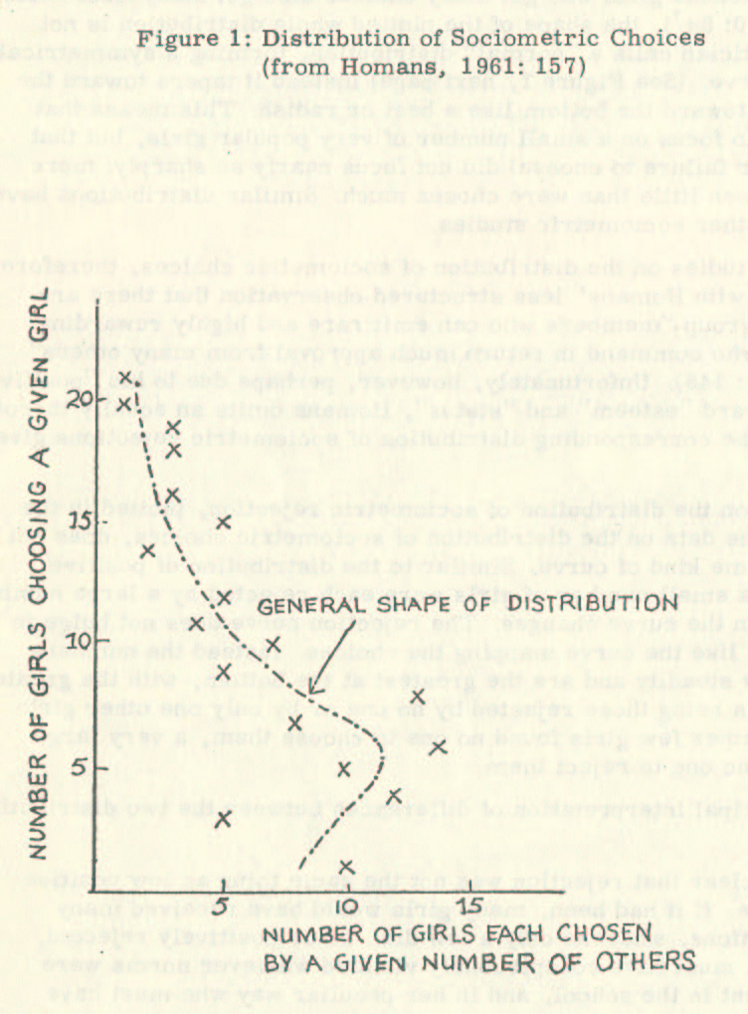

3.1.2. The Game-Theoretical Bargaining Model for Social Status
To be equipped with the "tools" for our analysis of the dynamics of attaining and retaining social status, our next step is the presentation of a synopsis of modern decision theory, especially of the game-theoretical bargaining model developed by Harsanyi. After a short history of the decision theory, we shall introduce the bargaining problem and then discuss the notion of utility and the rationality postulate underlying both normative and descriptive decision theory. Finally, we shall present Harsanyi’s game-theoretical bargaining model for social status.
When introducing a game-theoretical bargaining model, we have to start by clarifying the objectives of modern game theory and its possible implications for social science.
Game Theory and Social Science
Game Theory deals with game rules per se and rules for playing games intelligently. It has been rules of the latter sort which have claimed by far the larger share of the game theorists' attention -- and quite properly so, given the motivation that guides most game-theoretical studies.
The research in modern decision theory was essentially initiated by von Neumann and Morgenstern’s famous book, Theory of Games and Economic Behavior (1944), where they laid the foundation for the new science, game theory. In some ways, the name "game theory" is unfortunate, for it suggests that the theory deals only with the socially unimportant conflict found in parlor games, whereas it is far more general than that. It is the study of c o n f l i c t of interest, both among individuals and institutions.
In the thirty years since von Neumann and Morgenstern’s book, the game theory has been developed into a complex construct by scientists, especially in mathematical economics and finance theory. While von Neumann and Morgenstern "attempted to write their book so that a patient scientist with limited mathematical training could absorb the motivation, the reasoning, and the conclusions of the theory" (Luce and Raiffa, 1957: 3), game theory today has developed into an area largely accessible only to the specialist, the mathematician, and econometrician. Social scientists had an initial "naive band-wagon feeling that game theory solved innumerable problems of sociology and economics, or that, at the least, it made solutions a practical matter of a few years work" (Luce and Raiffa, 1957: 10), have generally become disillusioned with game theory, as it turned out that their expectations were not fulfilled. Consequently, the social science literature in game theory is sparse.
However, we must keep in mind that game theory, presented today, is predominantly a (conditionally) normative theory. Mostly it prescribes, rather than describes,
for given assumptions courses of action for the attainment of outcome having certain formal 'optimum' properties. These properties may or may not de deemed pertinent in any given real world conflict of interest. If they are, the theory prescribes the choices, which must be made to get to that optimum (Luce and Raiffa, 1957: 63).
In social science, we are predominantly interested in a descriptive decision theory, that is, in system-understanding instead of system-planning. Therefore, a direct "application" of game theory, which the social scientists mentioned above had in mind, is out of the question. Instead, the use of game-theoretical concepts has to focus on the descriptive elements of game theory.
Hence, the predominantly descriptive game-theoretical bargaining model developed in the last fifteen years, especially by Harsanyi, is of particular interest for the social scientist. The general purpose of the bargaining model is to predict the outcome of a bargaining process for given initial bargaining positions.
The bargaining model formalizes the processes, which we usually refer to as "bargaining" in our everyday life. Often we speak of bargaining when an economic and monetary exchange is involved. However, that is not the only way we use the term. We also speak of bargaining in our everyday lives if we describe social exchange. For instance, we use the term "bargaining" to describe the social process between parents and children attempting to postpone bedtime, just as we use it when we describe the process of the exchange of goods in the marketplace.
In the explanation of the social exchange concept by Thibaut and Kelley (1959), Homans (1961), and Blau (1964), "bargaining" was used to describe the process of social exchange. Unfortunately, these authors either misunderstood (see Thibaut and Kelley, 1959: 24f.) or did not know about the parallel conceptualizations of exchange processes developed in game theory. As we later show in this chapter, using these conceptualizations as a vehicle for presenting the social exchange concept will lead to a more concise and, at the same time, more comprehensive understanding of social exchange, social behavior, and social status.
The Bargaining Problem
From basic economic theory, we know that the following two properties define the range of practicable bargains:
- It is on the Edgeworth contract curve, i. e., the locus of situations, where neither party’s position can be improved without at the same time worsening the position of the other party.
- It is on this curve between two limits, which may be called the "maximum-concession points" of each party and which are determined by the fact that neither party would accept an agreement that puts him in a worse position than the conflict situation (not reaching an agreement). In other words, each party’s maximum-concession point is at that point at which all the net gain resulting from an agreement and the cooperation agreed upon would go wholly to the other party.
Then, the game-theoretical bargaining model explains how the position of the actual agreement is determined within this range of practicable bargains; that is, how the division of the net gains is determined between the two bargaining parties.
A graphical representation of the bargaining problem looks as follows:
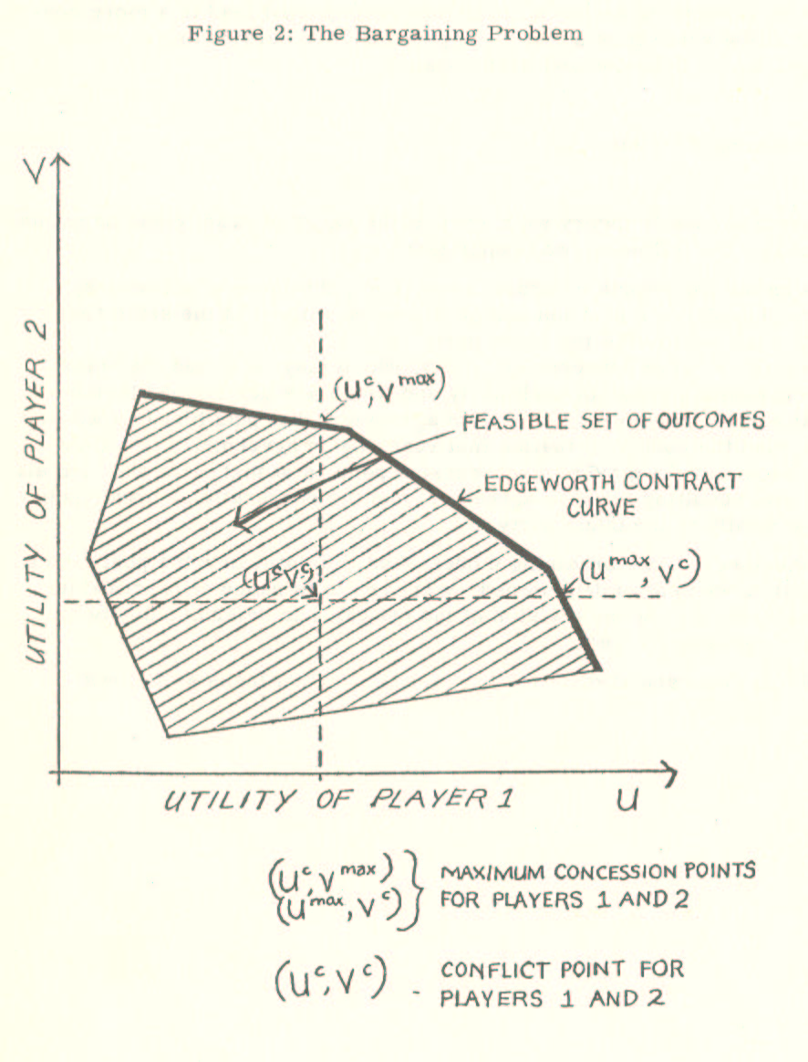
The Notion of Utility
In order to determine the actual agreement point, the game theory uses standard utility as measurement and makes assumptions about the rationality of the bargaining parties. The utility theory (see, e.g., Savage, 1954: 69ff; Luce and Raiffa, 1957: 12ff; Anscombe and Aumann, 1963) employs axioms for rational behavior to establish a non-tautological notion of utility as a measurement standard.
The concept of "anticipation" is essential in this theory. For example, if A and B are the only two anticipations, then there is an anticipation which we can represent by pA + (1 - p) B where 0 ≤p ≤1, which is a probability combination of the two anticipations where there is a probability p of A and (1 - p) for B.
By making the following assumptions, we can develop the utility theory for an individual (from Nash, 1950):
- An individual offered two possible anticipations can decide which is preferable or that they are equally desirable.
- The ordering thus produced is transitive; if A is better than B and B is better than C, then A is better than C.
- Any probability combination of equally desirable states is just as desirable as either.
- If A, B, and C are as in assumption (2), then there is a probability combination of A and C, which is just as desirable as B. This amounts to an assumption of continuity.
- If 0 ≤p ≤1 and A and B are equally desirable, then pA + (1 - p) C and pB + (1 - p) C are equally desirable. Also, if A and B are equally desirable, A may be substituted for B in any desirability ordering relationship satisfied by B.
These assumptions are sufficient to show the existence of a satisfactory utility function, assigning an actual number to each anticipation of an individual. This utility function is not unique; that is, if u is such a function, then au + b is also such a function, provided a > 0. Letting capital letters represent anticipations and small ones real numbers, such a utility function will satisfy the following properties:
- u (A) > u (B) is equivalent to A is more desirable than B, etc.
- If 0 ≤ p ≤ 1, then u [pA + (1 - p)B] =
pu (A) + (1 - p) u (B). This is the important linearity property of a utility function.
Of course, the question with which we now have to deal is whether we can accept the rationality postulates used to establish the utility theory in describing social behavior. Is man really a utility maximizer?
The Rationality Postulate
Rationality itself is a concept that encompasses the assumptions of the social exchange concept. However, what is rationality?
If the term "rationality" is mentioned in social science circles, one can almost see the hair bristling at the neck of the social scientists, and almost inevitably, an emotionally laden discussion starts. Therefore, we shall attempt to clarify some common misunderstandings of the concept of rationality. We shall discuss "rationality" in terms of its applicability as a set of assumptions in the context of social science.
The subject of our investigation is the exchange object "esteem" in a multitude of "esteem-currencies" as presented in the exchange concept, and this concept stands and falls with the acceptance of the assumption that man is basically rational. Therefore, the question is whether this assumption can "reasonably" be made.
Economic theory is built on the assumption that man can basically be regarded as rational. Many of the misconceptions held by social scientists are based on a misunderstanding of the economic man. The economic man indeed and necessarily is a generalized, conceptual man (Idealtyp). However, he is also a complex man.
Social scientists frequently remember only the pithecanthropus-stage of the rational man, the monster we all have met in our introductory economics classes who is willing to sell his mother in slices as long as the marginal return per slice is higher than the marginal cost of slicing. That is, unfortunately, the first and last impression many social scientists have of the economic man.
However, the new economic man, the homo sapiens of the rational man, looks somewhat different. The creature sired by modern economic theory, although by definition an Idealtyp in Max Weber’s sense, has become considerably more complex and sophisticated. Bernoulli (1738) considered a man maximizing the utility of money, whereas Friedman and Savage’s (1948) individual maximized the utility of income. Markowitz (1952), Hakansson (1970), and other modern theoreticians finally talked about a man maximizing the utility of wealth, where wealth is the probability estimate for the attainment or retainment of tangible and intangible goods.
The access to information and the computational capacities of this new economic man is limited (Simon, 1957). Therefore, the new economic man is a man with "approximate" rationality. Empirical studies on utility maximization in a social context (cf., Ofshe and Ofshe, 1970; Rapoport and Chammah, 1965) confirm the existence of this rational man as it was developed by modern economic theory and decision theory.
The trouble with the "old" economic man
was not that he was economic, that he used his resources to some advantage, but that he was antisocial and materialistic, interested only in money and material goods . . . What was wrong with him were his values: he was only allowed a limited range of values; but the new economic man is not so limited. He may have any values whatever, from altruism to hedonism, but so long as he does not utterly squander his resources in achieving these values, his behavior is still economic. Indeed, if he has learned to find reward in not husbanding his resources, if he values not taking any thought for the morrow, and acts accordingly, his behavior is still economic. In fact, the new economic man is a plain man (Homans, 1961: 79f.).
Therefore, the assumption underlying the use of the game-theoretical bargaining model for the analysis of human behavior from a decision-making perspective (namely, that although decisions vary in content, importance, and social context, the abstract principles which guide behavior in these choice situations are basically the same) was verified and is verifiable through empirical investigations. The economic situation for which the bargaining model was developed is just one type of social situation, and the assumption of rationality is valid there as it is in non-economic social situations.
Given the concept of social exchange, social psychology and sociology differ from economics not in their perspective but only in their history. The title of a "dismal science" for economics (Berger, 1963: 93) is just as appropriate, or inappropriate, for social psychology and sociology. In all social interactions, an individual is forced to choose a particular set of alternatives, and it is assumed that he makes his decision in a manner that maximizes his expected utility.
The Nash-Solution
An excellent description of how the complex economic man maximizes his expected utility, that is, of how a bargain is struck, assuming rationality of the bargaining parties, is given by Schelling:
In bargaining, each party is guided mainly by his expectations of what the other will accept. But with each guided by expectations and knowing that the other is too, expectations become compounded. A bargain is struck when somebody makes a final, sufficient concession. Why does he concede? Because he thinks, the other will not. ‘I will concede because he won’t. He won’t because he thinks I will. He thinks I will because he thinks I think he thinks so . . . ' (Schelling, 1963: 21f.).
Given that this description of the bargaining process is adequate, we can say that the bargaining problem has an obvious, determinable solution for fixed conflict points, in at least the case where the bargaining situations for both parties are entirely symmetric. In this case, it is natural to assume that the two parties will tend to equally share the net gain since neither would be prepared to grant the other better terms than the other would grant him.
Nash (1950) generalized this principle for the case of asymmetric bargaining situations by postulating that the general solution of the bargaining problem is at that point on the Edgeworth contract curve at which the product of the utilities, which each party ascribes to his net gain over the conflict situation, is maximized (Nash-solution). Nash assumed (in addition to the usual assumptions of utility theory) that there is a set of points R representing all possible bargains, where R is bounded, convex and closed. If there is within the set R a point (u^{c}, v^{c}) directing the conflict pay-off, we know that the players enter a bargain so long as there are any points (u, v) in R both above and to the right of (u^{c}, v^{c}). The Nash solution to the bargaining game is the unique point (u_{o}, v_{o}) on the Edgeworth contract curve such that
(u_{o} -u^{c}) (v_{o} -v^{c}) ≥ (u-u^{c}) (v - v^{c})
for all (u, v) belonging to R and such that u ≥u^{c} and v ≥ v^{c}.
It is worth noting that this solution, where both parties' utilities are measured by von Neumann and Morgenstern cardinal utility indexes, does not presuppose the interpersonal comparability of utilities, since the index for each party’s utility can be chosen independently of the other’s, because the solution is invariant to changes to the zero point or the unit of either party’s utility index. In effect, this invariance is one of the postulates used by Nash in deriving his solution.
A Numerical Example for the Nash-Solution
Luce and Raiffa (1957: 129) give us a simple numerical example for the Nash solution:
Consider the game where two players are to divide $ 100 between them if they can reach an agreement, or where they will receive nothing if they do not agree . . . Suppose (player) 1 is rich and selfish and 2 is poor. Player 1 may then make a good case for (75, 25), let us say, on the grounds that the utility increment to 2 of $ 25 is at least as great as the gain to 1 of $ 75. We would argue that an ethically fair division of the proceeds is a fair division of utility, not of money. For example, suppose that (part of) the utility functions were these:
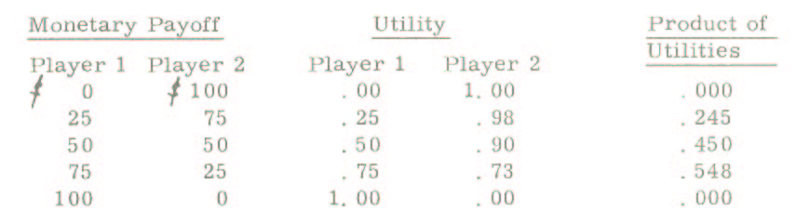
Harsanyi’s Solution
The Nash-solution of the bargaining problem was primarily designed as a prescriptive solution. However, as stated before, social science is essentially interested in description rather than prescription. Luce and Raiffa’s example of the Nash-solution, which we cited above already, provided us with the idea that at the basis of Nash’s prescriptive model lays a descriptive analysis of social situations. We shall now present another solution of the bargaining problem, which corresponds in the outcome to the Nash-solution, but which arrives at the solution through descriptive analysis.
This way of solving the bargaining problem was proposed by Harsanyi (1956, 1961), who based his approach on an earlier analysis by Zeuthen (1930). Harsanyi’s approach to the bargaining problem is to determine, for a given stage of the bargaining process, which of the players is likely to (in a normative formulation: should) make the next concession. Basically, therefore, Harsanyi’s approach corresponds to the way we analyze a situation in social science and, as its result is the solution of the bargaining problem, which is mathematically equivalent to the Nash-solution, it illustrates our thesis that the social exchange concept can be extended through the use of parallel conceptualizations in game theory.
Harsanyi shows that "the Nash-solution can also be obtained from weaker and, I believe, more fundamental postulates if one uses the Zeuthen model of the bargaining process" (Harsanyi, 1961: 183; cf. also, 1956). He uses the following "strong" postulates of rationality (1961: 183f.):
(1) Individual utility maximization; (2) efficiency; (3) acceptance of higher payoffs; (4) symmetry; (5) restriction of variables; and (6) mutually expected rationality.
He then assumes that each player knows his opponent’s subjective probability of conceding, so it becomes meaningful to consider the (expected) utility of conceding or not conceding. In a descriptive bargaining theory, the knowledge assumed in Harsanyi’s model has to be weakened, of course, to a reasonably accurate estimate where accuracy is partly attained through self-fulfilling prophecies.
Given the same general bargaining situation we described in the exposition of the bargaining problem and Nash's approach, Harsanyi starts his analysis of the bargaining problem at a stage of the bargaining process where player 1's offer is A₁ with the coordinates (u₁¹, v₁¹) and player 2's last offer is A₂ with the coordinates (u₂¹, v₂¹) and where A₁ is different from A_{2,} and both points are Pareto optimal. The conflict point is, as before, C with the coordinates (u^{c}, v^{c}). The offer A₁ then would yield the utility u₁ or U₁ (A₁) to player 1 and the utility v₁¹ or U₂ (A₁) to player 2. Correspondingly, the utilities of A₂ are U₁ (A₂), and the utilities of C are U₁(C) and U₂(C).
Harsanyi’s resulting concession rule is that player 1 "should" concede if and only if
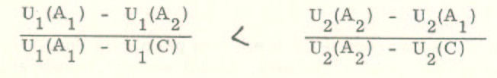
Moreover, player 2 "should" make it if the inequality is reversed. In case both expressions are equal to each other and A₁ ≠ A₂ both players "should" yield.
Making concessions continues until the common point A on the Edgeworth contract curve is reached where the product of [U₁ (A) - U₁(C)] and [U₂ (A) - U₂ (C)] takes its maximum value. This point is unique, and it is the Nash-solution of the bargaining game.
We can restate Harsanyi's concession rule more tersely if we use our assumption made to establish the utility theory, namely that the utility function is not unique; that is, if u is such a function, then au + b is such a function provided a › O. Then we can define the point C with the coordinates (u^{c}, v^{c}) as (0, 0). The concession rule for player 1 changes to
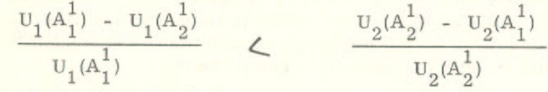
which is obviously equivalent to
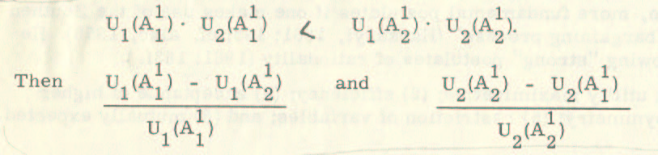
obviously, measure the relative losses incurred when players 1 and 2 conceded. Harsanyi’s concession rule then predicts that the player whose relative loss is the smaller will concede.
It is the predictive value of Harsanyi’s game-theoretical bargaining model, which makes it possible to use it to explain elementary social behavior if we accept the concept of social exchange. Harsanyi’s bargaining model bridges the gap which seems to have existed between the conceptualizations of exchange in economics and in social science. Thereby it opens avenues of thinking that may prove generative not only for new ideas in social science but also, in a reciprocal process, for innovative approaches to economics and the economic "W e l t b i l d “.
Harsanyi’s Model of Status Acquisition
Harsanyi realized the implications for the analysis and the explanation of elementary social behavior if the game-theoretical bargaining model is combined with the concept of social exchange. In his papers, "A Bargaining Model for Social Status in Informal Groups and Formal Organizations" (Harsanyi, 1966) and "Individualistic and Functionalistic Explanations in the Light of Game Theory: The Example of Social Status" (Harsanyi, 1968), Harsanyi analyzes social status in terms of some more basic human motivations by asking the questions why all people seek high social status and why some people are granted high social status by others. Understanding Harsanyi’s concise analysis will significantly help our own analysis of the closely related problem concerning the dynamics of status change and status retainment.
Harsanyi starts by proposing a simplifying assumption that a given individual’s services (and/or disservices) have the same importance to all group members so that the analysis can be based on a two-person bargaining model. Therefore, one bargaining unit consists of the individual A and the other bargaining unit of the other (n - 1) members of a social grouping.
From bargaining theory, we know that the outcome of the bargaining process depends on players' bargaining position. The bargaining position, in turn, "will depend on the costs of a possible conflict to each side. Each side will be in a stronger position the smaller its own conflict costs would be and the greater those of the other side" (Harsanyi, 1966: 363).
As the net conflict costs of either side, Harsanyi specifies the following items:
- loss of rewards usually provided by the other side;
- damages resulting from the penalties imposed by the other side;
- the costs incurred by actively imposing penalties on the other side; less
- the costs of the rewards usually provided for the other side (in case of a conflict, these rewards would be withheld so their costs would be saved).
Restating these relationships in mathematical symbols, Harsanyi denotes the rewards received and the penalties or costs incurred by individual A by the small letters r, p, and c, and the rewards received and the penalties and costs incurred by each of the other (n - 1) members of the group by the
capital letters R, P, and C.
Individual A’s net conflict costs are then:
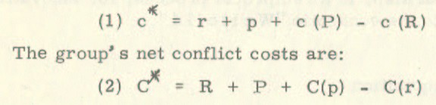
If, in the computation of these conflict costs, we take into account the alternative arrangements available to each side in a conflict situation (individual A might be able to join other groups, and his losses would consist only of those payoffs that these other groups could not provide for him; or, the group might be able to replace him by other individuals, and the group's losses would consist only of those services that these other individuals could not provide for the group), "the strength of individual A's bargaining position vis-a-vis the other members of the group will depend on the quantities c* and C* of the equations (1) and (2). The social status we can achieve within the group will be higher the smaller the quantity c* and the greater the quantity C*" (Harsanyi, 1966: 364).
Harsanyi's bargaining model (see also, Harsanyi, 1962: 77) then predicts that the amount of esteem e that individual A will receive within the group will be given by the expression:
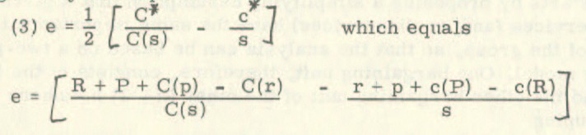
where: s - denotes the utility that individual A would assign to the very highest social status position in the group, and
C(s) - denotes the disutility the other group members would incur, on average, by granting him such a high social position.
Two principal comments on Harsanyi’s game-theoretical bargaining model for social status seem to be appropriate. The first one concerns the scarcity and relativity of status positions, and the other is Harsanyi’s method to determine the social bargaining position.
We know that rank differentiation in social systems is a universal phenomenon. Further, we know that social status in any social system is determined by the relative position of the individual in the system (Svalastoga, 1964). Generally speaking, a change in the social status of an individual, therefore, means not only a change in the social status of this individual but in the case of an upward movement, also a downward change of status of others (and their allies) who previously had a higher status. According to the interpretation of social status as perceived esteem, these others are part of the body providing the esteem. Assuming an equilibrium situation of the social system under observation, any status change threatens their status position and the general equilibrium of the system. From Harsanyi's equation (3), however, it is by no means evident that the value of e in a static model, i. e., a model dealing only with one interaction changes, is bounded from above and below by the present social status.
The second comment is based on the same idea. Whenever we enter a social interaction, or, in our terminology, a social bargaining situation, we enter it with a status already assigned. If this status is not apparent to the partner in the interaction, the initial part of the encounter will consist in its determination. However, most of our life is spent in situations where our relative status is known to the partner of the interaction. Being like Homans predominantly concerned with attaining status, Harsanyi presents a more helpful model for mapping the dynamics of the acquaintance process (Newcomb, 1961) than the dynamics in an ongoing group.
While we do not doubt that the variable c* in Harsanyi's equation (1), defining the actual bargaining position of individual A through his net conflict costs, is adequately described through r, p, and c, it appears that we have more information available about the value of the variables. We know that these variables are all a function of the social status (perceived esteem) before the bargaining process begins. Our problem formulation, therefore, differs slightly from that of Harsanyi. Harsanyi is asking why some people are granted high social status. We shall attempt to develop this problem formulation to: What is the process affecting a change in social status? Harsanyi’s game-theoretical bargaining model will provide us with the vehicle for analyzing elementary social behavior, picking up the discussion of where Homans left off.

3.2. Games for Social Status
Homans' propositions about the concept of social exchange have provided us with the building blocks for a theory of elementary social behavior. Harsanyi’s game-theoretical bargaining model gives us the instructions about how we should fit them together. In the previous section, we laid out the building blocks and the instructions, and now we are ready to work.
We saw that both Homans and Harsanyi were predominantly concerned with processes to attain status, with the dynamics of the acquaintance process. In discussing their models, we pointed out that generally, we are already assigned a status in social life. With this initial "capital”, a person enters an interaction. Therefore, in our analysis of elementary social behavior, we will consider the status quo ante, as we call it, to determine the bargaining position for each encounter. In this respect, our analysis will attempt to supplement the work of Harsanyi and Homans.
In another respect, we will try to extend their work to attain a more comprehensive theory of elementary social behavior. Both authors primarily directed their research to the investigation of high status. It appears, however, that only a theory, which also incorporates low status, its attainment, and retainment, can claim to be a theory of elementary social behavior. Therefore, the extension of Harsanyi’s and Homans' work to low status is the other area where we shall attempt to supplement their work.
This section will try to explain the "reasonableness" of the thesis: If a basic behavioral pattern is the non-monetary cost-benefit analysis, then the game-theoretical bargaining model using the social exchange concept predicts that social status is a "sticky" state. It further predicts that social status is the major explanatory factor for social behavior, i. e., in the interrelation of social status and social behavior, the socially constructed reality, social status, limits the range of possible constructions of social behavior.
The "result" of this study, therefore, does not provide any revolutionary new knowledge on the ordering of the "familiar chaos: ordinary, everyday social behavior" (Homans, 1961: 1). Indeed, our results conform to the claims made by role theory, which states that social behavior conforms to the social position of the actor. What is new is the method by which we attain this result. Suppose we accept the legitimacy of the proposed method (the combination of Harsanyi’s game-theoretical model with Homans' propositions to the social exchange concept) to analyze social contexts in general. In that case, it leads us to a novel understanding of social systems, which makes us doubt the foundations of some cornerstones of our present social system.
One example of this is our notion of justice. If we analyze the criminal status as obtained through a succession of bargaining games with agents of the Criminal Justice System whose basic behavioral pattern is non-monetary cost-benefit analysis, the analysis is bound to make us question whether the commonly accepted reasons for the existence of the Criminal Justice System are not mere rationalizations, covering the fact that immunity is differentially distributed.
Another example is our notion of the educational system. In fact, we shall start the explanation of our thesis with a more anecdotal than analytical quote concerning an educational game, the graduate school game, as seem from the perspective of transactional analysis. After this introduction, we shall analyze social interaction as a bargaining game in general, discussing the social correspondent of bargaining position, feasible set, and utility.

3.2.1. Bargaining for Esteem
Joen Fagan (1967: 103) describes the graduate school game as follows:
Graduate school as a sub-section of the educational enterprise generally fosters Parent-Adolescent interaction on the part of professors and graduate students. Most graduate students live on a relatively meager stipend (allowance) provided by the department or a professor's research project and in return help keep the house running by providing various low level services. Any involvement outside the department that would make for greater financial or personal independence is discouraged. Students are expected to act like responsible adults yet still defer to the professor's superior judgment and wisdom. The professor overtly communicates to the student, 'Grow up and get wise,' but this may hide messages that say, ' But if you end up different from me, you’re wrong, ' or ' But if you do, I’ll zap you for showing me up, ' or ' But if you do, I’ll make you feel guilty for leaving me behind. ' As a result, graduate students often feel perplexed about how smart to be, what to do if they either do or don't know more than the professor, whether they are supposed to do it their way or his, whether they are actually supposed to finish their degrees and leave. This atmosphere powerfully supports games involving hanging on and phobic avoidance of the outside world.
The graduate school game is a particular case of the general bargaining game of social interaction. The professor, a high-status person, interacts with a low-status person, the graduate student. The initial bargaining position of the professor is so much stronger than the position of the student that for nearly any offer A _{p} ¹ (last offer of professor) better than the conflict solution, and for any offer A _{s} ¹ (last offer of the student), where U_{p} (A _{p} ¹) › U_{P} (A _{S} ¹) and U_{s} (A _{S} ¹) > U_{s} (A _{P} ¹), Harsanyi’s concession rule predicts that
U_{p} (A _{p} ¹) x U_{s} (A _{P} ¹) › U_{P} (A _{S} ¹) x U_{s} (A _{S} ¹)
which means the student makes the next concession A_{s}².
This result follows Harsanyi’s formula of net conflict costs for the two individuals. The initial bargaining position of the student, given by
C*_{S} = R_{s} + P_{s} + C_{s} (P_{p}) - C_{s} (R_{p}), is obviously weaker than the bargaining position of the professor, given by
C*_{P} = R_{P} + P_{P} + C_{P} (P_{S}) - C_{P} (R_{S}), because we can assume that
R_{S} > R_{p}, P_{S} > P_{P}, C_{S} (P_{P}) > C_{P} (P_{s}) and
C_{S} (R_{P}) < C_{P} (R_{S}), especially as the number of possible bargaining partners in the graduate school game is smaller for the student than for the professor.
Let us now leave the professor and his graduate student and present the first part of our model of "Games for Social Status", where we map interaction as bargaining for esteem. Perceived esteem, as we defined it following Homans, is social status. It has the property to diminish over time if it is not constantly reconfirmed. According to Homans' exposition of the exchange concept, we acquire esteem in social interactions as an exchange object in various "esteem-currencies".
If we postulate approximate rationality in social interaction (i. e., if we postulate that more is always preferred to less, where individual preference determines what is more and what is less, and where individual preferences can be generalized to some extent), we can represent the social exchange of esteem as a bargaining game in which the social reality of behavior is constructed from the feasible set of constructions. To keep the representation simple, we collapse the n-person games on the social scene into two-party bargaining games.
Let us then introduce three categories of players: H, belonging to a high-status category (a category of players who enter a game with a large "capital" of perceived esteem), M, belonging to a medium status category, and L, belonging to a low-status category. Let us for now assume that the players of all three categories are equal in bargaining skill, i. e., any bluff about the initial bargaining positions will be discovered, and we, therefore, can assume the bargaining positions as given and known to the players. Finally, let us assume the following simple bargaining situation, where the conflict point with the coordinates (u^{c}, v^{c}) is "normalized" at (0, 0) and the line bounds the feasible set through the "normalized" points (1, 0) and (0, 1) on the utility scales of the players. What, then, are the outcomes predicted by bargaining theory for all possible games between players H, M, and L?
We can represent these types of games by the following figure:
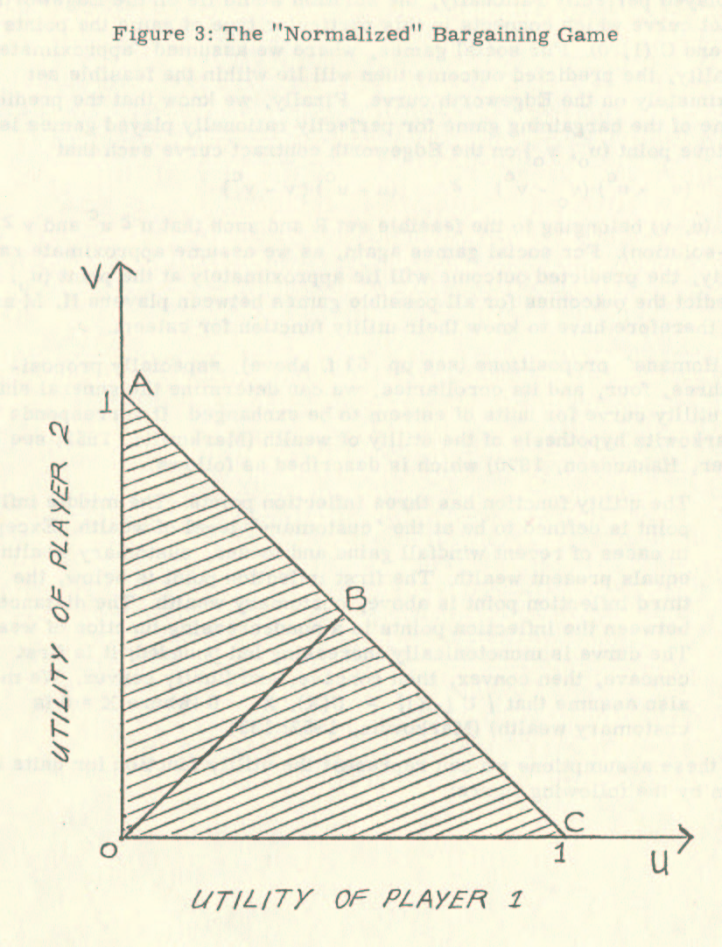
From our discussion of the bargaining problem, we know that the solution lies within the feasible set. Further, we know that if the bargaining game were played perfectly rationally, the solution would lie on the Edgeworth contract curve, which connects in this particular type of game the points A (0, 1) and C (1, 0). For social games, where we assumed "approximate" rationality, the predicted outcome then will lie within the feasible set approximately on the Edgeworth curve. Finally, we know that the predicted outcome of the bargaining game for perfectly rationally played games is the unique point (u_{o}, v_{o}) on the Edgeworth contract curve such that
(u_{o} - u^{c}) (v_{o -} v^{c}) ≥ (u-u^{c}) (v-v^{c})
for all (u, v) belonging to the feasible set R and such that u ≥ u^{c} and v ≥ v^{c} (Nash-solution). Again, as we assume approximate rationality for social games, the predicted outcome will lie approximately at the point (u_{o}, v_{o}). To predict the outcomes for all possible games between players H, M, and L, we, therefore, have to know their utility function for esteem.
From Homans' propositions (see pp. 51 f. above), especially propositions three, four, and its corollaries, we can determine the general shape of the utility curve for units of esteem to be exchanged. It corresponds to the Markowitz hypothesis of the utility of wealth (Markowitz, 1952; see, however, Hakansson, 1970), which is described as follows:
The utility function has three inflection points. The middle inflection point is defined to be at the 'customary' level of wealth. Except in cases of recent windfall gains and losses, customary wealth equals present wealth. The first inflection point is below, the third inflection point is above, customary wealth. The distance between the inflection points is a nondecreasing function of wealth. The curve is monotonically increasing but bounded; it is first concave, then convex, then concave, and finally convex. We may also assume that
lU (-X) l > U(X), X 0 (where X = 0 is customary wealth) (Markowitz, 1952: 155).
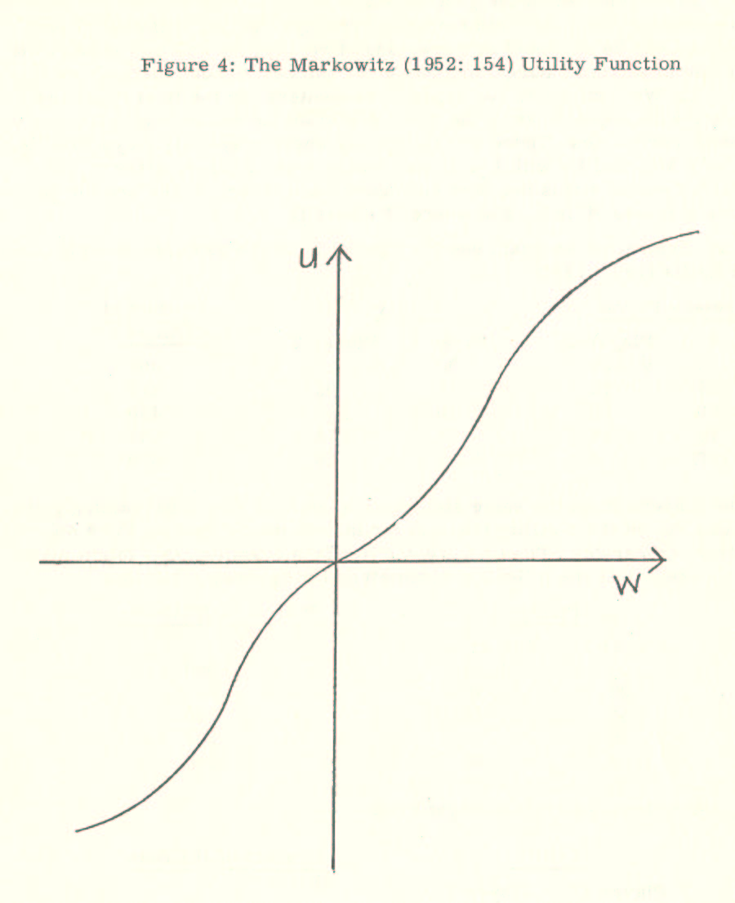
If our assumption about the general shape of the utility function for esteem approximates adequately the empirical reality, that is, if Homans' propositions can be accepted as a mapping of reality, we can now predict the outcome of a simple bargaining game for esteem between the players H, M and L. We distinguish two types of encounters. In the first type, two players with approximately the same social status quo ante play a game for esteem currencies. These are the games where player H₁ plays with H₂, M₁ with M₂, and L₁ with L₂. In the second type of game, players with different social status quo ante encounter each other. These are the games where H meets M or L and M meets L.
As an illustration, we again use the figures from the example given by Luce and Raiffa (1957: 129):
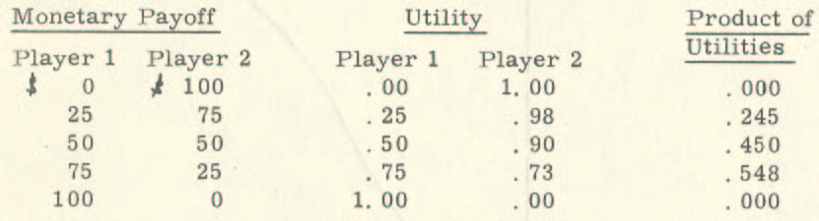
If the same status group members meet to play a bargaining game, we can expect their utility function for increments of esteem to be approximately comparable. Taking Luce and Raiffa’s example, this might mean that there exists the following symmetrical bargaining situation:
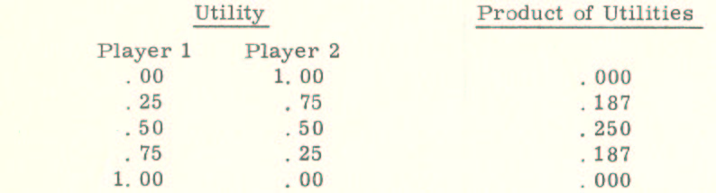
Alternatively, the following situation might exist:
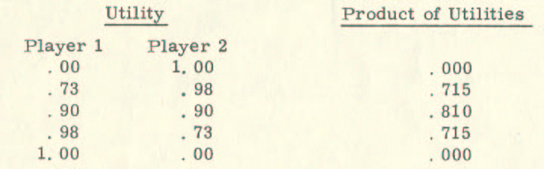
Our model predicts that in both cases, the outcome of the bargaining game will lie at or approximately near the halfway point B, which has, in our normalized bargaining game (figure 3, p. 71 above), the coordinates (1/2, 1/2). The predicted outcome corresponds to what we are used to observing in everyday life, namely, parties of equal social status tend to share the net gain in esteem from encounters with each other.
If we now turn to the second type of encounter, the meeting of players with differing social statuses, we can use the original figure combination in Luce and Raiffa’s example. There, the utility of the bargaining parties is no longer symmetrical; instead, we can assume that the first and the third inflection points of the utility curves of the players are the closer to the u - axis (see figure 4, p. 73 above), the lower the social status quo ante of the player. In Luce and Raiffa's example, we, therefore, can take as utility function of the player with the higher status, e. g., of player H, the one of Player 1, and can use the utility function of Player 2 for the person with the lower status quo ante in the encounter, for instance, for player L.
The game can be represented in two ways: first, in terms of the payoff in esteem units (EU) of some esteem currency, where the bargaining outcome is determined by the point of tangency of the highest possible indifference curve on the Edgeworth contract curve, or, second, in the utility space of the players. (See figures 5a and 5b on the following pages).
The first representation (figure 5a) is the normalized bargaining game (figure 3, p. 71 above), where we filled in the values for our specific bargaining situation. The second representation (figure 5b) assumes comparability of the utility scales and extends the outer right boundary of the feasible set to the right of the straight line through points A (0, 1) and C (1, 0).
In the game, the halfway point B of the normalized game (figure 3, p. 71 above) has the coordinates (. 5, 9), which is obviously not the Nash-solution of this bargaining game. Instead, the outcome lies to the right of the point B at B* on the Edgeworth contract curve, where the product of the utilities is a maximum (see figures 5a and 5b).
The esteem available for distribution among the parties, which would be evenly divided at the halfway point B in the distribution space (see figure 5a), is divided evenly at the halfway point B* in the utility space (see figure 5b). The division of esteem is made so that a greater part goes to the player whose utility function for esteem increases slower. According to our assumption about the utility function for esteem, this person is the player who entered the encounter with the higher status quo ante.
We attain the same solution with Harsanyi's concession rule (see pp. 63ff. above), because, as illustrated already in the "Graduate School Game", the net conflict cost of a high-status person, C^{high-status} is considerably smaller than the net conflict costs of a low-status person, C^{low-status}.
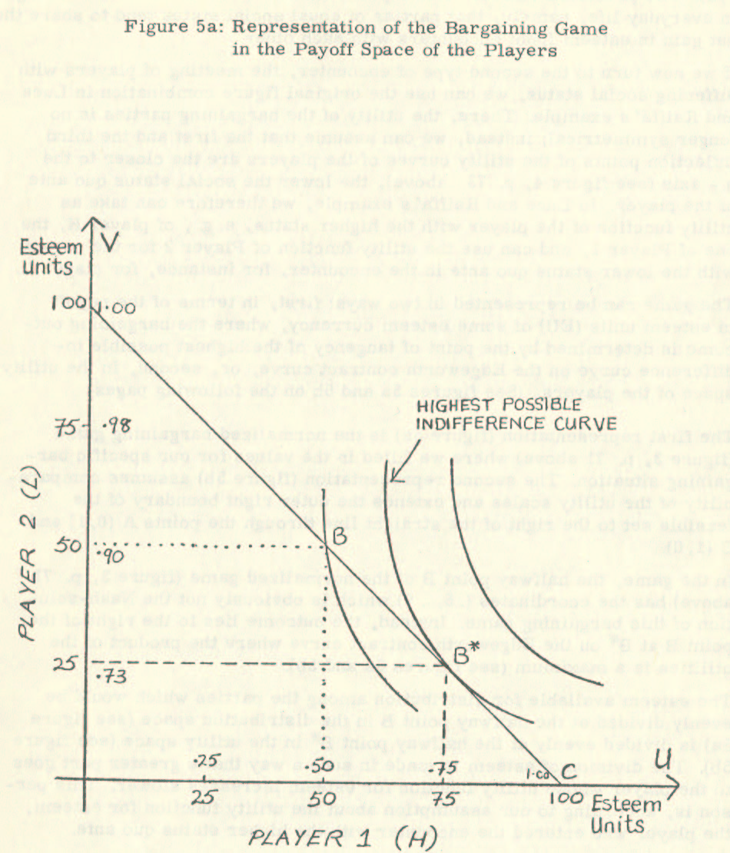
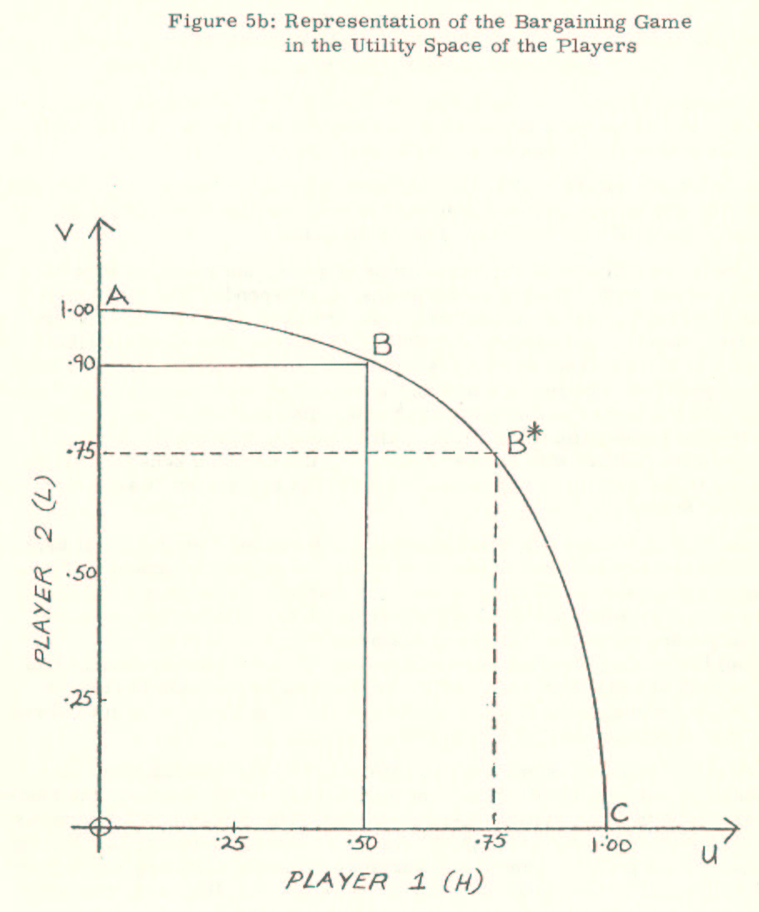
Using the figures from Luce and Raiffa’s example, the steps for attaining a bargaining agreement according to Harsanyi’s concession rule are the following:
- Assuming as last offer by H, the division of the available esteem of 75 esteem units for himself and 25 esteem units for the other player (75/ 25) gives us B₁¹ (. 75, .73). If the last offer by L is 25 / 75, i. e., if B₂¹ has the value of (. 25, .98), Harsanyi's concession rule results in 2/3 › -25/73, which means that L has to make the next offer.
- Assuming as next offer by L the division 50 / 50, B₂² has the value of (. 5, .9). Harsanyi's concession rule results in 1/3 > -17/73, which again means that L has to make the next offer.
- Only when L offers 75/25, that is, when B₂³ has the value (. 75, 73) and, therefore, equals B₁¹, an agreement is reached. However, B₂³ = B₁¹ also equals B*, the Nash-solution of the game.
The predicted outcome of the second type of game, the game for esteem among parties with differing social status, corresponds, like the outcome of the first type of game, to that which we are used to observing in everyday life, namely, that parties of differing social status tend to distribute the net gain in esteem from encounters with each other according to their bargaining position. The lion’s share in the second type of game falls to the party with the higher social status quo ante. His share is the larger the more significant the status difference. Among other things, this construction of reality in its conflict with another construct, the common sense notion of justice, is the subject of our fourth chapter, the chapter on "Games for Criminal Status".
We can strengthen our argument about the differential distribution of esteem by removing a restrictive assumption, which we implicitly upheld in the preceding analysis. Until now, we assumed that any player in any encounter plays with the same approximate rationality, i. e., that any player knows his bargaining situation, the one of his opponent, and, therefore, also the optimal bargaining strategy available to him. Now we want to weaken this assumption of equal bargaining skill, as it seems reasonable to assume that the bargaining skill of a low-status individual is likely to be less adroit than the bargaining skill of a high-status person.
Under this modified assumption of a differentially distributed approximate rationality, the predicted outcome of the first type of encounters, the games of persons with equal status, does not change. The outcome will be approximately a division of the net gain in esteem from the encounter, that is, the outcome of all possible games will variate around the halfway point B (see figure 3, p. 71 above, and examples on p. 74 above). However, the outcome changes in the second type of game, namely the encounter between persons with differing status quo ante. Instead of a variation around the predicted outcome B* (see figures 5a and 5b, pp. 76f. above), as we assumed with the strong postulate of approximate rationality, the outcome with our weakened assumption is likely to be a distribution on the Edgeworth contract curve which is centered to the right of B*. Therefore, weakening the rationality assumption further supports our analysis: the net gain of esteem from an encounter is differentially distributed by the parties such that a larger share falls to the party with the higher status quo ante.

3.2.2. Selecting Partners
Our analysis up to now has assumed that there always exists a feasible set of bargaining outcomes. We can maintain this assumption if we admit sets where the outcomes are not necessarily positive. Then, every player could play a bargaining game for esteem with any other person as well as with any combination of persons. However, as we know that the bargaining games actually played are limited in number, we now have to answer the question of how games and partners are selected.
The fact that partners select each other for specific encounters has consequences for the simple bargaining model presented in the previous section. There, we assumed a uniform set of feasible interpartes constructions of social behavior for all games, and we assumed the conflict point as being located within the feasible set and as given. In this section, we shall explain that the feasible set is a function of the social status of the players and that the position of the conflict point depends on each partner's available alternative choices. Therefore, we shall modify our simple model to account for the varying size and the varying location of the feasible set and the variability of the conflict point. Further, we shall supplement our model by explaining the dynamics of the choice of partner and game.
An inroad towards a solution to the problem of how games and partners are selected is given by Homans' propositions about elementary social behavior and by the results of the sociometric study by Jennings (1950). According to these studies, we can observe a pattern of choices. The high-status person typically is a person chosen by many and rejected by few. He himself preferably chooses persons who have a high-status position. On the other hand, the low-status person does not receive many choices.
Given our assumption of approximate rationality, we can deduce from this observation that the outcomes of encounters, that is, the gain in esteem through the encounter and the social definitions of the reality of the behavior, are directly and positively related to the status of the players. Moreover, we can deduce that the higher the social status of the players, the more esteem is likely to be available, or, in other words, the more positive inter-partes definitions of the behavior are attainable. This deduction illustrates the Thomas theorem, which states: "If men define situations as real, they are real in their consequences" (Thomas, 1928: 572; cf. also, Merton, 1968: 475ff.).
To illustrate the notion that high status positively correlates with the availability of choices, and to describe its effects on the model of "Games for Social Status", we give an example in which we shall show that a dynamic conception of social bargaining necessitates the modification of our initial simple bargaining model to a more complex one. We shall see that, if there is the possibility to choose an alternative partner or game, the outcome depends on a game played with threat strategies, the choice of which is interdependent with the process of choosing a partner and a game.
Let us assume a group of games represented in the distribution space, where each game is played as if the conflict point between any player were the point (0, 0). Further, let us assume the participation of a player of the category H in any of these games has the effect that the net gain in esteem distributable is α = 200 esteem units (EU), such that the total esteem distributable in a game with another player of the category H is (α + α) = 400 EU. Correspondingly, let us assume that the increment of net gain in esteem distributable is β = 100 EU if a player of the category M participates and that it is γ = 50 EU if a player of category L participates.
From our previous analysis, we know the outcomes of these games, given the utility distribution in Luce and Raiffa’s example. In the games of the first type, that is, in games between H₁ and H₂, between M₁ and M₂, and between L₁ and L₂, the total esteem available is shared equally. There, H₁ and H₂ receive 200 EU each, M₁ and M₂ receive 100 EU each, and L₁ and L₂ receive 50 EU each. Taking, as an illustration, the encounter of H with L for the outcomes of games of the second type, our predicted outcome is that H will receive 187.5 EU and L will receive 62.5 EU of the total available esteem of (α + γ) = 250 EU.
For the values given, a player of the category H is always better off if he plays a game with a player of the same status category. This is true as long as α ≥ β ≥ γ, which we assume. On the other hand, it is likely that a player with lower status than his bargaining partner can attain higher outcomes in encounters with him than he could attain in encounters with partners of the same status category, even though the esteem available for distribution is not divided into equal parts. Consequently, we can expect a high-status person to be chosen more often than he himself can choose. At the same time, we can expect that the situation of the low-status person is the reverse: He has fewer choices available to him than he actually could make. A further consequence is that we can expect a high-status person to preferably choose other high-status persons.
We now leave our example and turn our attention to the cases where a person chooses somebody with lower status. For this purpose, we introduce a new element into our model, the cost of choosing, which diminishes the outcome. We assume that the cost of choosing can vary between zero and infinite, whereas infinite costs describe the impossibility of choosing a specific partner. Because of the rationality postulate, only the introduction of the costs of choosing makes any choice outside the status category of the chooser conceivable.
Under this assumption, anybody might choose anybody. We are then faced with the two interdependent problems of how choices are made and the effect of the availability of alternative choices on the outcomes of the encounters chosen. We start with an analysis of the second problem. There we shall show how the differential availability of choices of alternative partners modifies our initial simple bargaining model. Then we shall extend the modified bargaining model by a supplement describing how choices are made.
John F. Nash discussed the effect of the availability of choices on the outcomes in his analysis of optimal threat strategies (Nash, 1953). Extending his model of the solution for bargaining games for a fixed conflict point, the Nash-solution (Nash, 1950), to a broader class of situations where threats can play a role, Nash presents a predominantly prescriptive theory on the choice of optimal threat strategies for two-party games. Of relevance for our study are the descriptive elements of this theory.
Nash draws attention to the fact that bargaining can be understood as a process consisting of two stages. In the first stage, the players determine whether the feasible set consists of any outcomes that have a positive value. Whenever there are no expected positive outcomes for one party, the encounter is not further pursued by this party -- if this party can choose to abandon the game. We can call this stage the fact-finding stage. The decision to continue the encounter leads to a second stage, the negotiation stage. Here, the players point out to each other their alternative games, thereby determining the conflict point. As we have seen in our simple bargaining model, knowing the conflict point and the utilities of the parties means that the outcome of the bargaining game can be predicted.
Therefore, we can represent the bargaining process in a more complex version, which also considers the availability of alternative choices by the following figure:
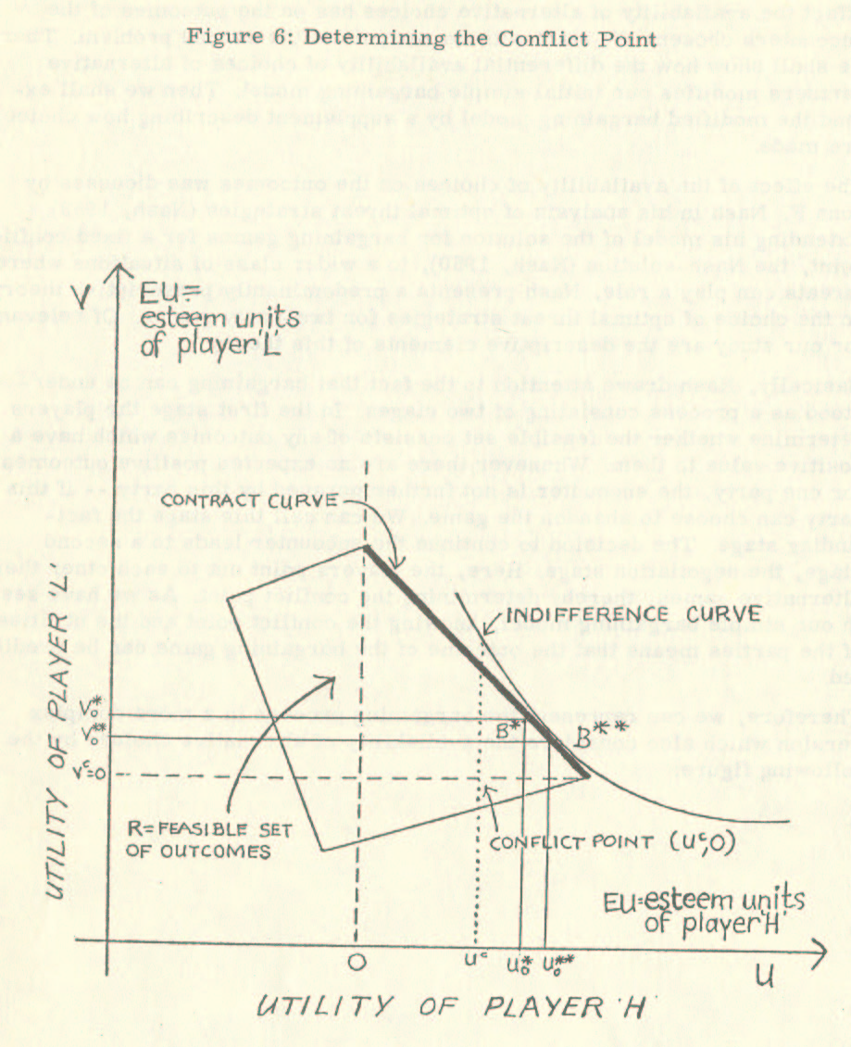
This figure represents a possible bargaining game between the players H and L. In the fact-finding stage, both players have determined that there are outcomes (u, v) such that u > 0 and v > 0. As a result, they decide to enter the negotiation stage. Had there been no alternative choice for either player, the game's outcome would have been B* with the coordinates (u _{o}*, v _{o}*). In the negotiation stage, however, player H claims that he has at least one alternative choice available, which would give him the utility u^{c} > 0. As player L accepts the claim of player H as true and cannot make the claim that he also has alternative choices available, the conflict point for the game is (u^{c}, 0). The outcome of the game, then, is B** with the coordinates (u₀*⁺, v₀**), such that u₀** > u₀* > 0 and v₀* > v₀** > 0. Our modified bargaining model, which considers the availability of alternative choices, therefore, predicts that in games between players of differing status, not only does the player with the higher status quo ante receive the lion’s share of the esteem distributable but also that he still increases his share by pointing out his alternatives.
Having updated our basic bargaining model for esteem by including the effect of alternative choices, we see that our conclusion from the simple bargaining game is once again confirmed. There we reasoned that any individual entering an encounter with much perceived esteem is likely to receive a disproportionately large share of the net gain in esteem when interacting with an individual entering the encounter with less perceived esteem. Assuming differential bargaining skill, i. e. , skill "to propagandize each other into misconceptions of the utilities involved" (Nash, 1953: 138), this result was reinforced, as we could assume the low-status individual to be comparatively less skilled. In the following pages, where we shall analyze the process of choosing, we will find further support for our claim that esteem is unequally distributed in encounters.
In building our supplementary model of the process of choosing a partner, we have to return to the observation that a high-status person has many choices available, as he is chosen more often than his capacity for encounters would allow him to return the choices received. We can assume a limited capacity for encounters since each encounter requires a certain amount of the scarce good -- time. Because of the rationality postulate, we can expect that the high-status person will tend to allocate his resources so that the most rewarding interactions are assigned priority. Therefore, the problem of how partners and games are chosen is the same as when a decision-maker in monetary exchange is confronted if he has to allocate his scarce resources to investment proposals exceeding his resources. This problem is known as the "capital budgeting problem". Weingartner’s (1967: 17) basic solution to this problem, although designed as a prescriptive model, can describe the process of choosing partners and encounters if we weaken the underlying assumptions of perfect information and unlimited computational ability with our assumption of approximate rationality.
We can then supplement our modified bargaining model by the following model describing the selection of partners and games: Under the assumption of approximate rationality ("social" rationality), a high-status person will tend to husband his scarce resource -- "time for social exchange", and he will tend to choose interactions so that he
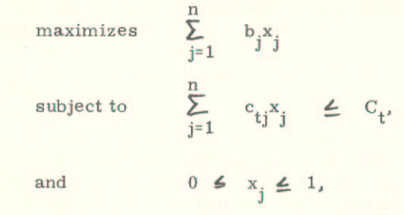
where b_{j} is the perceived net-present value which he assigns to interaction proposal j (as the total utility may be a non-linear function of esteem [see figure 4, p. 73 above, this value is interdependent with the ordering of the proposals), x_{j} is an amount between 0 and 1, c_{tj} is the perceived net outlay (cost) required for interaction proposal j in the period t.
Although a shortcoming of this model is the implicit simplifying assumption that the utility of esteem is a linear function of esteem, we can find consolation in the fact that we share this shortcoming with Weingartner’s solution to the capital budgeting problem. In other respects, the model can be seen as an adequate and concise mapping of the process of choosing partners and encounters in social life.
According to this model, the high-status person maximizes his utility gain from encounters within his capacity constraint if he prefers encounters with persons similar to him in social status. He will enter an encounter with a person with lower status only if there is no better choice available to him.
As the same model applies to the choices of persons in all status categories, the model maps as a reality that choices are preferably made within the status category of the chooser and that the likelihood of a choice decreases with the perceived status difference. Low-status persons of any social grouping are then left with a smaller number of bargaining games (encounters) than persons of other status categories, and, especially, they are excluded from games whose feasible esteem set includes particularly large outcomes.

3.2.3. Status Maintenance and Status Change
We have now reached a point in our discussion where we can summarize the results. With Homans, we assumed that social status or perceived esteem has the property to diminish over time if it is not constantly re-confirmed. Then, our research question was how esteem is acquired in a social system.
According to Homans' exposition of the social exchange concept, we acquire esteem in social interaction as an exchange object in various "esteem-currencies". In our discussion of Homans' conceptualization of the acquisition of esteem, we pointed out that although it parallels conceptualizations in modern economics, it does not make use of them. As a result, the discussion of the social exchange concept omits such fundamental conceptions as, for example, probability, utility, or probabilistic decisions, which in economics by now have allowed the conceptualization of exchange to go beyond the purely monetary exchange. Therefore, we proposed extending the analysis of social exchange by using a game-theoretical approach to interaction.
As a basic unit of analysis, we chose the encounter. Within an encounter, we argued, esteem in various esteem-currencies is exchanged. Our game-theoretical analysis of interaction as a bargaining game showed that individuals who enter an interaction with much perceived esteem, i. e., high-status individuals, are likely to receive as "due amount" half of the esteem distributable when interacting with "equals". However, they are likely to receive as due amount a "lion’s share" when interacting with individuals entering an encounter with less perceived esteem. On the other hand, low-status individuals are also likely to receive their due amount of esteem. However, regardless of whether they interact with persons of higher status or with "equals", our analysis showed that their "due amount" of esteem from an encounter is likely to be considerably smaller as compared with the amount likely to be received in any encounter by a person belonging to a high-status category.
Given this unequal replenishment of esteem, any encounter, therefore, is likely to enhance the present social position of the actors on the social scene, and we can say that social status is a "sticky" state. The term "sticky" means that we can expect status changes in social life to take place rung by rung up or down the "status ladder", and, further, that the probability of a status change towards a new status in any time period is the higher, the closer the new status ranks to the old status, the highest probability being that a person retains his present social status.
These results, which we obtained, by deduction from our analytical model, are in accord with the findings of empirical studies on social differentiation (see, e.g., Svalastoga, 1964: 530ff.). We find them confirmed, regardless of whether we look at the larger society and observe intragenerational or intergenerational mobility, or whether the object of observation is the status stability in a smaller social grouping as, for instance, in an organization or a small group.
What is new is the method by which we attained these results. We saw the social reality as a social construction and observed the actors on the social scene in their construction process. Our model was built as a construct of constructs, i. e., as a construct that attempts to comprehend the construction of social reality and reduce its complexity, then gives us more than merely the results. At the same time, the model constitutes a conceptualization of the object of the construction processes, namely, elementary social behavior, where the results check the adequacy of the conceptualization.

3.3. Behavior as Negotiated Reality
In the previous section, we used our bargaining model for esteem to make Homans' social exchange concept more encompassing. By laying this foundation, we now have support for the statement made in the introductory chapter that the social status quo ante limits life chances and life styles in a probabilistic way.
We conclude from our analysis that, because the outcome of a bargaining game is determined by the initial bargaining position of the parties involved, in the interrelation between social status and social behavior, perceived behavior is a negotiated reality. The major explanatory factor for an understanding of elementary social behavior is social status, which, in turn, solidifies the results from previous negotiations of social reality. In other words, we can conclude from our analysis of social interaction as a bargaining game for esteem that behavior is limited to status-specific behavior. Any behavior is likely to be perceived as such regardless of its phenomenality. Because the actor participated in the construction process, any behavior is also likely to be enacted so that it is phenomenally similar for persons from the same status category.
As an illustration for our claim that behavior is a negotiated reality in which one and the same behavior is differently constructed depending on the social positions of the actor and the evaluator, we propose to consider the quote mentioned in the introductory chapter:
In the bright glow and the warm presence of the American Dream all men are born free and equal. Everyone in the American Dream has the right, and often the duty, to try to succeed and to do his best to reach the top. Its fundamental themes and propositions, that all of us are equal and that each of us has the right to the chance of reaching the top, are mutually contradictory, for if all men are equal there can be no top level to aim for, no bottom one to get away from; there can be no superior or inferior positions, but only one common level into which all Americans are born and in which all of them will spend their lives.
Let us stop here for a self-administered Garfinkel-experiment and look back to the last paragraph, observing ourselves in our construction of the everyday world in terms of "What Anyone Like Us Necessarily Knows" (Garfinkel, 1967: 54). Let us be for a moment our own experimenter and our own subject for the experiment and successively interchange the persons to whom the quote is ascribed. We might, for example, assume the quote originated from a speech of the American president; or the talk of a French tourist to a local rotary club; or the term paper on stratification by an undergraduate sociology major; or, finally, from the introduction of W. Lloyd Warner’s famous work, Social Class in America (Warner et al., 1949: 3), from which it was actually taken.
Each time we observe within ourselves a change in the perception of credibility, quality, and acceptability of the communication. (Pertinent experiments can be found especially in the studies constituting the Yale series: Hovland et al., 1953; Hovland et al., 1957; Janis et al., 1959; Rosenberg et al., 1960). Depending on his perceived status, the amount of esteem we are willing to give to the imaginary originator of the communication differs. His behavior, the communication, is primarily evaluated according to the amount of esteem we allot to him, though the esteem apportioned to some extent is also dependent on the perception of behavior enacted. In our self-administered experiment, the evaluations might range from "immature utterance", to "impertinence", to "sophisticated statement", depending on whether the undergraduate, the French tourist, or Warner is seen as the originator of the communication, and, of course, depending on our own, self-perceived status. If we, the readers, were American presidents or high school juniors, our evaluation of the behavior of the various communicators would again differ.
Our self-administered Garfinkel-experiment chose a straightforward situation. We had complete information about the status of our imaginary partner in the negotiation and our own status. No interference in our perception of his or our status could be expected from our imaginary partner. Negotiating the social reality of his behavior, the communication, then, was a process consisting of only one step, our evaluation based on the amount of esteem we were willing to give to him.
The situation in face-to-face encounters differs in complexity. There, our willingness to give esteem to the other party is interdependent on the willingness of the other party to allot esteem to us. There, we can no longer play the dreamlike Walter-Mitty role of our Garfinkel-experiment. There, our negotiation on how to evaluate a behavior is interdependent on the outcome of a bargaining game for esteem.
In conceptualizing the differential patterns of social behavior as a consequence of social differentiation, we have to be aware that these patterns, in turn, affect the system of social differentiation. The pattern of mutual dependence is operating here, as it does with social phenomena in general. (For the classical criticism of the concept of one-sided causation in the study of social phenomena, see Pareto, 1935: §§ 245ff.). In social life, the effects of conditions react on the conditions themselves, or, as Homans expressed it, "they wax and wane together" (Homans, 1950: 7).
In summarizing our construction of the process by which reality is socially constructed, we can say that since esteem is a function of the social status of the bargaining parties, the process of constructing a behavior as a social reality is again a function of esteem. This process, in turn, influences the amount of esteem to be distributed and therefore indirectly influences the social status of the bargaining parties. Social differentiation has a double implication: different evaluations for the same behavior in differing social conditions ("Quod decet Jovi, non decet bovi! ") and differing behavior in differing social conditions. Both are implications that must be considered simultaneously if we want to avoid "finding" rationalizations for unequal evaluations, i. e., for a system of structured social inequality.
Now that we have presented our notion that behavior is a negotiated reality and that status is both the result and cause of social negotiations, we would like to apply the "Games for Social Status" model in the following analysis of the criminalization process. In this analysis of "Games for Criminal Status", we have to keep in mind that whatever we learn about the dynamics of obtaining criminal status not only clarifies the criminalization process; it is "not simply the study of some marginal, exotic or esoteric group, be they criminals or criminologists" (Gouldner, 1973: x), but contains the properties for a new understanding of the everyday life, of becoming prominent, of becoming an outsider, or of simply being a plain man.

4. APPLYING THE MODEL: THE CRIMINAL JUSTICE SYSTEM AS AN INSTITUTIONALIZED STATUS SLIDE
In much of the literature on social science, especially in that portion which terms itself criminological, we observe that behavior is not seen as negotiated reality but is investigated as if it could be divorced from the social conditions in which it is enacted. Although this is done in many cases after paying initial lip-service to interdependence, the emphasis is on the differences of social behavior in different social conditions rather than on the differences in evaluation of phenomenally similar social behavior in differing social conditions.
This social-psychological reductionism detaches behavior from the social conditions in which it takes place and the context in which it is evaluated. By its implicit claim that parts add up approximately to the whole, it goes beyond merely sacrificing complexity for the sake of analysis. This reductionism approach distorts the perception of the social phenomenon of structured social inequality and thereby creates a socially acceptable perception. One of the most gruesome products of the reductionist approach is the functionalist explanation of social differentiation (Davis and Moore, 1945).
The so-called radicals and tolerance of them by the community of scientific practitioners provide the figleaf for the scientific cementation of societal rationalizations by the reductionist approach. The very direction of the radicals' attack and their preoccupation with the conduct model make them tolerable and even useful for perpetuating social systems based on social inequality. In this respect, Sutherland's treatise on "White-Collar-Criminality" (Sutherland, 1945), which was regarded as radical at the time it was written, lies on the same level as The Schwendingers' recent attempt (The Schwendingers, 1970; 1972) to rename as criminal the phenomena which displease them. Perhaps contrary to their self-image, these authors give validity to the objects of their attacks and, therefore, present system-sustaining schemes.
In contrast to these reactive and reactionary attempts at redefining crime, we endeavor to identify the basis for active approaches. In our analysis, we shall show that the Criminal Justice System is a sub-system of the general social system of structured social inequality and that it constructs its reality in the same fashion as the general system. We shall follow the intricacies of the construction process, which builds a reality such that, although an individual is punished as a criminal by virtue of personal condition or by virtue of belonging to a particular class (Turk, 1969: 9f.), this fact can be obscured by a criminology-sponsored construction of reality which confers on the Criminal Justice System "an artificial character of humanness, of goodness and, sometimes of scientific seriousness" (Bertrand, 1973: 37). Through our analysis, we shall demonstrate that both traditional and radical-reactive criminologists are "engaged in a collective fraud" (Bertrand, 1973: 37). As a result, we shall be able to subscribe to Peter Macnaughton-Smith’s recent harsh characterization of the criminologist’s role in society as a caretaker of rationalizations:
The criminologist is . . . a government-paid obscurantist. He is a person who studies the causes of crime, that is to say, why people that society calls criminals did certain things; he ignores the more basic question why, in the face of certain circumstances, certain members of society respond by criminalizing other members (Macnaughton-Smith, 1973)
Our next chapter will deal with this fundamental question. To provide an answer, we shall break with a tradition in criminology, namely "the insulation of criminology from sociology in general" (Taylor et al., 1973: 268). However, we shall not join the chorus of latter-day meliorists who demand that "the new criminology must . . . be a normative theory" (Taylor et al., 1973: 280). Instead, we will try to solve the problem, which Macnaughton-Smith pointed out by our conceptualization of the process of criminalization as a process of status attainment, that is, as "Games for Criminal Status" which are played by the actors in the social scene not differently, though in a more ritualized form, than "Games for Social Status".
We begin our analysis of the construction process of the social realities "crime" and "criminal" by considering what has been called the attrition of justice. In the attempt to identify the persons who construct the social realities of crime and criminal, that is, in the attempt to identify the agents of the Criminal Justice System, we will trace the career of an individual whose behavior could be defined as violating a criminal law through a succession of encounters. This first section will show that the traditional analysis of the criminalization process has left out the most important agent of the Criminal Justice System, the victim and/or the general public. It has thereby severely distorted the attainable perceptions of the construction process.
The following section will demonstrate that these successive encounters with the Criminal Justice System agents can be conceptualized as successive status degradation ceremonies, systematically connected as "Games for Criminal Status". In each one of these encounters, a part of the social reality crime and criminal is sculptured and is eventually handed over to the next agent until the construction is completed in a final ceremony at the court stage.
In the third section of this chapter, we will summarize the results of our conceptualization of the criminalization process as "Games for Criminal Status". There we shall see that criminal status and criminal behavior are two separate, though interconnected, constructions of the social reality whose construction process are, in its fundamental principles, not different from processes by which our everyday reality is constructed.
Then, the final section will illustrate the model of "Games for Criminal Status". There, we shall expand on the interrelations within the model by developing propositions that can be deduced from the model.
This will bring us to the concluding chapter of our study. At this point, we shall have reached an understanding of the distribution of criminal justice as a process in which a part of the social reality is constructed, not however determined from "facts" as common sense postulates. We shall see that cowed behind common sense rationalizations, justice is an artifice that maintains structured social inequality.

4.1. The Attrition of Justice
We know that only a few known offenses lead to a conviction from criminal and delinquency statistics. Data indicate, for example, that of 2,780,000 index crimes known in the United States in 1965, only 3 % resulted in offenders being sentenced to prison (Task Force Report: Science and Technology, 1970). This process of screening offenders in the Criminal Justice System has been called the attrition of justice (Ennis, 1967: 78).
Since we are interested in the construction of the social reality "crime" and "criminal", we turn our attention in this section to the functioning of the screening process in the Criminal Justice System. We propose to understand the construction of the social reality as consisting of four stages. These stages are (1) the victim and/or general public stage, (2) the police stage, (3) the prosecutor stage, and (4) the court stage. In each of these stages, the "offender" and an agent of the Criminal Justice System create a part of the social reality of the behavior and the status leading to criminal status. Depending on whether or not the status degradation and the definition of a behavior as criminal behavior was successful at one stage, the "offender" is handed over to the next stage for further processing.
Our general model of the Criminal Justice System as a four-stage process in which a status degradation ceremony between two parties is successively enacted at each stage is, of course, a simplification both of the multitude of interrelations between the stages and of interrelations within the stages (cf., Reiss and Bordua, 1967: 38). As the further analysis will show, however, it is a simplification, which is an adequate reduction of the complex reality, corresponding to the one we proposed in the previous chapter when we conceptualized the "Games for Social Status" as two-party games.
Using a general model of screening as a four-step process enables us to consider a forgotten agent, the victim and/or the general public. As the study by Ennis (1967a) shows, it is at this stage that the primary screening, the construction of "good" and "bad", is enacted. Therefore, including the victim and/or the general public in a model of the screening process has a double effect: Firstly, it clarifies that most of the time, the police" constitute only the second screen, that is, they deal with an already prestructured reality (cf., Wilson: 1968, 85). Secondly, it establishes a link between the general societal process of status change and status maintenance and the process by which criminal status is attained. Therefore, our perception of the victim and/or the general public as the first screening agent provides the basis for our statement that "Games for Criminal Status" are special rather than unique forms of "Games for Social Status". In other words, it means that criminology is a part of social science and not a science, which can be undertaken by itself.
This new understanding of the screening process in the Criminal Justice System and of the identity of screening agents allows us to bring some order into the present confusion about the screening process. As it is now,
we know very little about the properties of this screen, but we do know that it takes many factors into account which are not directly related to the deviant act itself: it is sensitive to the suspect’s social class, his past record as an offender, the amount of remorse he manages to convey, and many similar concerns which take hold in the shifting mood of the community. This may not be so obvious when the screen is dealing with extreme forms of deviance like serious crimes, but in the day-by-day, filtering processes, which take place throughout the community this feature is easily observable. Some men who drink too much are called alcoholics and others are not, some who act oddly are committed to hospitals and others are not, some men who have no visible means of support are hauled into court and others are not - and the difference between those who earn a deviant label and those who go their own way in peace depends almost entirely on the way in which the community sifts out and codes the many details of behavior to which it is witness (Erikson, 1962: 11f.).
In the past, criminology only paid attention to the screening procedure within a narrowly defined Criminal Justice System. Agents of this system who do the screening were perceived to be the official agents -- "the police", "the prosecutor" and "the court".
It is important to note here that many well-intentioned studies of the screening process focused primarily on the police as the most visible and, at the same time, the weakest component of the system. Oblivious to the fact that one of the functions of the police in the social structure is to act as "a social lightning rod" (Blumberg, 1967: xxxi; cf. also, Silver, 1967: 11), that is, to attract and neutralize criticism of the Criminal Justice System, some of these studies fell into the trap prepared by a system which protects its existence by a smoke-screen of justice. An example of this "injudicious" critique of the workings of the Criminal Justice System is Skolnick’s Justice without Trial (1966).
For some time, at least, it seemed that an understanding of the screening process in the Criminal Justice System could be reached if a system approach is chosen where not only the screening by the police is studied, but where at the same time the screening by the prosecutor and by the court is investigated, that is, where the career of an individual is followed after he has been handed over to the prosecution and from there to the court.
This avenue was chosen, for instance, by the American Bar Foundation’s Survey of the Administration of Criminal Justice in the United States (Tiffany et al., 1967; LaFave, 1965; Miller, 1969; Newman, 1966; Dawson, 1969). This series focuses
on two basic aspects of criminal justice administration: (1) the study of the process of criminal justice as a system, one which must be studied as a whole if individual decisions and agencies are to be adequately understood; (2) a study of the exercise of discretionary power by criminal justice agents and agencies (Remington, 1969: xvii).
Although it was able to collect and order a plethora of information about the workings of the screening procedure in the Criminal Justice System, the editor, in a final assessment, admitted that the survey remained incomplete (cf., Remington, 1969: xx ff.). As a result of insufficient funds, overtaken by the rapid development in the study of crime in the last decade (e. g., the conception of "criminality as a status rather than behavior", Turk, 1969:8), and ailing from some of its theoretical and empirical foundations, the series had fallen short of its goal to provide a basis for continuing research of the overall process of criminal justice. However, its conceptual approach, the understanding of the criminal justice administration as a system of agents with discretionary power, remains.
The relative failure of the series of the American Bar Foundation typifies the situation of traditional criminology. Characteristics of both are the presuppositions that there is a science of criminology, which is not part of social science, and that sufficient legitimation for its practitioners is "goodwill" and a "sound" common sense.
If we perceive the social reality as socially constructed, both presuppositions are erroneous. In order to reach an understanding of the construction of social reality, we have to reconstruct this reality, that is, seek to attain a construction of the second degree. Common sense, however, by definition does not allow us to transcend common sense, which is the first-degree construction of reality. Therefore, for the study of the screening processes in the Criminal Justice System, our assumption means that we have to transcend common sense. We have to study the construction processes of social reality following construction principles, which are not dissimilar from the principles used for other constructions of social reality. This means we have to do criminology as social science.
We know that, although the police are on principle the first agents of the Criminal Justice System acting in an official capacity in the career of an individual who is suspected of having violated a criminal law, they only uphold or reject definitions of reality conveyed to them by the victim and/or the general public in many, if not in most, cases. A narrow definition of the Criminal Justice System, then, does not consider that the police as first official agents deal in a similar way with a prestructured reality, just as the prosecutor does with the prestructured reality conveyed to him by the police, and just as the court does with the reality handed to it by the prosecutor. Therefore, the American Bar Foundation’s survey's system approach is incomplete. In a social science study, we have to widen the definition of the Criminal Justice System and include as one of its agents the initial constructor of the social reality. We have to include the victim and/or the general public as a player in the "Games for Criminal Status".

4.2. Games for Criminal Status
Having indicated in the previous section the identity of the principal actors on the social scene who collectively construct the social reality of "crime" and "criminal", this section's task is to reconstruct the construction process by which these actors build the social reality. We shall do this by building a "Games for Criminal Status" model. This model, which is non-contradictory to empirical findings, is a second-degree construction of the social reality of the criminalization process. It orders the findings into general propositions based on understanding social reality as we have developed it in our discussion.
Our method of presentation will be similar to the one used in developing the model of "Games for Social Status". We introduce our model in a simplified world and, gradually relinquishing the simplifying assumptions, guide it through more and more complex worlds until we can accept it as a model for describing and explaining processes of criminalization.
We begin the explanation of our model by showing how negative esteem is distributed in successive encounters with agents of the Criminal Justice System. Next, we discuss the effect of the capacity constraint of the agents on the outcome of the "Games for Criminal Status".

4.2.1. Distributing Negative Esteem
Our model of the criminalization process corresponds in nearly all details to the model of the social construction of behavior and status, which we presented in the third chapter. In both models, we make the simplifying assumption of encounters as two-party games, where the inter-partes-possible constructions of their behavior constitute the feasible set of outcomes. We assume that the bargaining object is esteem in various esteem-currencies and that the bargaining outcome, the distribution of the available esteem among the parties, is an inter-partes construction of their behavior as well as a replenishment of their perceived esteem, that is, a determinant of status change and status maintenance.
In contrast to the general model of "Games for Social Status", the special model of "Games for Criminal Status" is, as far as the "offender" is concerned, characterized by the depletion of his perceived esteem, i. e., the shift from the status quo ante to the marginal status of "being a criminal". In successive encounters with agents of the Criminal Justice System, the "offender" is processed if, and only if, he loses a game, which means if he acquires negative esteem in this encounter, while his opponent, the agent, acquires positive esteem through the encounter.
A general representation of a game for criminal status, then, is given by the following figure:
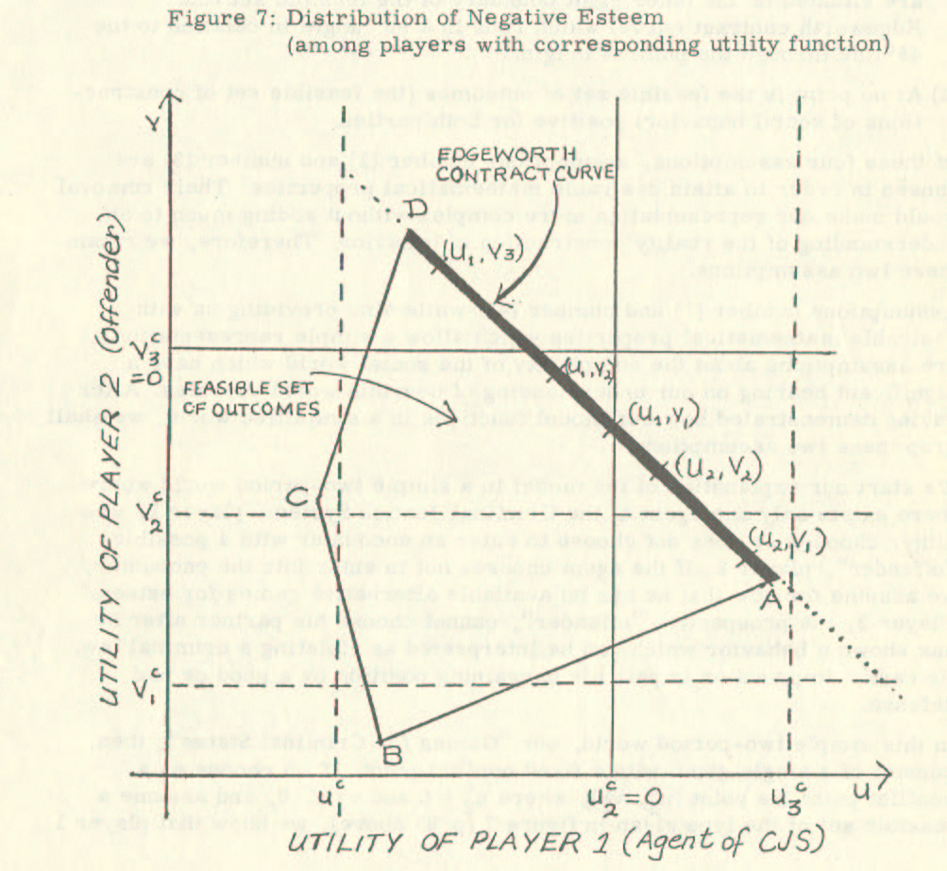
In this general representation of a game for criminal status, we make the following simplifying assumptions in addition to the ones implicit in the conceptualization of the construction of the social reality of behavior and status as a two-party bargaining game:
- The players have equal status quo ante and corresponding utility functions for esteem.
- The feasible set is bounded by the lines through the points A, B, C, and D in the utility space of the players.
This means:
  - Between the players, at least four inter-partes constructions of their behavior are possible such that each construction results in an outcome represented by the points A, B, C, or D.
  - Any probability mix of these four constructions is possible.
- The constructions A and D and their mix are connected such that they are situated on the outer right boundary of the feasible set (the Edgeworth contract curve), which runs at a 90º angle with the 45° line through the point of origin.
- At no point is the feasible set of outcomes (the feasible set of constructions of social behavior) positive for both parties.
Of these four assumptions, assumptions number (2) and number (3) are chosen to attain desirable mathematical properties. Their removal would make our representation more complex without adding much to an understanding of the reality construction of behavior. Therefore, we retain these two assumptions.
Assumptions number (1) and number (4), while also providing us with desirable mathematical properties which allow a simple representation, are assumptions about the complexity of the social world which have a significant bearing on our understanding of how this world operates. After demonstrating how our model functions in a simplified world, we shall drop these two assumptions.
We start our explanation of the model in a simple two-period world where there exists only one agent of the Criminal Justice System, player 1, who either chooses or does not choose to enter an encounter with a possible "offender", player 2. If the agent chooses not to enter into the encounter, we assume for now that he has no available alternative games for esteem. Player 2, the prospective "offender", cannot choose his partner after showing behavior that can be interpreted as violating a criminal law. He cannot improve or impair his bargaining position by a good or bad defense.
In this simple two-period world, our "Games for Criminal Status" consist of a single game with a fixed conflict point. If we choose as a conflict point the point (u₂^{c}, v₂ ^{c}), where u₂^{c}= 0 and v₂ ^{c} < 0, and assume a feasible set of the type given in figure 7 (p. 95 above), we know that player 1 will choose to play the game as long as there are feasible outcomes which are larger than u₂^{c} = 0. According to our assumption, player 2 has no choice. Therefore, from our reasoning in chapter three, we know that the game's solution is the reality construction (u₂, v₂) of the inter-partes behavior. This means that player 1 acquires in the example the esteem of (u₂ - u₂^{c}) > 0 and that player 2 acquires the esteem of (v₂ - v₂^{c}) < 0.
If we assume that any esteem outcome below the value v_{x}, where 0 > v_{x} > v₂, means that a behavior is evaluated as criminal, the behavior of player 2 has been constructed in this encounter as behavior that violates a criminal law. However, if we remember our definition of status, this does not necessarily mean that player 2 also attained criminal status. According to our assumptions of status as accumulated perceived esteem and of criminal status as marginal status, player 2 has attained criminal status only if, as a result of the encounter, the amount of negative esteem received there sufficiently decreased his "capital" of accumulated perceived esteem.
From our simple two-period world, we can then take as an intermediate result that social status quo ante has a double effect:
- As the utility function for esteem is dependent on social status (pp. 72f. above), social status quo ante influences the construction of the social reality of a behavior, such that it becomes more unlikely that a behavior is constructed as criminal behavior, the higher ranking the status of a type 2 player.
- The more the distance between the ranking of the social status quo ante of a player 2 and the ranking of criminal status, the more unlikely it is that the construction of a behavior as violating a criminal law has the effect of demoting the social quo ante to criminal status.
We can illustrate these two results by an example from everyday life. Let us imagine a law firm in which there are three people employed. One is a lawyer, another is a secretary, and the third is an office boy. Each one of these people takes stationery from the office to use for writing personal letters. Phenomenally, therefore, each of these three people does the same thing: he appropriates property that does not belong to him and, assuming that there is neither an explicit nor implicit permission by the owner of this property, thereby "technically" violates criminal law. Conceptually, however, the reality of their behavior is different. The reality of the behavior of the employed lawyer might be perceived as "taking", the action of the secretary as "swiping" and, finally, the action of the office boy might be perceived as "stealing". In our example, then, only the action of the lowest ranking individual, the office boy, is constructed as criminal behavior. Because of the value of the objects appropriated, we can assume that the construction of the behavior of the office boy as "stealing" is not per se sufficient to demote his social status to criminal status.
If we now increase the value of the objects appropriated, we can observe that the reality construction "stealing" next reaches the secretary and, finally, the lawyer. At one point in our succession of appropriations, we might construct the reality of the behavior of both the office boy and the secretary as "criminal behavior" while the lawyer's action is not perceived as such. At this point, the status quo ante of the office boy might be already sufficiently lowered so that he has now conceptually reached "criminal status".
Our example, therefore, illustrates the two intermediate results, namely (1) that the chance of attaining the reality construction of "criminal behavior" and the chance of being demoted to "criminal status" correlates positively with the actor’s status quo ante, and further, (2) that the reality construction of a behavior as criminal behavior does not necessarily demote the social status quo ante to criminal status.
With these two intermediate results, we now enter a more complex world, a three-period world in which a second agent of the Criminal Justice System exists. In this world, player 2 has a chance to play a second game with the second agent (who is then player 1) if he leaves the first game with the first agent with at least the new status of "being suspect". Having attained the status of "being suspect" is analogous to our previous reasoning that player two’s behavior has been defined in the first game as violating a criminal law a n d that, in the perception of the agent, the actor’s status has been sufficiently demoted so that a further degradation in the second game could lead to the attainment of criminal status.
From our reasoning about game-playing in the two-period world, we know that the likelihood for a status degradation to the status of "being suspect" is a function of the social status quo ante, given the same feasible set of outcomes for all players of type 2. Therefore, not all players of type 2 will have a chance to enter a second game with a second agent as player 1.
For the ones who do enter the second game, we know that since they have undergone a status degradation, their utility function for esteem has changed to one which differs from the one in the first game in that the utility for esteem increases more rapidly (see our assumptions on the shape of the utility curve, p. 72 f. above). Further, we know that the feasible set of outcomes is now prestructured. This means that, although the second agent brings his own interpretation of the behavior of player 2 into the game, the feasible set in the second game is likely to have changed for the worse for player 2, because a second game is about to be played influences the range of the possible inter-partes constructions.
The result, however, is similar to the one we attained in our considerations about the two-period world: The higher the status before the second game of a player of type 2 (i. e., the higher the remaining status of a player who is a suspect), the less likely it is, for the same set of feasible outcomes, that behavior is constructed as violating a criminal law and the less likely it is that the status is degraded to the marginal status of criminal.
Increasing the number of periods, that is, the number of successive games with agents of the Criminal Justice System and the gradations of status loss necessary to qualify for another game, reinforces the general result attained in the analysis of a game for social status in a two-period world.
Any screen works to the disadvantage of low-status persons, and successive screening compounds this effect.

4.2.2. Choosing Conflict Points
So far, our model of "Games for Criminal Status" has included three assumptions, which we would now like to remove. These assumptions are: (1) the players have equal status and corresponding utility functions for esteem. (2) At no point is the feasible set of outcomes positive for both parties. (3) The point of conflict, the minimum outcome for each player, is given.
By removing the first assumption, we know from previous discussions that the outcome is changed in favor of the player whose utility function for esteem increases more slowly. A high-status person, whether a player of type 1 or type 2, then, can always expect better outcomes for a game with the same structure than a low-status person. Therefore, discarding the first assumption does not change the results of our previous analysis.
Elimination of the second assumption also does not change our results. In effect, it supports our claim that "Games for Criminal Status" are merely a particular form of "Games for Social Status", as moving the Edgeworth contract curve in our example (figure 7, p. 95 above) to the right given us the "normalized" bargaining game (figure 3, p. 71 above) from which we developed our model of "Games for Social Status".
Discarding the third assumption, the assumption of fixed conflict points has more complex consequences for our model. If we assume that each player has one possibility of impairing and one possibility of improving his conflict outcome, we have nine conflict points, each with a possibly different predicted outcome. As in our example in figure 7 (p. 95 above), these conflict points might be the points determined by u₁^{c}, u₂^{c}, u₃^{c,} and v_{l}^{c}, v₂^{c}, v₃^{c}. Since we are concerned with a descriptive theory of the criminalization process, we have to characterize the situations in which each of these points might be the conflict point and, then, by predicting the outcomes for each conflict point, make the necessary changes in our model of "Games for Criminal Status" such that it encompasses these situations.
We begin by considering the circumstances under which player 1 has conflict outcomes, better or worse than the conflict outcome u₂^{c}. From our discussion of "Games for Social Status," we know that there are two situations that can influence the conflict outcome. One of them is the availability of other games, which guarantee at least the conflict outcome of the game under consideration, and the other one is the successful bluff pretending an alternative of this kind.
Let us first assume the possibility of a successful bluff. Then, we can assume that in the succession of the Criminal Justice System agents, an agent is the more sophisticated in bluffing the later is his turn in playing the games for social status. This means that we assume that the police are more sophisticated in bluffing than the victim and/or the general public, that the prosecutor is more sophisticated than the police is, and that the court is more sophisticated than the prosecutor is. If we then introduce the possibility that a player of type 2, an "offender", also can bluff about the availability of alternative games, which would move the conflict outcome, we can say that the introduction of a bluff supports our argument. As high-status persons are likely to be screened out earlier, this is to say that the chances of the reality construction of criminal behavior and criminal status for the same feasible set of constructions are the higher, the lower the social status quo ante of a type 2 player.
The same is true, as can be shown easily, for the case of the actual availability of alternative games for players of type 1. If we first consider the case where the actual conflict outcome is u₁^{c} < u₂^{c} = 0, which means that player 1's conflict outcome is below his no-alternative-choice outcome u₂^{c} = 0 because he is dependent on player 2 -- either because of family relations or because of community relations (cf., Stinchcombe, 1963: 154; Whyte, 1943: 138f. ; Miller, 1969: 6), or because player 1 has accepted graft money, for instance, -- we know that no reasonable player 1 will enter into an encounter as long as the outcome, the inter-partes construction of the behavior, is smaller or equal to the outcome attainable by simply not playing the game, that is, as long as u₁ ≤ 0. According to our assumption, only player 1 has the choice. Therefore, through our analysis, we have excluded a group of games and, as the access to these types of games is differentially distributed according to social status, we have at the same time confirmed our intermediate results.
If we now remove our assumption that no other games are available to a player of type 1 and instead take the more realistic assumption that any agent of the Criminal Justice System has more games available than he actually could or would play (Reiss, 1971: 14; Miller, 1969: 157), we have a second group of cases. As we explained in chapter three (p. 84 above), the agent chooses encounters so that he
He will tend to husband his scarce resources, "time for encounter", and he will tend to maximize the sum of the outcomes. He can attain this in two ways.
First, he might perceive his minimum conflict outcome to be at u₃^{c} > 0. Given the values in our example in figure 7 (p. 95 above), this means that regardless of the conflict outcome of player 2, the agent will never enter into an encounter, as all values in the feasible set are below his minimum expected outcome. Examples for this situation are (a) the individual in the general public who observes a "crime" but does not report it because he shuns the inconvenience, (b) the victim who does not notify the police because he doubts police effectiveness or fears a cancellation of or increase in insurance rates (Ennis, 1967a: 44), (c) the policeman or the prosecutor who does not pursue a case, although there is sufficient probability of guilt, because he regards it as a minor case (Wilson, 1968: 83f. ; Miller, 1969: 5ff.).
The second alternative involves a two-step procedure. After the agent has decided that, on principle, he is not averse to entering into the encounter, after the agent has perceived a feasible set of outcomes, which might make the encounter interesting to him, he first plays a game for the conflict point. This could be described as a game to determine the optimal threat strategies in game-theoretical terms. The objective of this game is to test the opponent's strength. If an opponent turns out to be strong in this game for the conflict point, the agent might be inclined to concede to him and, thus, save his resources for playing other games in a similar fashion.
For instance, in a given case, an agent might be able to reach a conflict point (u₂^{c} + δ, v₁^{c}) if he uses all his resources in this case. He will thereby attain in the second game for esteem the outcome of approximately (u₂, v₁). However, if he decides to use only a part of his resources on this given case, thus saving the remainder for other encounters to be played in a similar fashion, he might, for example, reach in the game for the conflict point the point (u₂^{c} + δ, v₂^{c}). This means that in the subsequent game for esteem, he will reach the outcome of approximately (u₂, v₂). The outcome (u₂, v₂) is, of course, less than the outcome (u₂, v₁), but the agent will seek to attain the former outcome because, in the long run, he will, by playing games in this fashion, use his scarce resources more efficiently. By conceding to an opponent in an individual case and thus saving the resources, "time for encounter", he might, for example, have the opportunity to pursue nine other cases in a similar fashion, which, in an overall evaluation, would give him a better outcome for his limited resources. This theoretical deduction from our model has been documented empirically (cf., Wilson, 1968: 49; Miller, 1969: 151ff.).
If we now look back at the changes in our model of "Games for Criminal Status" effected by eliminating the assumption of fixed conflict points, we find the general result derived from the simplified two-period model confirmed. We found that for given agents of the Criminal Justice System --although we assume that for players of type 2 there are no or only negligible opportunities for selecting agents, or, in other words, that there is no "court-shopping" -- player 2 can influence his conflict outcome by more or less astutely playing the game. Astutely playing a game for criminal status means playing a game with all available resources, be it one's own resources like intelligence and/or the ability to master social games, or be it the help of someone else who contributes his ability to play games for criminal status, such as a defense counsel. From our general analysis of "Games for Social Status", we can conclude that these resources are differentially distributed according to social status (cf., Stinchcombe, 1963: 157). Using this conclusion in the model of "Games for Criminal Status'.', we arrive at two general results. Firstly, social status negatively correlates with the chance that a behavior is socially constructed to the social reality "criminal behavior". Secondly, the process of screening of "offenders" in successive encounters with various agents of the Criminal Justice System gives an "unjust" advantage to the "offender" with high social status, so that the chances of attaining criminal status are inversely related to the ranking of the status before the first encounter.

4. 3. Criminal Status and Criminal Behavior
The results we attained in our analysis of the criminalization process as "Games for Criminal Status" are not novel. They are in accord with the conceptions of most criminologists, with the empirical findings, with the official statistics, and with the results of studies on the "dark-figure" of crime. Had we been primarily concerned with reaching these results, our study would have been as inane as the attempt to carry water to the sea.
Instead, our primary interest was to understand the processes by which these results become a reality. For this purpose, we developed a model which is non-contradictory to findings in social science but integrates the information we have about "crime" and "criminals" into the information we have about social behavior and social status in general, ordering it into consistent and valid propositions. Therefore, it is the method that allows us to build models of "Games for Social Status" and "Games for Criminal Status" and whose validity is indicated by the results that are of interest and importance.
Guided by the notion of social reality as construction by the actors on the social scene, we followed the construction processes using the simplifying assumption of encounters as two-party games. In the discussion of the attrition of justice, we showed that the first game for criminal status in most cases is played with an agent of the Criminal Justice System who is often not perceived as such, namely the victim and/or the general public. In the encounter with this first agent, most incidents, which could be regarded as violations of the criminal law, are screened out. This was demonstrated for the case of the victim in a study done by Ennis (1967 a: 41ff.).
In this first encounter, the social reality of the behavior is constructed. As our analysis showed, there are on principle four outcomes to such an encounter: Either (1) the agent abstains from the game, or (2) he plays it and the result is a construction of the behavior as non-criminal, or (3) he plays it and constructs the behavior as criminal but does not perceive the status as sufficiently downgraded so that a next agent can be notified to play another game, or (4) he plays the game, regards the behavior as criminal, and perceives the status as sufficiently downgraded for a game with the next agent.
Only if the first agent decides on a construction of the behavior as criminal, and a l s o considers the status of his opponent as sufficiently down-graded, that is, considers his opponent as a result of the encounter as a "suspect", will he notify the next agent, "the police" or "the prosecutor", who then starts a similar game, but now with a partially prestructured reality of the behavior and the status of the opponent. In the final stage of the succession of games, then, "the court" constructs its reality of behavior and status, evaluating, like other agents before it, the behavior as criminal or non-criminal. In contrast to the other agents, who only have the opportunity of conferring upon the "offender" less finalized constructions of the reality of his status, like the status of being "suspect" or of being "accused", the court, however, decides on the social reality of the criminal status of the "offender".
Therefore, according to our analysis, we have to distinguish between criminal status and criminal behavior in the same way we make such distinctions in everyday life situations. Criminal behavior as one form of social behavior is a construction of the social reality, which any individual can make in a social system. The social reality of criminal status, as one form of social status, is a construction of the social reality made by an authorized agent, "the court". It is the result of multiple encounters in which, at each encounter, the sum of the perceived esteem of the "offender", his social status, is depleted or replenished. In the Criminal Justice System, this process has been ritualized so that only one of its agents, "the court", can change the reality of a social status to the marginal status of being "criminal".
The method of reconstructing the construction processes of social reality enables us to show that our analysis of the criminalization process as "Games for Social Status" is a corollary to an analysis of status change and status maintenance. The result of the latter analysis was the seemingly innocuous statement that social status is a "sticky" state, as the status quo before any encounter probabilistically determines the construction of social behavior and social status after the encounter. For the special case of criminal status and criminal behavior, we can now state as a corollary that the chances that behavior is constructed as criminal behavior and the chances that an actor on the social scene attains criminal status are probabilistically determined by the actor’s status before any game for criminal status.
With this understanding of the workings of the Criminal Justice System, derived through our method of analyzing social life through the concept of social exchange, we would be able, in an "applied" criminology, to evaluate change proposals and to influence or manipulate the process of reality construction at each stage of the criminalization process and thereby alter the differential distribution of immunity. Corresponding to our argument in the second chapter, however, we have to refrain, for the sake of a system understanding, from such an application of our model within the "real" world, and we have to leave this more pleasing task of adjusting the social is-world to a social ought-world for others, for the system-planners.

4.4. Propositions on the Construction of the Social Reality of Criminal Behavior and Criminal Status
The task remaining is to illustrate our model of "Games for Criminal Status" in the form of propositions.
By propositions, we mean statements in the form of theorems, which can be deduced from our model. The propositions to be developed in this section serve a double purpose. Firstly, by expanding on the interrelations within the model, they further our understanding of the construction of social reality by the Criminal Justice System and clarify what might have remained arcane within our model. Secondly, by stating the interrelations within the model in the form of theorems, they open the model for empirical investigation -- i. e. Hypotheses, as operationalized propositions, could be developed from the propositions and the validity of these hypotheses investigated in the field.
The Basic Proposition
At the end of the previous section, we stated - as a result of the inquiry into the criminalization process - a corollary to a game-theoretical analysis of status change and status maintenance based on the concept of social exchange. Focusing on the construction of the social reality of criminal behavior and criminal status, this corollary is at the same time the first and most basic proposition which can be deduced from our model of "Games for Criminal Status". It can be formulated as follows:
Proposition 1: The chances that behavior is constructed as criminal behavior and that an actor on the social scene attains criminal status are probabilistically determined by the actor’s status before any game for criminal status.
We can clarify and supplement this basic proposition further through a series of propositions if we analyze the effect of (hypothetical) changes in existing conditions within a Criminal Justice System on the outcome of bargaining games (encounters) for negative esteem. Then, to generate other propositions from the model of "Games for Criminal Status", we shall be analyzing in this section the complex function of the model by varying the state of the elements constituting the bargaining situation.
Varying the State of Elements in a Bargaining Situation
We must first identify the elements characterizing a given bargaining situation within a game for criminal status. Furthermore, we must look at the conceivable combinations, which these elements can assume if their state is varied.
If for the moment, we leave the elements in their abstract form, we can distinguish the following six elements within a given bargaining situation (see figure 8 on the next page):
  - Feasible set
a. Contract curve
b.Conflict-line of Player 1, the u^{c}-line
c.Conflict-line of Player 2, the v^{c} -line
B. Utility functions
d.Utility function of Player 1
e.Utility function of Player 2
C. f. Number of successive games necessary to obtain criminal status
As our model is based solely on these six elements, it might appear that we can draw our propositions only from a few straightforward situations. However, we have to consider that the elements themselves are abstractions from complex situations. Furthermore, we have to take into account that, even if we restricted ourselves to the analysis of only three states for each element (that is, to x₀, x₁, and x₂, where x_{o} is a given state of an element x and where x₁ and x₂ are chosen such that, e. g., in the case of the conflict line of Player 1 b₁ > b₀ and b₂ < b₀), we would have to derive the propositions from a matrix of the following type:
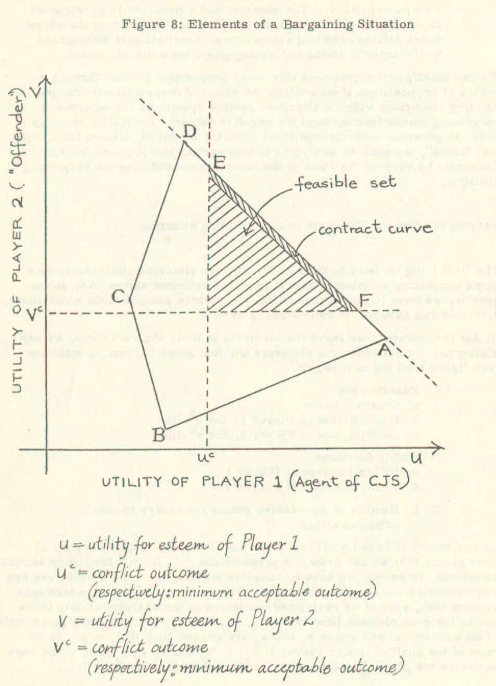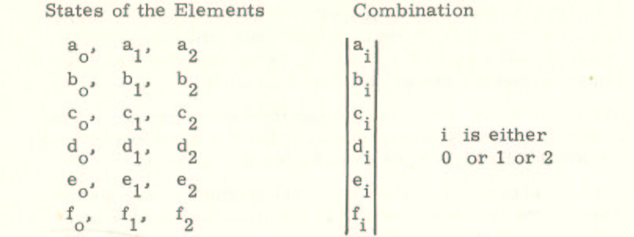
This matrix means that the number of combinations, each of the type (a_{i}, b_{i},… f_{i}), is:
(3) x (3) x . . . (3) - (1) = 3⁶ - 1 = 728.
At a second glance, we see that even the small number of elements in the bargaining model provide for a larger number of combinations from which propositions could be drawn than it is feasible to analyze within this study. This problem becomes even more evident if, instead of three states for each element, we admit two gradations within each direction of change such that each element could assume the states x₀, x_{1a}, x_{1b}, x_{2a}, and x_{2b}. The number of possible combinations from which propositions could be drawn would be much higher, namely 5⁶ - 1 = 15, 624. Alternatively, if there were just five more states admitted for each element, the number of possible combinations would rise to the astronomical amount of 10,000,000.
Based on the theoretical reflections presented in chapter 2, we already excluded an evaluation of the different conceivable combinations in favor of a system understanding. At this point, then, we have to further restrict our discussion to a few of these combinations. Given the matrix presented above, it seems reasonable to confine our discussion to only those combinations (a_{i}, b_{i}, … f_{i}) where all but one i equal 0. In other words, it appears to be reasonable to restrict the further discussion to combinations where the state of only one element of a given bargaining situation is altered.
This will still leave us with twelve combinations from which we shall draw six propositions belonging to a large family of propositions. These exemplary propositions are the following ones:
Proposition 2: If it were mandatory for any "offender" to enter a coalition with a person capable of demonstrating additional interpretations of given facts at least at the court stage, then the influence of social status quo ante of the "offender" on the construction of the social reality of a behavior and a status would be lessened.
Proposition 3: If a player of type 1 knows about his opponent's "criminal record", this will increase the chances that Player 2's behavior is constructed as criminal behavior and his status as criminal status.
Proposition 4: The clearer the "evidence" (i. e., the fewer the possible interpretations) for the same phenomenal behavior, the higher the chances for a conviction.
Proposition 5: The larger the number of successive encounters necessary to obtain criminal status, the more likely it is that one would find a disproportionately large number of low-status persons among the persons convicted.
Proposition 6: One's peers are likely to come to less favorable constructions of reality for the same phenomenal act than agents of a Criminal Justice System whose status is below the one of a prospective "offender" and to more favorable constructions than agents with higher status.
Proposition 7: The greater the number of alternatives for an agent, the more he will be inclined to choose from the number of available encounters those encounters in which the return in esteem, compared to the effort to attain this esteem, is the highest.
The GORSHEN Case
The first three of these propositions we intend to illustrate through hypothetical changes in the situation of a "real"-life case, namely: PEOPLE v. GORSHEN (51 C. 2d 716 (1959); 336 P. 2d 492 (1959)). The analysis of this case at the trial court stage will give us at the same time also the opportunity to demonstrate once again the explanatory and analytical powers of the model of "Games for Criminal Status".
PEOPLE v. GORSHEN is a criminal case that an appellate court decided. We shall only be interested here in the presentation of the case and the decision-making process at the trial court stage.
In this case, a fifty-five-year-old longshoreman had shot and killed his foreman in the presence of police officers after having announced that he would do so. Two hours before the shooting, the foreman had told the defendant that he was drunk and was not doing his work properly and had directed the defendant to go home.
The defendant was charged with first-degree murder on the theory that the homicide was willful, deliberate, and premeditated. The theory of the defense was that GORSHEN’s mental condition had impaired his mental facilities to such an extent that, although not insane, he lacked the capacity to deliberate and premeditate. This case is unique because prior to GORSHEN, evidence of mental condition could not be received in a California Court except upon a plea of not guilty by reason of insanity. The decision of the Supreme Court of California, in this case, introduced the doctrine of limited or diminished capacity.
At the trial court, a psychiatrist, Dr. Bernard L. Diamond, diagnosed the defendant as suffering from chronic paranoic schizophrenia. Dr. Diamond testified that the defendant became concerned about the loss of sexual power a year before the shooting. With this concern, the defendant’s sexual hallucinations, which he had had for the previous 20 years, occurred with increased frequency, and his ability to work became increasingly important to him as proof of manhood. On the night of the shooting, the foreman’s statement that the defendant was drunk and should leave his work was to the defendant the psychological equivalent of the statement that "You’re not a man, you're impotent . . . you’re a sexual pervert.”
In the doctor's opinion, at this point, the defendant felt threatened by the loss of his sanity and was compelled to act in a way that would serve as a defense against this. At the time of the shooting, he acted almost like an automaton; "even the fact that policemen were right at his elbow and there was no possibility of getting away with this, still couldn't stop the train of obsessive thoughts which resulted in the killing . . . (H) e did not have the mental state which is required for malice aforethought or premeditation or anything which implies intention, deliberation or premeditation.”
The Bargaining Situation in the GORSHEN Case
In terms of our abstract model of "Games for Criminal Status”, this situation at the trial court can be represented by the following figure (see figure 9 on the next page):
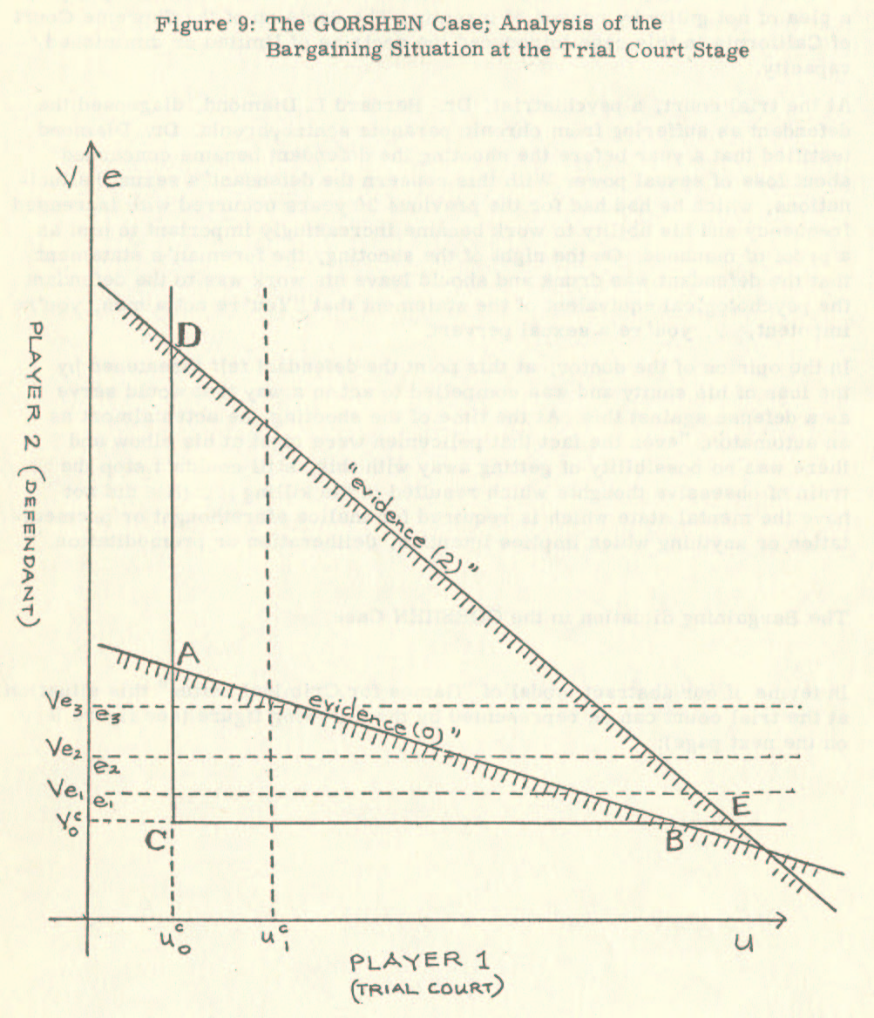
In this representation of the GORSHEN case, u stands for the utility for esteem of Player 1 (trial court) and v for the utility for esteem of Player 2 (defendant). Both the utility function u and the utility function v are assumed to be given and not subject to change. u_{o}^{c} is the conflict outcome for Player 1, i. e., which he can expect as a minimum should the opponent refuse to agree to any other bargaining solution within the feasible set or on the Edgeworth contract curve. v_{o}^{c} is the corresponding conflict outcome for Player 2. Finally, the line through the points A and B on the conflict lines uoc and voc is the Edgeworth contract curve.
Then, the feasible set of bargaining outcomes is described by the reality constructions A, B, and C and any mix thereof. From the previous discussion, we know that the reality construction to be chosen (i. e., the bargaining outcome for this game) will be a point X_{o} with the coordinates (u_{o}, v_{o}) on the Edgeworth contract curve.
As this case takes place at the court stage within the sequence of encounters in the Criminal Justice System -- that is, as the finalized status determination (disregarding appellate proceedings, for our purposes) for Player 2 is made at this stage -- we know that the construction of the reality of Player 2’s behavior means at the same time the reconstruction of the reality of Player 2’s status. If for Player 2 the minimum esteem loss necessary for a judgment of first-degree murder is e₁ (corresponding to the value v_{e1} on his utility-scale), and if e₂ (corresponding to the value v_{e2}) is the minimum esteem loss necessary for a judgment of second-degree murder and, finally, if e₃ (corresponding to the value v_{e3}) is the minimum esteem loss necessary for a judgment of "other homicide", we also know that the judgment in the GORSHEN case of second-degree murder, i. e. the bargaining outcome X₀, has in our model the coordinates (u_{o}, v_{e2} ≥ v_{o} > v_{e1}).
The Decision Making Process in the GORSHEN Case
Before we make our first change in the bargaining situation, observe its results on the outcome, and draw from it the first of a series of propositions, which explain the basic Proposition 1, we shall let the trial court state the matters considered in reaching its decision. Beyond preparing the basis for later hypothetical changes in the situation, this will give us a concrete example of the analytical value of the "Games for Criminal Status" model.
According to the trial court, "up till the time that Dr. Diamond testified in this case, there was no explanation of why this crime was committed. . . . (The doctor is) the first person that has any reasonable explanation. Whether it’s correct or not, I don’t know . . . (I)f I would follow Dr. Diamond’s testimony in toto, I should acquit this man. .. .
"I' m willing to go on record that in all probability his theories are correct . . . that he (the defendant) had no particular intent to commit this crime.
"I like to be advanced. But it seems to me that my hands are tied with the legal jurisprudence as it stands today, and that’s why I' m saying this for the purpose of the record. The Appellate Court might say that my hands are not tied, but I think they are. . . . (E)ven accepting in part the testimony of Dr. Diamond, I still feel that this man is guilty of second degree murder. "
In reply to defense counsel’s assertion that "There is not one scintilla of malice,” the court said, "it all depends on how you view it. . . . Some other person or another Judge, might say, ' Malice, why, it’s full of it. He planned it. He said he was going to do it, he went home, he had an hour. ' "
Again defense asked, "Does your Honor feel that there is malice (afore-thought) here?" The court replied, "there was some intent. Now, whether you have free will or not free will, that’s so advanced, we’re not prepared for that . . . There’s plenty, plenty of malice as far as statements are concerned, and plenty of malice as far as actions are concerned. Now, whether he was compelled to do this because of some mental condition, that is so advanced and so far from us that we don't understand it. . . . (I)t would be a perfect first degree if it wasn't for the fact that he’s never been in trouble and because of the statement of the Psychiatrist. "
Three Propositions Exemplified on the GORSHEN Case
If we now begin our changes in the state of elements of the bargaining situation by considering the very last statement of the trial court, we can establish as a first proposition supplementing the basic Proposition 1:
P r o p o s i t i on 2: If it were mandatory for any "offender" to enter a coalition with a person capable of demonstrating additional interpretations of given facts at least at the court stage, then the influence of social status quo ante of the "offender" on the construction of the social reality of a behavior and a status would be lessened.
From the GORSHEN case, we arrive at this proposition by hypothesizing that the same case was to be decided by the same court, however with the difference that no psychiatric testimony was available. Here we have recourse to the trial court’s statement.
We can also arrive at the same proposition from our abstract model. The reasoning is as follows: If we accept the claim made through our model that the model is an abstraction of the situation in the criminalization process or, in other words, if we accept the claim that the six elements of the bargaining situation are both necessary and sufficient conditions for the description and analysis of any game for criminal status, then we know that any change in the situation corresponds to a change in the state of one or more of the six elements in the model. Therefore, if we want to have a probabilistic prediction of the construction of the social reality of behavior and status in a given case, we must "translate" the change in the "real"-life situation into the parameters of the model. We can accomplish this by identifying the element of the bargaining situation, which has been changed, and the direction in which it has been changed. Then we can observe the result in the model, compare it to the result without the change, and, finally, we can "translate" the observed parameter back into the "real"-life situation. On the other hand, if we want to arrive at a proposition, the procedure to attain it differs only insofar as we "translate" the parameter which results in our model after a hypothetical change into the general statement: a is a function of b (a = f (b) ). Furthermore, of course, we can also arrive at such a proposition if we do not have a specific case in mind and generate propositions directly from the model.
Returning now to the GORSHEN case, we know that if the psychiatric testimony is omitted, we certainly have not changed the status of the Players (and, therefore, their utility functions for esteem), the number of successive games necessary to obtain criminal status or the conflict outcome of Player 2. Therefore, four elements of the bargaining situation are untouched by the change in the situation. Also, since the "evidence" in the case has remained the same and only the number of possible interpretations of the same "evidence" has been decreased, we know that the position of the Edgeworth contract curve (which we also could call "evidence"-line in a game for criminal status) has remained unchanged. This leaves us with the last of the six elements in a bargaining situation, namely the conflict outcome of Player 1.
It becomes immediately apparent that this is the parameter of the model, which has been changed by the hypothetical omission of the psychiatric testimony in the GORSHEN case, if we envision the case of a "conflict", i. e., a situation where both parties refuse to deal with each other and to come to an agreement. Then, the conflict outcome of Player 2 would remain the same, whether with or without the psychiatric testimony. However, Player 1’s outcome in a conflict would be better if there was no psychiatric testimony, as his esteem would not additionally and negatively be influenced for not considering this testimony.
In terms of our model, then, the hypothetical omission of the psychiatric testimony in the GORSHEN case would mean that we moved the conflict line u_{c}^{c} from its previous position u_{o}^{c} to the new position u₁^{c} , such that u_{o}^{c} < u₁^{c}. This has the effect that the feasible set of reality constructions becomes smaller than before. From the rules developed for the bargaining game for esteem, we further know that the new outcome X₁ has the coordinates (u₁, v₁), such that compared to the previous outcome X₀ with the coordinates (u_{o}, v_{o}), we have u₁ > u_{o} and v₁ < v_{o}. This means that the outcome for the defendant is more disadvantageous than before the change of state of the element. Generalizing this result leads us to Proposition 2.
However, Proposition 2 is only one of the propositions which can be developed based on this analysis. It has to be remembered here, as well as with the propositions brought forward later in this section, that each one belongs to a family of propositions and that these families are interrelated. On the one hand, the same proposition could be stated more or less expressly (e. g., in Proposition 2, we also could say: ". . . to be represented by a counsel, then . . . "); on the other hand, coalitions are not the only way by which the conflict line of Player 1 can be changed. Other ways by which it could be changed would be by procedural rules or even simply by the ability of players of type 2 to play a game for criminal status.
Another proposition belonging to the family of proposition 2 would be, then: If every player of type 2 has to be told his legal rights at the time of arrest (cf. MIRANDA v. ARIZONA, 384 U. S. 436 (1966)), this will tend to equalize the chances of members of different status groups that the social reality of their behavior will not be constructed as criminal behavior and the chances that their status after the final encounter at the court stage will not be constructed as criminal status.
If we now leave the psychiatric testimony and the position of the conflict line for Player 1 and turn to the other part of the trial court’s candid final statement ("It would be a perfect first degree, if it wasn't for the fact that he’s never been in trouble . . . "), we can develop another proposition concerning the state of a second element of the bargaining situation. This proposition also seems at odds with the traditional understanding of "equal justice before the law". However, it follows from the proposed approach in the "Games for Criminal Status" model and provides an ordering of seeming incongruities in the administration of "justice".
First, we have to "translate" this statement of the court into the parameters of our model. Here, the state of two elements in the model could be involved: One is the conflict line of Player 2, the other is his utility function for esteem.
Though cases are imaginable where a previous criminal record might influence the position of Player 2’s conflict line, this certainly is not so in the GORSHEN case, since here Section 190 of the California Penal Code provides an absolute conflict line through the death penalty in cases where one of the possible reality constructions is first-degree murder. Instead, the court’s statement concerns the utility-function for esteem of Player 2. If we bring the court’s perception of the bargaining situation into the form of a proposition, it could be restated in the following way:
Proposition 3: If a player of type 1 knows about his opponent's "criminal record", this will increase the chances that Player 2’s behavior is constructed as criminal behavior and his status as criminal status.
Proposition 3 follows directly from our model if we remember our previous discussion of the effect of the utility curve on the bargaining outcome in the example between a rich man and a poor man (see above, pages 62 f. and 72 ff.).
As in the previous proposition, we have to remember that this proposition is only one of a family of propositions concerning the state of the utility function of Player 2. Another one belonging to this family would be, e.g.: The same amount of status information (e. g., on occupation, on sex, on childhood) about a prospective "offender" works to the advantage of a "high"-status "offender" and the disadvantage of a "low"-status "offender".
Turning now to the "evidence" in the GORSHEN case, we come to the fourth proposition:
Proposition 4: The clearer the "evidence" (i. e., the fewer the feasible interpretations) for the same phenomenal behavior, the higher are the chances for a conviction.
If we regard the Edgeworth contract curve as the "evidence" line and if we define "evidence" as being the "clearer", the smaller the angle of the lines through CB and AB (see figure 9, page 110), this follows directly from our model.
This proposition seems very obvious and almost too superfluous to mention. However, as "evidence" is regarded as a function of privacy and privacy as differentially distributed among status groups (Stinchcombe, 1963), propositions belonging to the same family are not quite so obvious and even contradict prevailing beliefs. E.g., another proposition belonging to this family would be: A law protecting the privacy of one’s home has the effect that in criminal cases, the chances for a conviction are higher for "low"-status persons in a social system.
At this point, we propose to leave the GORSHEN case, as there is a danger of overinterpretation given the limited information on it. At any rate, it was meant to be used mainly as an illustration for both the explanatory and analytical powers of the model of "Games for Criminal Status". We have to keep in mind that even though this case, through the candid language of the trial court, demonstrated the criminalization process as a "Game for Criminal Status", it had at least two serious shortcomings. Firstly, it is a specific case where a decision has already been made. That means that propositions drawn from it run the danger of not being sufficiently abstract and valid only for this and related cases. Secondly, there is more danger that our illustration of the model with the GORSHEN case, just like the traditional approaches in criminology, concentrates too much on the official agents of the Criminal Justice System, thereby losing sight of what we perceive to be the most important agent, the victim and/or the general public.
Another Three Propositions
There are still three elements of the bargaining situation which have to be discussed and the parameters of which have to be illustrated through propositions. These are (1) the number of successive games necessary to obtain criminal status, (2) the utility function for esteem of Player 1, and (3) the conflict line of Player 2.
Starting with the element, "number of successive games necessary to obtain criminal status", we can set up the following proposition:
Proposition 5: The larger the number of successive encounters necessary to obtain criminal status (e.g., the determination of guilt separated from sentencing would mean an additional game), the more likely one would find a disproportionately large number of low-status persons among the persons convicted.
We can derive this proposition from the results theoretically obtained through our model. We found that a low-status person automatically has a disadvantage in any game for criminal status. If that is true, then a sequence of games compounds this disadvantage, and our Proposition 5 follows.
This proposition also belongs to a family of propositions. Another one would be: The free choice of counsel (which itself is a subgame for coalition) results in a disadvantage to the bargaining position of low status "offenders".
If we turn now to the next element, the utility function for esteem of Player 1, we can derive from our model the following proposition:
Proposition 6: One's peers (e. g., lieutenants in a court-martial for a lieutenant) are likely to come to less favorable constructions of reality for the same phenomenal act than agents of a Criminal Justice System whose status is b e l o w the one of the prospective, "offender" (e. g., privates) and to more favorable constructions than agents with higher status (e. g., generals).
The reasoning here is similar to the reasoning used for Proposition 3. A member of the family of this proposition is, e.g.: A "war on white-collar crime" is more likely to produce results if high-status agents are in charge of detection, investigation, prosecution, and judgment of white-collar "offenders".
Coming, finally, to the last element in the bargaining situation, namely the conflict line of Player 2, a proposition would be:
Proposition 7: The greater the number of alternatives for an agent, the more he will be inclined to choose from that number those encounters in which the return in esteem, as compared to the effort to attain this esteem, is the highest (i. e., encounters in which a player of type 2 is not likely to be able to engage in a "hard" bargain for the position of his conflict line guaranteeing his minimum outcome).
117
This proposition directly follows from the rationality postulate that more is always preferred to less. A more specific proposition within the same family is, e. g.: If the outcome level of alternatives for an agent is reduced (as this can be the case with a special law enforcement group, e. g., IRS-agents), then the likelihood increases that previously unacceptable games (tax fraud would be in most cases an unacceptable game in a non-specialized law enforcement group) might now be accepted.
The Model of "Games for Criminal Status" and the Propositions Deduced from It
The propositions in this section are all examples of the descriptive and analytical powers of the "Games for Criminal Status" model. As we repeatedly emphasized in this section, many more propositions on different levels of generality could be deduced from the model. The ones chosen here were selected more or less arbitrarily from the universe of possible propositions to delineate the model's scope.
Propositions such as those demonstrated in this section could be empirically investigated once they are brought into an operationalized form. They could also be used for social policy decisions concerning the Criminal Justice System, that is, they could be used for system planning. However, as we explained previously, both these steps are beyond the scope of this study.
What we tried to achieve instead was the construction of an alternative model capable of providing an understanding of the workings and the dynamics of a Criminal Justice System based on fewer assumptions than traditional approaches in criminology. Using the conception that "crime" is one of the possible relationships of an individual to his society, we designed such an alternative model and illustrated it by propositions.
The model of "Games for Criminal Status" might not be a very pleasing conceptualization of the criminalization process to traditional preconceptions of "crime" and "criminal" or of "behavior" and "status". However, it is a conceptualization that provides an understanding of the criminalization process beyond the one, which can be reached with traditional preconceptions. It explains what seemed to be not explainable: The Criminalization of Man in Society.

5. SUMMING UP: JUSTICE AS ORDER THROUGH STRUCTURED SOCIAL INEQUALITY
We began our study with the statement that "criminology has been and still is a laymen’s science, traditionally incapable of transcending insights beyond common sense and traditionally occupied with rationalizing societal irrationalities.” In the course of our reasoning, we attempted to step beyond common sense. Now, we can sum up the results of our study with the statement that justice is order through structured social inequality.
When we use the term justice, we mean more than merely criminal justice; what we have in mind is the justice of social differentiation in social groupings in general. We see the principles of justice at work in the evaluation of the behavior and the status of the "leader" and the "outsider" in a small group, just as we observe them in the "making of a president" and the making of a criminal in the larger society. As we understand it, justice is a functional device, an artifice, which maintains structured social inequality in general. It is a complicated, intricate cover for the existence of social differentiation. The idea of justice could be seen as making the social world livable. It could be understood as supporting constructions like the American Dream, just as it could be regarded as providing reasons for differential social evaluation and, in the case of criminal justice, for the differential distribution of immunity.
Social science has done its share in justifying the existing social structure. Only in recent years has social science come to recognize its problem of being a serf to a social structure, which distributes the good things in life in a way, which is blatantly inconsistent with society’s own maxims. Gouldner's book The Coming Crisis in Western Sociology (1970) and Bertrand’s characterization of the criminologists as being "engaged in a collective fraud" (1973: 37) are jarring testimonials to the growing awareness of today’s problematic situation in social science.
In the light of these circumstances, the current reorientation of social science towards a social meliorism becomes understandable -- and indeed predictable from a position which perceives, as we do, social science as a social activity and, therefore, social science as a metascience of social science. It was predictable because we know from the findings on the behavior of individuals or social entities in situations of diffused reality, of feeling " u n b e h a u s t ", that there is a tendency to restructure a shattered environment, actually and cognitively. For instance, in Festinger’s study, When Prophecy Fails (Festinger et al., 1956), a group of religious fanatics stepped up proselyting after their prophecy, predicting the end of the world, failed. Similarly, we know from the study of group problem-solving that groups experiencing severe difficulties in the stage of problem definition are likely to skip this stage and become "actionistic ".
In our own study, we considered the comparable crisis in social science. We proposed, as an attempt to avoid the ought-worlds of the traditional and the radical-reactive approach, a 1' art pour 1' art approach to social science, that is, an approach which postulates the restriction of social science to problem definitions, to a "pure" social science, and which abdicates the claim that a scientific endeavor of social investigation can simultaneously provide problem definitions and problem solutions. Through the example of "Gouldner’s Complaint", we showed that such a distinction between "pure" and "applied" social science is both challenging and painful to draw. However, we also showed that this distinction is necessary if we want to improve the chances that our constructions in social 'science are reconstructions of the construction of social reality, instead of merely constructions of the first degree which run parallel and in competition with the common sense structuring of the social environment. Furthermore, we showed that this distinction between "pure" and "applied" social science is a precondition for restructuring (changing) the presently existing social reality.
Within this theoretical framework, we developed our "Concept of Marginality" and the models of "Games for Social Status" and of "Games for Criminal Status". Perceiving the second model as a particular case of the first model, we attempted to integrate criminology into an overall concept of social science as the study of social differentiation. As a result, we could state that justice is order through structured social inequality. This result is bleak and much less pleasing than a construction of a social ought-world. It does not show us a world as we would like it to be. However, it is a second-degree construction of the social reality that is non-contradictory to empirical findings, which orders them into general propositions, thus providing a basis for restructuring the social is-world. Then, our models of "Games for Status" are a problem definition, not a problem solution.
Whether we have to or want to accept a social reality of structured inequality, as it exists now, was not at issue. This is a separate question for T h e Sociology of the Possible (Ofshe, 1970a) and a significant challenge for social science and the sociological imagination.

BIBLIOGRAPHY
ANSCOMBE, F. J. and R. J. Aumann
1963 "A Definition of Subjective Probability.” The Annals of Mathematical Statistics 34 (1963): 199ff.
BARBER, Bernard and Walter Hirsch, editors
1962 The Sociology of Science. New York: The Free Press of Glencoe
BECKER, Howard S.
1963 Outsiders: Studies in the Sociology of Deviance. New York: The Free Press of Glencoe
BECKER, Howard S., editor
1964 The Other Side: Perspectives on Deviance. New York: The Free Press of Glencoe
BENDIX, Reinhard and Guenther Roth
1971 Scholarship and Partisanship: Essays on Max Weber. Berkeley: University of California
BERGER, Peter L.
1963 Invitation to Sociology: A Humanistic Perspective. Garden City, N. Y.: Doubleday
BERNOULLI, Daniel
1738 "Exposition of a New Theory on the Measurement of Risk. Econometrica 22 (1954): 23ff.
BARTALANFFY, Ludwig von
1968 General System Theory: Foundations, Development, Applications. New York: Braziller
BERTRAND, Marie Andree
1973 "Dialogue with Marie Andree Bertrand. An Interview by Virginia Enquist Grabiner. " Issues in Criminology 8 (1973): 31ff.
BEVERIDGE, Wilbert E.
1957 The Art of Scientific Investigation. (3rd ed.) New York: Norton
BLAU, Peter M.
1964 Exchange and Power in Social Life New York: Wiley
BLAU, Peter M.
1967 "The Research Process in the Study of ' The Dynamics of Bureaucracy'.” In: Hammond, 1967: 18ff.
BLUMBERG, Abraham S.
1967 Criminal Justice. Chicago: Quadrangle
BORDUA, David J., editor
1967 The Police: Six Sociological Essays. New York: Wiley
CONANT, James B.
1947 On Understanding Science. An Historical Approach. New Haven: Yale University Press
DAHRENDORF, Ralf
1968 Essays in the Theory of Society. Stanford, Calif.: Stanford University Press
DAVIS, Kingsley and Wilbert E. Moore
1945 "Some Principles of Stratification.”
American Sociological Review 10 (1945): 245ff.
DURKHEIM, Emile
1885 "The Normal and the Pathological". In: Wolfgang, et al., 1970: llff.
DAWSON, Robert O.
1969 Sentencing: The Decision as to Type, Length, and Conditions of Sentence. Boston: Little, Brown
ENNIS, Philip H.
1967 "Crime, Victims, and the Police". In: Wolfgang, et al. 1970: 74ff.
ENNIS, Philip H.
1967a Criminal Victimization in the United States: A Report of a National Survey. Washington, D. C.: U.S. Government Printing Office
ERIKSON, Kai T.
1962 "Notes on the Sociology of Deviance.” In: Becker, 1964: 9ff.
ERIKSON, Kai T.
1966 Wayward Puritans. A Study in the Sociology of Deviance. New York: Wiley
FAGAN, Joen
1967 "Graduate School Games. " Transactional Analysis Bulletin 6 (1967): 103ff.
FARIS, Robert E. L., editor
1964 Handbook of Modern Sociology. Chicago: Rand McNally
FESTINGER, Leon, Henry W. Rieken, and Stanley Schachter
1956 When Prophecy Fails. Minneapolis: University of Minnesota Press
FRIEDMAN, Milton and Leonard J. Savage
1948 "The Utility Analysis of Choices Involving Risk.” The Journal of Political Economy LVI (1948): 249ff.
GARFINKEL, Harold
1967 Studies in Ethnomethodology. Englewood Cliffs, N. J.: Prentice-Hall
GAROFALO, Raffaele
1885 Criminology. Boston: Little, Brown. 1914. (first published in Italian)
GERTH, H. H. and C. Wright Mills, editors
1958 From Max Weber: Essays in Sociology. New York: Oxford University Press
GOULDNER, Alvin W.
1970 The Coming Crisis of Western Sociology. New York: Avon
GOULDNER, Alvin W.
1973 "Foreword to: The New Criminology.” In: Taylor, et al., 1973: ix ff.
HAKANSSON, Nils H.
1970 "Friedman-Savage Utility Functions Consistent with Risk Aversion.” The Quarterly Journal of Economics LXXXIV (1970): 472ff.
HAMMOND, Philip E., editor
1967 Sociologists at Work: Essays on the Craft of Social Research. Garden City, N. Y.: Anchor
HARSANYI, John C.
1956 "Approaches to the Bargaining Problem before and after the Theory of Games: A Critical Discussion of Zeuthen’s, Hicks’, and Nash’s Theories.” Econometrica 24 (1956): 144ff.
HARSANYI, John C.
1961 "On the Rationality Postulates Underlying the Theory of Cooperative Games.” Journal of Conflict Resolution 5 (1961): 179ff.
HARSANYI, John C.
1962 "Measurement of Social Power, Opportunity Costs, and the Theory of Two-Person Bargaining Games.” Behavioral Science 7 (1962): 67ff.
HARSANYI, John C.
1966 "A Bargaining Model for Social Status in Informal Groups and Formal Organizations.” Behavioral Science 11 (1966): 357ff.
HARSANYI, John C.
1968 "Individualistic and Functionalistic Explanations in the Light of Game Theory: The Example of Social Status". In: Problems in the Philosophy of Science. Amsterdam: North-Holland, 1968: 305ff.
HOMANS, George Caspar
1950 The Human Group. New York: Harcourt, Brace
HOMANS, George Caspar
1961 Social Behavior: Its Elementary Forms. New York: Harcourt, Brace & World
HOVLAND, C. I., I. L. Janis, and H. H. Kelley
1953 Communication and Persuasion. New Haven: Yale University Press
HOVLAND, C. I., W. Mandell, Enid H. Campbell, T. Brook. A. S. Luchins, A. R. Cohen, W. J. McGuire, I. L. Janis, Rosalind L. Feierabend, and N. H. Anderson
1957 The Order of Presentation in Persuasion. New Haven: Yale University Press
JANIS, I. L., C. I. Hovland, P. B. Field, Harriet Linton, Elaine Graham,
A. R. Cohen, D. Rife, R. R. Abelson, G. S. Lesser and B. T. King
1959 Personality and Persuasibility. New Haven: Yale University
Press
JENNINGS, Helen Hall
1950 Leadership and Isolation. (2nd ed.) New York: Longmans, Green
KERR, Clark
1966 The Uses of the University. New York: Harper and Row
KUHN, Thomas S.
1962 The Structure of Scientific Revolutions. Chicago: University of Chicago Press
LAFAVE, Wayne R.
1965 Arrest: The Decision to Take a Suspect into Custody. Boston: Little, Brown
LEMERT, Edwin M.
1951 Social Pathology. A Systematic Approach to the Theory of Sociopathic Behavior. New York: McGraw - Hill
LEMERT, Edwin M.
1970 Social Action and Legal Change. Revolution within the Juvenile Court. Chicago: Aldine
LU CE, R. Duncan and Howard Raiffa
1957 Games and Decisions. New York: Wiley
LUHMANN, Nikolas
1967 "Soziologische Aufklarung". Soziale Welt 18 (1967): 97ff.
MACNAUGHTON-SMITH, Peter
1973 "The Role of the Criminologist in Society". Center of Criminology, University of Toronto, Contribution to Round Table Discussion, 14th Annual Congress of the Quebec Society of Criminology, Montreal, March 15, 1973
MARKOWITZ, Harry
1952 "The Utility of Wealth". The Journal of Political Economy 60 (1952): 151ff.
MERTON, Robert K.
1962 "Foreword to: The Sociology of Science". In: Barber and Hirsch, 1962
MERTON, Robert K.
1968 Social Theory and Social Structure. (1968 enlarged edition) New York: The Free Press
MILLER, Frank W.
1969 Prosecution: The Decision to Charge a Suspect with a Crime. Boston: Little, Brown
MILLS, C. Wright
1959 The Sociological Imagination. London: Oxford University Press
MORGENSTERN, Christian
1963 Galgenlieder; a Selection. Translated, with an Introduction by Max Knight. Berkeley: University of California Press
NASH, John F., Jr.
1950 "The Bargaining Problem". Econometrica 18 (1950): 155ff.
NASH, John F., Jr.
1953 "Two-Person Cooperative Games". Econometrica 21 (1953): 128ff.
NEUMANN, John von, and Oskar Morgenstern
1944 Theory of Games and Economic Behavior. Princeton: Princeton University Press
NEWCOMB, Theodore M.
1961 The Acquaintance Process. New York: Holt, Rinehart and Winston
NEWMAN, Donald J.
1966 Conviction: The Determination of Guilt or Innocence without Trial. Boston: Little, Brown
NISBET, Robert A.
1970 The Social Bond. An Introduction to the Study of Society. New York: Knopf
OFSHE, Lynne and Richard Ofshe
1970 Utility and Choice in Social Interaction. Englewood Cliffs, N. J.: Prentice-Hall
OFSHE, Richard, editor
1970a The Sociology of the Possible. Englewood Cliffs, N. J.: Prentice -Hall
PARETO, Vilfredo
1935 The Mind and Society (Trattato di Sociologia Generale). New York: Harcourt, Brace
POPPER, Karl R.
1935 Logik der Forschung. Zur Erkenntnistheorie der modernen Naturwissenschaft. Wien: Springer
POPPER, Karl R.
1952 The Open Society and Its Enemies. (2nd ed.) London: Routledge & Kegan Paul
QUINNEY, Richard
1970 The Social Reality of Crime. Boston: Little, Brown
QUINNEY, Richard
1970a The Problem of Crime. New York: Dodd, Mead
QUINNEY, Richard
1971 "Dialogue with Richard Quinney. An Interview Conducted and Prepared by Eileen Goldwyn". Issues in Criminology 6 (Summer 1971): 41ff.
RAPOPORT, Anatol and Albert M. Chammah
1965 Prisoners' Dilemma. Ann Arbor: University of Michigan Press
REICHENBACH, Hans
1938 Experience and Prediction. An Analysis of the Foundations and the Structure of Knowledge. Chicago: University of Chicago Press
REICHENBACH, Hans
1947 Elements of Symbolic Logic. New York: Macmillan
REISS, Albert J., Jr., and David J. Bordua
1967 "Environment and Organization: A Perspective on the Police". In: Bordua, 1967: 25ff.
REISS, Albert J., Jr.
1971 The Police and the Public. New Haven: Yale University Press
REMINGTON, Frank J.
1969 "Editor’s Foreword". In: Dawson, 1969: xvff.
ROSENBERG, M. J. , C. I. Hovland, W. J. McGuire, R. P. Abelson, and J. W. Brehm
1960 Attitude Organization and Change. New Haven: Yale University Press
ROSENTHAL, Robert
1966 Experimental Effects in Behavioral Research. New York: Appleton-Century-Crofts
ROTH, Guenther
1971 "Value-Neutrality in Germany and in the United States". In: Bendix and Roth, 1971: 34ff.
SAVAGE, Leonard J.
1954 The Foundations of Statistics. New York: Wiley
SCHELLING, Thomas C.
1963 The Strategy of Conflict. Cambridge, Mass.: Harvard University Press
SCHUTZ, Alfred
1953 "Concept and Theory Formation in the Social Sciences". In: Schutz, 1962: 48ff.
SCHUTZ, Alfred
1962 Collected Papers I: The Problem of Social Reality. The Hague: Martinus Nijhoff
the SCHWENDINGERS, Herman and Julia R.
1970 "Defenders of Order or Guardians of Human Rights?” Issues in Criminology 5 (1970): 123ff.
the SCHWENDINGERS, Herman and Julia R.
1972 "The Continuing Debate on the Legalistic Approach to the Definition of Crime". Issues in Criminology 7 (1972): 71ff.
SELLIN, Thorsten
1938 "A Sociological Approach". In: Wolfgang, et al., 1970: 3ff.
SILVER, Allan
1967 "The Demand for Order in Civil Society: A Review of Some Themes in the History of Urban Crime, Police, and Riot". In: Bordua, 1967: 1ff.
SIMON, Herbert A.
1957 Models of Man: Social and Rational. Mathematical Essays
on Rational Human Behavior in a Social Setting. New York:
Wiley
SKOLNICK, Jerome H.
1966 Justice without Trial. Law Enforcement in Democratic Society. New York: Wiley
STINCHCOMBE, Arthur
1963 "Institutions of Privacy in the Determination of Police Administrative Practice". American Journal of Sociology 69 (1963): 150ff.
SUTHERLAND, Edwin H.
1945 "Is ' White Collar Crime' Crime?” In: Wolfgang, et al. , 1970: 32ff.
SUTHERLAND, Edwin H. and Donald R. Cressey
1970 Criminology (eighth edition). Philadelphia: Lippincott
SVALASTOGA, Kaare
1964 "Social Differentiation". In: Faris, 1964: 5 3 Off.
TAPPAN, Paul W.
1947 "Who is the Criminal? “ In: Wolfgang, et al. , 1970: 41ff.
TASK FORCE REPORT: Science and Technology, President’s Commission on Law Enforcement and Administration of Justice, Washington, D. C.
1967 "Measuring Crime". In: Wolfgang, et al., 1970: 101ff.
TAYLOR, Ian, Paul Walton and Jock Young
1973 The New Criminology: For a Social Theory of Deviance. London: Routledge & Kegan Paul
THIBAUT, John W. and Harold H. Kelley
1959 The Social Psychology of Groups. New York: Wiley
THOMAS, William I., and Dorothy Swaine Thomas
1928 The Child in America. Behavior Problems and Programs. New York: Knopf
TIFFANY, Lawrence P., Donald M. McIntyre, Jr., and Daniel L. Rotenberg
1967 Detection of Crime. Boston: Little, Brown
TURK, Austin T.
1969 Criminality and Legal Order. Chicago: Rand McNally
WARNER, W. Lloyd, Marchia Meeker, and Kenneth Eells
1949 Social Class in America. A Manual of Procedure for the Measurement of Social Status. Chicago: Science Research Associates
WEBER, Max
1918 "Science as a Vocation". In: Gerth and Mills, 1958: 129ff.
WEBER, Max
1923 Gesammelte Aufsatze zur Wissenschaftslehre. Tübingen: Mohr (Siebeck), 1951
WEINGARTNER, H. Martin
1967 Mathematical Programming and the Analysis of Capital Budgeting Problems. Chicago: Markham
WHYTE, William Foote
1943 Street Corner Society. The Social Structure of an Italian Slum (2nd ed., 1955), Chicago: University of Chicago Press
WILSON, James Q.
1968 Varieties of Police Behavior. The Management of Law and Order in Eight Communities. Cambridge, Mass.: Harvard University Press
WOLFGANG, Marvin E., Leonard Savitz, and Norman Johnston
1970 The Sociology of Crime and Delinquency (2nd ed.). New York: Wiley
ZEUTHEN, Frederik
1930 Problems of Monopoly and Economic Warfare. London: G. Routledge

